Children’s rights in the digital age – animation
Instructions for use and translation

This animation was produced by the London School of Economics and Political Science (LSE) for the Youth Skills (ySKILLS) project. It can be used and translated under an Attribution-NonCommercial 4.0 International (CC BY-NC 4.0) license.

The animation explains children’s rights in the digital age and the main principles that policy-makers and industry should follow to fulfil these rights.

Please, include the following credit when using the animation:
This animation was produced by the London School of Economics and Political Science (LSE) for the Youth Skills (ySKILLS) project. It is used and translated with permission (CC BY-NC 4.0).

The animation is available in different versions to accommodation different translation options:
- An example: a competed animation in English with voice over and subtitles. Available at: https://youtu.be/X376INRwEaE?si=MVMTMRWY8kk6RABX
- A version for subtitle translation: an animation in English with voice over, no subtitles. Add substitles with your translation of the script below. Available at: https://eprints.lse.ac.uk/120373/
- A version for full translation: an animation with background sound/music, no voice over and no subtitles. Add voiceover and substitles with your translation of the script below. Available at: https://eprints.lse.ac.uk/120375/
- A version with no sound: an animation no background sound/music, no voice over and no subtitles. Add voiceover and substitles with your translation of the script below and your own sound. Available at: https://eprints.lse.ac.uk/120377/

How to download the animation files
1.Visit the link above and press “Download” | 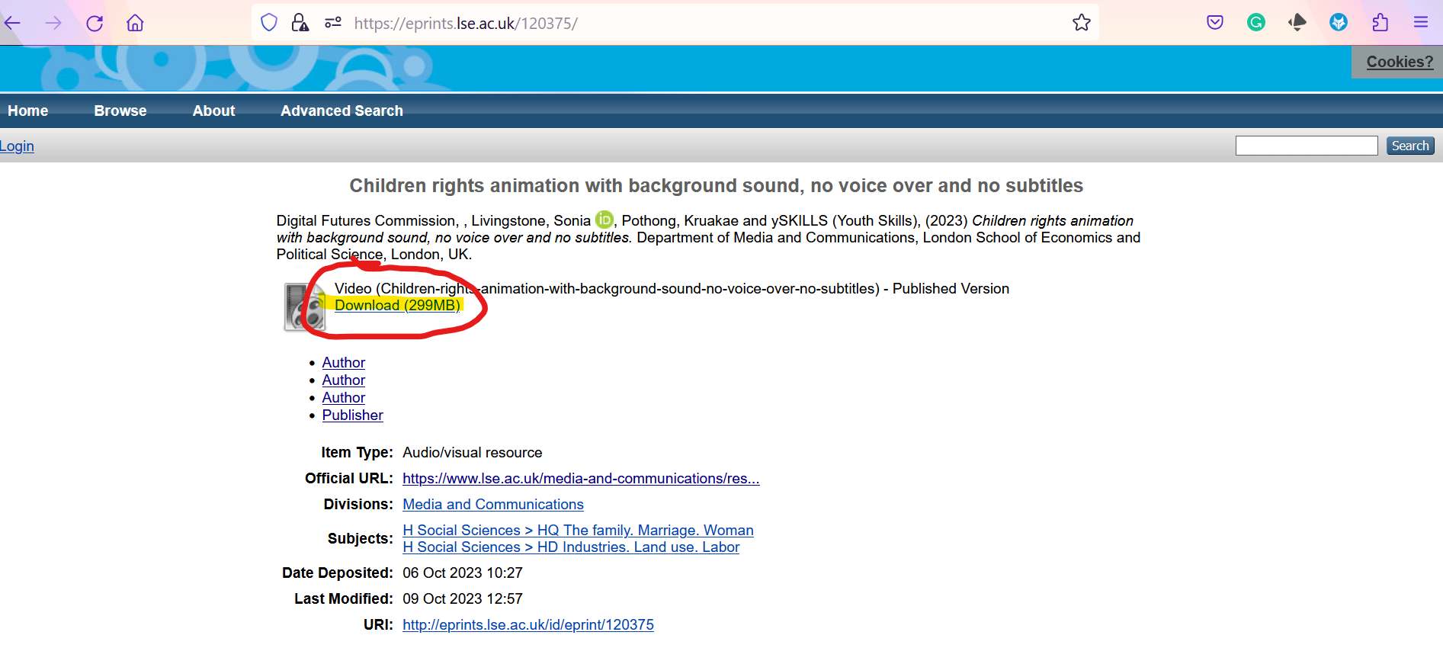
2. Once the video starts playing, you can downlaod it by right-clicking anywhere on the video and choosing “Save video as” | 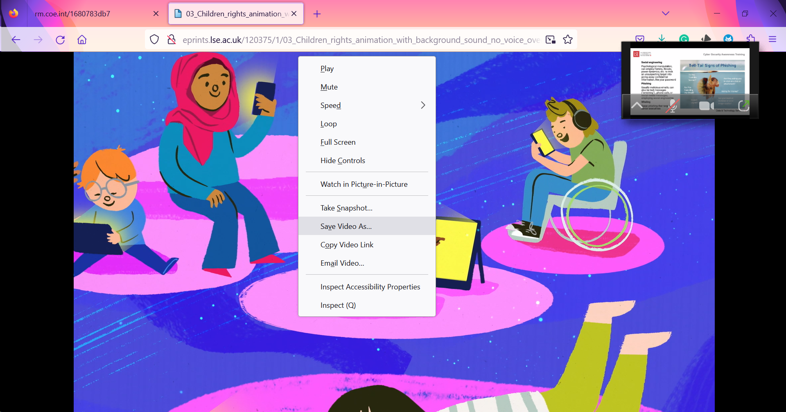

Translating the script
VISION | SCRIPT
Opening shot of various kids with various digital gadgets, playing and scrolling online | Narrator: In the digital world children have more access to a vast realm of exploration and opportunities.
Cut to a grid with 4 kids on each side  Grid 1: Shows a child clicking on an accept button and revealing an inappropriate page and being scared by the content  Grid 2: A deaf child looking gloom as he is not able to follow commands being called out  Grid 3: Shows distracted child playing a [S1] game while walking on the road and almost gets run over  Grid 4: Child being cyber bullied on an 18+ website | Narrator: Though exciting, the digital environment also houses inappropriate content and potentially dangerous situations.  We need to make it a safer and more empowering place for children. But how do we do that?
Cut to a wide shot of people [developers, parents/caregiver] looking at a scroll titled “Child Digital Rights” with all 11 policies visually portrayed | Narrator:  Eleven principles help guide policymakers and businesses to ensure children's rights and best interests.
A diverse group of children smiling and playing together, then cut to an isolated child with a disability within the group struggling to use an app that isn't accessible. | Narrator: First, there's equity and diversity.  Just like in the real world, children face different challenges. We must ensure that all children have equal access to safe and engaging digital experiences.
Side-by-side videos of kids playing a violent video game, another being shown inappropriate ads and their personal information being stolen by a third-party app | Narrator: A child's well-being should always be a top priority when designing digital products. Games and content need to be age-appropriate and protect children's privacy. Safety matters!
A shot of children with caregivers sitting around a table with app developers and policy makers, giving their opinions on digital products. | Narrator: It's also important to listen to children's voices and consult with them as decisions are made about the digital world.
A shot of a child's mental health being negatively affected by social media then to children using digital products that promote learning. | Narrator: Digital products and services must enhance not harm children's physical and mental health. They need to enable children to develop important creativity, problem-solving, digital literacy and socialization skills.
Children using digital products that give them control and avoid addictive or exploitative features [buttons that give more info] | Narrator: And finally, agency. A child should be free to explore and enjoy the digital world without feeling pressured or manipulated.
A shot of an app interface with compulsive and exploitative features being removed.  Closing shot of the four grids unfreezing to reveal the safe versions of each of the earlier. | Narrator: Taking steps to realise children’s rights by design creates a safer, age-appropriate and more inclusive digital space for everyone.  These 11 principles are grounded in the United Nations Convention on the Rights of the Child which applies to everyone under the age of 18 and is the most widely ratified international human rights treaty ever.  Underpinned by decades of research on children's digital engagement, these principles were formulated by the Digital Futures Commission and developed by the ySKILLS project.
 | CLOSING SCREEN
Credits: This animation was produced by the London School of Economics and Political Science (LSE) for the Youth Skills (ySKILLS) project. It is used and translated with permission (CC BY-NC 4.0).

Final links
www.digitalfuturescommission.org.uk
https://5rightsfoundation.com/
https://yskills.eu/
https://www.lse.ac.uk/media-and-communications
https://childrightsbydesign.digitalfuturescommission.org.uk/

