The Relationship Between Health Spending And Social Spending In

High-Income Countries: How Does The US Compare?

ABSTRACT
There is broad consensus that the US spends too much on health care services. One proposed driver of the high US spending is low investment in social services. We examined the relationship between health spending and social spending across high-income countries. We found that US social spending (at 16.1 percent of gross domestic product [GDP] in 2015) is slightly below the average for Organization for Economic Cooperation and Development countries (17.0 percent of GDP) and above average when educational spending is included (US: 19.7 percent of GDP, OECD: 17.7 percent of GDP). We found that countries that spent more on social services tended to spend more on health care services. Adjusting for poverty and unemployment rates and the proportion of people older than age sixty-five did not meaningfully change these associations. In addition, when we examined changes over time, we found additional evidence for a positive relationship between social and health spending: Countries with the greatest increases in social services spending also had larger increases in health care spending.
In 2015, the US spent approximately 17 percent of its gross domestic product (GDP) on the health care system. This was almost twice the average of other high-income countries and nearly a third more than Switzerland, the next highest spender.¹ Yet the US achieves relatively poor population health outcomes. Life expectancy at birth is 78.8 years,² compared to the average of 80.6 for Organization for Economic Cooperation and Development (OECD) countries, and is declining. The US fares no better on other population health measures. Indeed, it manages to spend substantially more than any other country while achieving some of the worst outcomes across high-income countries.³
There have been many theories to explain the high health spending and poor health outcomes in the US. One commonly cited hypothesis is that high US health care spending is the result of low social spending.^{4–6} The argument is based on the evidence that low social spending leads to a population that is sicker and postulates that this sicker population not only has worse health outcomes but also utilizes more health care—which in turn leads to higher health care spending. While the social determinants literature establishes a clear link between social factors and health status,^{7–10} and some evidence suggests a link between social spending and health outcomes,^{5,11–14} whether lower social spending is a driver of the higher health care spending in the US is largely unclear. Despite the lack of evidence, policy makers and others have advocated that the US increase its social spending to reduce health care spending, driven by the notion that more social spending can often pay for itself with reductions in health care utilization and corresponding costs.^{15–18}
Given the central importance of this issue, empirical data on the association between social spending and health care spending would be helpful. Therefore, we used the latest complete data available from the OECD to answer three questions: First, how does the US compare to other OECD countries in terms of its overall social spending? Second, is there evidence that countries that spend less on social services have higher spending on health care? Finally, is there any evidence that increases in social spending over time are associated with decreases in health care spending?

Study Data And Methods

Data
We defined social spending as countries’ expenditures on social programs. As social spending is thought to influence health spending through its impact on health outcomes, we focused on spending related to social programs that influence the key determinants of health.^{7,9,10} This led us to focus on spending related to active labor programs (such as welfare-to-work programs), incapacity and unemployment benefits, family programs, housing, pensions, and education (for specific frameworks outlining social programs that influence health outcomes see online appendix exhibit A1).¹⁹
We used data from the OECD Social Expenditure Database (SOCX), which covers the period 1980–2015 and includes data on thirty-five OECD countries. The database includes internationally comparable statistics on total social spending, including public and (both mandatory and voluntary) private social spending. These social spending estimates are broken down into the following policy areas: health, old age, survivors, incapacity-related benefits, family, active labor market programs, unemployment, housing, and other (which includes spending for immigrants and refugees, citizens who fall outside of the main social spending programs, and social spending not otherwise categorized). The database excludes any expenditure related to loans and any costs that do not go directly to the beneficiary, such as administration costs.
Since the OECD SOCX database includes health-related social spending as a component of social spending, we subtracted all health-related social spending from the SOCX figures to obtain estimates of social spending. Many researchers and policy makers[please provide] consider education an important aspect of social spending. However, educational spending is excluded from the OECD SOCX database, with the exception of some child care and early education services that are classified under the category “family.” We obtained data on educational spending from the OECD’s educational finance indicators data set and used them to constitute an additional category within social spending for sensitivity analyses. These data examine public and mandatory private spending on education. We excluded spending on early childhood education, which was already included in the SOCX database. The educational data available were for the year 2014. We were unable to find educational spending data for 2015 and the years before 2014.
We defined total health care spending as spending on a comprehensive set of health care goods and services, including personal health care, public health, and preventive health services. This included any compulsory and government spending, as well as voluntary health insurance and private out-of-pocket spending, so it captured any expenditure related to health care seeking behavior. We obtained these data from the OECD health expenditure and financing database, which contains information that is jointly collected by the OECD, Eurostat, and the World Health Organization’s Health Accounts System of Health Accounts Questionnaires.

Key Variables
Our main outcomes of interest were health care spending and social care spending. We examined both of these variables as relative spending (spending as a percentage of GDP) and absolute spending (nominal values expressed as dollars per capita, adjusted for purchasing power parity [PPP], using 2015 prices). For longitudinal analyses, we used an OECD base year of 2010 with constant prices in US dollars. When we examined health care or social spending over time, we used 2010 as a fixed reference year for the PPP, as set by the OECD. Given that the longitudinal analyses were standardize to 2010 prices, the nominal figures might differ slightly from the 2015 prices presented in the contemporaneous analyses.
We included three variables that might influence the size of populations eligible for social programs in our partial correlation estimations: the poverty rate, the proportion of the elderly population, and unemployment rates. To measure poverty, we used the poverty measure captured by the Luxembourg Income Study, which measures the ratio of people in a given country whose household income falls below half of the median household income of the total population, after taxes and transfers. This measure also had fewer missing values than what was available through the OECD. The proportion of the elderly population was measured as the percentage of the population older than age sixty-five and was obtained from the OECD.

Statistical Analysis
First, we present some basic sociodemographic country characteristics that might contribute to health and social spending across the OECD: the proportion of the population older than age sixty-five, GDP per capita, life expectancy at birth, the unemployment rate, and the poverty rate. We then compare the US and the other OECD countries in terms of social spending as a percentage of GDP. We also compare the breakdown of social spending by policy area. We parse out all social spending separately, by whether it is public or private social spending. To make the presentation more accessible to readers, in the main text we present social spending data on only the US and selected countries (Australia, Canada, Denmark, France, Germany, Japan, the Netherlands, Sweden, Switzerland, and the UK). The values for the remaining countries are included in the appendix.¹⁹ We also include the mean of all OECD countries in exhibits 1 and 2.
Next, we explore the relationship between social spending and health care spending across the OECD countries. We do this descriptively by plotting total health care spending against total social spending and estimating the correlation between them using a Pearson’s correlation. We then analyze the partial correlation between health and social spending including three variables that might influence this magnitude relationship: the poverty rate, the unemployment rate, and the proportion of elderly people. We also estimate the association between social spending by type of social program and total health care spending, to explore the magnitude and direction of the association.
Finally, we examine the trends in social and health care spending over time. First, we plot the trend in spending for health and social care in the period 1980–2015 for both the US and the OECD. Next, we estimate the average yearly growth in social spending and health care spending for each country from 1980 to 2015 using a multivariate linear regression. We illustrate the association between the change in social spending over time and the change in total health care spending over time by plotting the average yearly growth rates for each country and estimating the correlation between them using a Pearson’s correlation.
As a sensitivity analysis, we carry out all analyses using health and social spending expressed as nominal income adjusted by PPP. We also carry out the contemporaneous analyses using a measure of social spending that includes educational spending. All analyses were carried out using Stata, version 15.

Limitations
Our study had several important limitations. First, this article presents only observational data that compare health and social spending across countries. We were not able to draw any inferences about the causality of the relationship through this analysis. In particular, we could not determine whether greater social spending was a driver of greater health spending or whether more spending on health led to greater spending on social services. Critically, confounding factors might affect this relationship, so national income or even societal or political structures could be associated with both social and health spending.
Second, the OECD SOCX data include only information on particular aspects of social spending, as outlined above. Certain areas that have been found to potentially influence health outcomes, most notably education and transport, are excluded. We were able to obtain educational spending from other sources, but we were not able to include spending on transport. To construct a measure of social spending that included education, we used two data sets that measured expenditure a year apart. This might have led to error in the estimates of total social spending, although we believe it did not largely influence our results. In addition, given the differences in data collection for education, we were unable to identify a complete and comparable time series to combine with social spending. Thus, any longitudinal descriptive statistics were unable to take into consideration trends in education spending over time.
Finally, to carry out the analysis, we relied on aggregated spending data available from the OECD, which had some limitations in terms of comparability. In particular, seven countries do not report data on private social spending, thus potentially underestimating their total social spending contribution. Also, as noted by the OECD, there are some issues in how countries report data that is reflective of differences in local data collection and accounting methods.

Study Results
Average PPP-adjusted GDP per capita varied across OECD member states, ranging from $18,414 in Mexico to $102,817 in Luxembourg (appendix exhibit A2).¹⁹ At $56,701, the US GDP was above the average OECD GDP ($41,259) (exhibit 1). The population older than age sixty-five made up 16.7 percent of the population on average across OECD countries, compared to 14.9 percent in the US. Finally, the poverty rate in the US was above the OECD average (17.0 percent versus 11.2 3 percent), and unemployment was slightly lower in the US (5.4 percent versus 8.1 percent).

Social Spending Across The Organization For Economic Cooperation And Development
Across the OECD, the average total social spending by member states—excluding education and health-related social spending—was 17.0 percent of GDP, made up of about 2.1 percent private social spending and 14.9 percent public spending (exhibit 2). This amounts to approximately $7,308 per capita, PPP adjusted, across the average OECD country (appendix exhibit A3). The US spends approximately 16.1 percent of GDP on social spending (just below the OECD average), made up of about 5.7 percent private social spending and 10.4 percent public spending (appendix exhibit A3). This amounts to $9,018 per capita, PPP adjusted—which is slightly above the OECD average (see appendix exhibit A3).¹⁹ There was considerable variation in social spending across countries. Mexico was the lowest spender, with total social spending amounting to 4.7 percent of GDP in 2015, or about $839 per capita, PPP adjusted. The highest spender was Denmark, which spent 26.5 percent of its GDP ($12,922 per capita).
There were also large differences across countries in the breakdown between public and private social spending. The Netherlands had the highest share of private social spending at 6.9 percent of GDP, while seven countries in the sample did not report social spending from private sources. Across countries, the greatest proportion of both public and private social spending went to old age spending, making up 9.4 percent of GDP on average. The US spent slightly above average on old age spending, at 11.7 percent of GDP. The appendix illustrates the breakdown of public and private social spending by function.¹⁹
Educational spending also varied across the OECD countries. When compared to the other policy areas that make up social spending, education was the second largest area, after old age spending. Across the OECD countries, educational spending made up 5.2 percent of GDP, or $1,865 per capita on average (excluding early childhood education, which was included in family-related social spending) (see appendix exhibit A6).¹⁹ The US spent above the average on education: 6.2 percent of GDP, or over $3,000 per capita. Across the different educational categories, the US spent slightly more than average in every category for which there were comparable data. However, US educational expenditure from public sources (4.2 percent of GDP) was just below that of the average OECD country (4.4 percent) (see appendix exhibit A7).¹⁹ If we included educational spending within social spending, the US social expenditure increased to 19.7 percent of GDP, which was greater than the OECD average of 17.7 percent (exhibit 2).

Health Care Spending Across The Organization For Economic Cooperation And Development
Average health care spending across the OECD was approximately 8.8 percent of GDP. Expressed as standardized monetary values, this amounted to approximately $3,757 per person. The US was a notable outlier, spending nearly double: 16.8 percent of GDP in 2015, broken down into 13.8 percent government or compulsory health care spending and 3.0 percent voluntary or household out-of-pocket health care spending in 2015 (see appendix exhibit A8).¹⁹ This amounted to a total of $9,491 per capita.

Social Spending And Health Care Spending Over Time
Social spending has been increasing over time at comparable rates across the OECD and the US. Relative spending has increased at approximately 0.13 percent of GDP annually in both the US and across the OECD (see appendix exhibit A10).¹⁹ Across the OECD, increases in social spending were observed across both public and private social spending, with the largest increase driven by the growth in old age spending (see appendix exhibits A11 and A12).¹⁹ On average, since the 1980s public old age spending has increased from 4.8 percent to 7.0 percent of GDP, and private old age spending has increased from 0.6 percent to 1.8 percent of GDP. Expenditure on social spending related to family and incapacity benefits has also increased in the past decade, although on a much smaller scale. These trends are also evident in the US, with expenditure increasing in broadly the same categories.
Over the same period, there have also been increases in health care spending across both public and private sources (see appendix exhibits A11 and A12).¹⁹ Total health spending has increased from an OECD average of 6.1 percent of GDP to 8.8 percent of GDP. Relative US health spending was notably higher than the OECD average across the entire time period, starting at 8.2 percent and reaching 16.8 percent of GDP by 2015. It has also increased at a faster rate (0.24 percent of GDP versus the OECD average of 0.08 percent).

The Relationship Of Social Spending To Health Care Spending
To illustrate the relationship between social spending and health care spending, exhibit 3 plots total social spending against total health care spending in 2015, both expressed as percentages of GDP. The US was a clear outlier, spending above the other OECD countries on health. The relationship between the two types of expenditure was positive. The association was still positive if educational spending was included in social spending (Pearson’s r: 0.58; p < 0.01), as well as when we used values of social spending and health care spending expressed as PPP-adjusted US dollars (Pearson’s r: 0.78; p < 0.01) (see appendix exhibit A17).¹⁹
To examine the relationship between the type of social spending and health care costs, we also estimated the correlation between spending on type of social program as a share of GDP and total health care costs as a share of GDP (see appendix exhibit A16).¹⁹ The relationships between all types of social spending and health care spending were positive, but the only significant relationships were for incapacity benefits (Pearson’s r: 0.36; p < 0.04), active labor programs (Pearson’s r: 0.29; p < 0.09), pensions (Pearson’s r: 0.60; p = 0.00), and education (Pearson’s r: 0.36; p < 0.04).
An estimation of partial correlation illustrates that the positive association between health care spending and social spending remained after we accounted for other variables—including the share of the population older than age sixty-five, the unemployment rate, and the proportion of the population living in poverty (see appendix exhibits A17 and A18).¹⁹ The association was slightly stronger for spending measured in nominal values than for it as a percentage of GDP.

The Relationship Of Social Spending To Health Care Spending Over Time
Finally, we explored the relationship between the change in social spending and the change in health care spending over time. When we examined the change from 1980 to 2015, we observed a positive association between the two types of expenditure, adjusted for changes in GDP per capita (exhibit 4).

Discussion
At 19.7 percent of GDP, the US spending on social services was above the OECD average (17.0 percent of GDP), and social spending as a percentage of GDP has been growing at a slightly faster rate in the US than in other OECD countries since the 1980s. Across the OECD, we found a consistent, positive association between social spending and health care spending. This association persisted even when we accounted for differences in the underlying populations that might drive social spending, such as the unemployment and poverty rates and the percentage of the population older than age sixty-five. When we explored the association between the growth in social spending and that in health care spending, we found that it was also positive. Taken together, these results suggest that countries that spend more on social services also spend more on health care.
Our findings have important implications for policy makers interested in understanding the drivers of high health care spending in the US. Many policy makers and researchers support that high health care spending in the US is a result of underinvestment in social services.^{15–17,20} This has been largely driven by the evidence showing that low social spending is associated with poor population health outcomes, and that the ratio of US social spending to health care spending is low. However, as our results show, while the US is an outlier in terms of health care spending, American social spending is very close to the OECD average. Thus, it appears that high health care spending may be what drives the low ratio between the two types of spending in the US.
If there were a trade-off between social spending and health care spending, one would expect the relationship between these types of spending to be negative. Yet our findings show that on average, countries with higher social spending tend to spend more on health care. A positive relationship may be observed due to other factors that contribute to higher social spending and higher health care spending, such as a population that has a higher concentration of older people, a higher after-tax poverty rate, or a higher unemployment rate. However, we found that the positive association persisted when we accounted for these factors.
Instead, it is possible that the positive relationship observed between social spending and health care spending is motivated by similar objectives: Societies that value spending in areas such as family, old age benefits, education, and incapacity are also likely to value spending on health care services. Furthermore, our results show that the relationship between social spending and health care spending over time is also positive. This suggests that as social spending has increased over time, it has been in line with increases in health care spending across the OECD.
The relationship between social spending and health care spending was much stronger when absolute dollars rather than relative values were used to measure spending. This may reflect a number of factors. It is possible that what is important is not what percentage of a country’s income is spent on social services but whether it exceeds a certain per capita amount. Furthermore, while the OECD data used is reflective of mostly high-income countries, there are still important differences across countries in terms of national income, population structures, and social norms that might influence the relationship between social services and health care spending. Further research using more granular data at the individual level is necessary to disentangle the role that these factors play.
We found that relative to the average OECD country, a greater proportion of US social spending comes from private sources and is particularly concentrated on old age spending. This is also the case in other countries such as the UK and the Netherlands. This may contribute to more inequities in the distribution of social spending and health outcomes within the US, and this may in turn drive up utilization and health care costs. However, as noted elsewhere, the US has average rates of utilization, which suggests that this is not likely a key driver of higher health care spending at the national level.²¹ More work is needed to better determine the extent to which public and private social spending affect health, social outcomes, and equity differentially.
Finally, it is important to note that our findings explore aggregate trends in spending patterns at the national level. These findings should not be interpreted as suggesting that social spending may not be effective at lowering health care costs for subpopulations, such as the frail elderly or the homeless. Indeed, other research has shown that investment in specific social interventions can result in a decrease in health spending for a subset of high-need patients, such as chronically homeless people with severe alcohol problems or asthma patients provided with Leadership in Energy and Environmental Design (LEED)–certified affordable housing.^{12,13}
Our findings add to a body of work that has explored social spending in the US and internationally. A study by Elizabeth Bradley and coauthors demonstrated a positive relationship between public social spending and population-based health outcomes such as life expectancy, infant mortality rate, and low birthweight across OECD countries.¹¹ In 2016, using US state–based data, Bradley and coauthors further explored the relationship between social spending and health outcomes, with similar findings.²² Many commentators have suggested that these findings may be indicative of an inverse relationship between social spending and health spending, as a sicker population is more likely to overuse health care services.^{6,15} Building upon this body of work, we explored the aggregate relationship between social spending and health care spending more explicitly, at the national level, by comparing the most recent data on social spending across OECD countries. Our work also made use of data on private social spending, which is often excluded from social spending estimates yet makes up a substantial proportion of social spending in some countries. We also examined how the addition of educational spending, which is perceived by many policy makers and researchers to be an important component of social spending, influences the relative distribution of social spending estimates across countries, as well as its association to health care spending.

Conclusion
We found that the US has greater or at most similar social spending, compared to other OECD countries, and it is increasing at a similar rate. Across the OECD, we observed that countries that spend more on social services tend to spend more on health care. Moreover, countries whose social spending increased from 1980 to 2015 also had increases in health care expenditures.

Notes
<unknown>1. Organization for Economic Cooperation and Development. Health at a glance 2017: OECD indicators [Internet]. Paris: OECD Publishing; 2017 [cited 2019 Jun 6]. Available from: https://www.oecd-ilibrary.org/docserver/health_glance-2017-en.pdf?expires=1559849827&id=id&accname=guest&checksum=319F762AD774BF1AF46A432ABD072001</unknown>
<bok>2. Kochanek KD, Murphy SL, Xu J, Arias E. Mortality in the United States, 2016 [Internet]. Hyattsville (MD): National Center for Health Statistics; 2017 Dec [cited 2019 Jun 6]. (NCHS Data Brief No. 293). Available from: https://www.cdc.gov/nchs/data/databriefs/db293.pdf</bok>
<bok>3. Commonwealth Fund. Mortality amenable to health care (deaths per 100,000 population), 2013 [Internet]. New York (NY): Commonwealth Fund; [cited 2019 Jun 6]. Available from: https://international.commonwealthfund.org/stats/mortality_amendable/</bok>
<jrn>4. Tran LD, Zimmerman FJ, Fielding JE. Public health and the economy could be served by reallocating medical expenditures to social programs. SSM Popul Health. 2017;3:185–91 PubMed.</jrn>
<bok>5. Bradley EH, Taylor LA. The American health care paradox: why spending more is getting us less. New York (NY): PublicAffairs; 2013.</bok>
<jrn>6. Wilensky GR, Satcher D. Don’t forget about the social determinants of health. Health Aff (Millwood). 2009;28(2):w194–8. DOI: 10.1377/hlthaff.28.2.w194 PubMed</jrn>
<jrn>7. Barton A, Basham M, Foy C, Buckingham K, Somerville M. The Watcombe Housing Study: the short term effect of improving housing conditions on the health of residents. J Epidemiol Community Health. 2007;61(9):771–7 PubMed.</jrn>
<jrn>8. Hawk M, Davis D. The effects of a harm reduction housing program on the viral loads of homeless individuals living with HIV/AIDS. AIDS Care. 2012;24(5):577–82 PubMed.</jrn>
<jrn>9. El-Bastawissi AY, Peters R, Sasseen K, Bell T, Manolopoulos R. Effect of the Washington Special Supplemental Nutrition Program for Women, Infants and Children (WIC) on pregnancy outcomes. Matern Child Health J. 2007;11(6):611–21 PubMed.</jrn>
<jrn>10. Arno PS, Sohler N, Viola D, Schechter C. Bringing health and social policy together: the case of the earned income tax credit. J Public Health Policy. 2009;30(2):198–207 PubMed.</jrn>
<jrn>11. Bradley EH, Elkins BR, Herrin J, Elbel B. Health and social services expenditures: associations with health outcomes. BMJ Qual Saf. 2011;20(10):826–31 PubMed.</jrn>
<jrn>12. Garland E, Steenburgh ET, Sanchez SH, Geevarughese A, Bluestone L, Rothenberg L, et al. Impact of LEED-certified affordable housing on asthma in the South Bronx. Prog Community Health Partnersh. 2013;7(1):29–37 PubMed.</jrn>
<jrn>13. Larimer ME, Malone DK, Garner MD, Atkins DC, Burlingham B, Lonczak HS, et al. Health care and public service use and costs before and after provision of housing for chronically homeless persons with severe alcohol problems. JAMA. 2009;301(13):1349–57 PubMed.</jrn>
<jrn>14. Sadowski LS, Kee RA, VanderWeele TJ, Buchanan D. Effect of a housing and case management program on emergency department visits and hospitalizations among chronically ill homeless adults: a randomized trial. JAMA. 2009;301(17):1771–8 PubMed.</jrn>
<eref>15. Davis K. To lower the cost of health care, invest in social services. Health Affairs Blog [blog on the Internet]. 2015 Jul 14 [cited 2019 Jun 6]. Available from: https://www.healthaffairs.org/do/10.1377/hblog20150714.049322/full/</eref>
<eref>16. National Indian Health Board. First-ever CMS Innovation Center pilot project to test improving patients’ health by addressing their social needs [Internet]. Washington (DC): NIHB; [cited 2019 Jun 6]. Available from: http://www.nihb.org/docs/02172016/cms.pdf</eref>
<unknown>17. National Coalition on Health Care. Strategies for improving the affordability of high-quality health care and coverage [Internet]. Washington (DC): NCHC; 2018 Jul 10 [cited 2019 Jun 6]. Available from: https://nchc.org/wp-content/uploads/2018/07/Final-Affordability-Report.pdf</unknown>
<bok>18. Rubin J, Taylor J, Krapels J, Sutherland A, Felician M, Liu J, et al. Are better health outcomes related to social expenditure? A cross-national empirical analysis of social expenditure and population health measures [Internet]. Santa Monica (CA): RAND Corporation; c 2016 [cited 2019 Jun 6]. Available for download from: https://www.rand.org/pubs/research_reports/RR1252.html</bok>
<unknown>19. To access the appendix, click on the Details tab of the article online.</unknown>
<bok>20. Rudolph L, Caplan J, Ben-Moshe K, Dillon L. Health in all policies: a guide for state and local governments [Internet]. Washington (DC): American Public Health Association; 2013 [cited 2019 Jun 7]. Available from: http://www.phi.org/uploads/application/files/udt4vq0y712qpb1o4p62dexjlgxlnogpq15gr8pti3y7ckzysi.pdf</bok>
<jrn>21. Papanicolas I, Woskie LR, Jha AK. Health care spending in the United States and other high-income countries. JAMA. 2018;319(10):1024–39 PubMed.</jrn>
<jrn>22. Bradley EH, Canavan M, Rogan E, Talbert-Slagle K, Ndumele C, Taylor L, et al. Variation in health outcomes: the role of spending on social services, public health, and health care, 2000–09. Health Aff (Millwood). 2016;35(5):760–8 PubMed.</jrn>

EXHIBIT

Exhibit 1: Sociodemographic characteristics for selected countries
 | Life expectancy  (years) | Population older than age 65 (%) | GDP per capitaª | Poverty (%) | Unemployment (%)
Australia | 82.5 | 14.9 | 47,351 | 13.9^{b} | 6.2
Canada | 81.9 | 16.1 | 44,509 | 13.7^{c} | 7.0
Denmark | 80.8 | 18.5 | 49,071 | 7.1 | 6.3
France | 82.4 | 18.4 | 40,861 | 6.5 | 10.1
Germany | 80.7 | 20.9 | 47,979 | 10.0 | 4.7
Japan | 83.9 | 26.6 | 40,406 | 16.1^{d} | 3.5
Netherlands | 81.6 | 17.8 | 50,302 | 5.8 | 6.9
Sweden | 82.3 | 19.5 | 48,437 | 9.3 | 7.6
Switzerland | 83.0 | 17.7 | 63,939 | 8.9 | 4.9
UK | 81.0 | 17.7 | 42,055 | 9.7 | 5.7
US | 78.7 | 14.9 | 56,701 | 17.0^{c} | 5.4
OECD Mean | 80.4 | 16.7 | 41,259 | 11.3 | 8.1
SOURCE Authors’ analysis of data from the following items: (1) For life expectancy, Organization for Economic Cooperation and Development (OECD), Health Status. (2) For elderly population, OECD, Demographic References. (3) For gross domestic product (GDP), OECD, Quarterly National Accounts; and Eurostat. (4) For poverty, Cross-national Data Center in Luxembourg; OECD Income Distribution and Poverty Database; and Eurostat Database. (5) For unemployment: OECD, Key Short-term Economic Indicators. NOTE The data are from 2015 except where otherwise indicated. ªIn US dollars, adjusted for adjusted for purchasing power parity. ^{b}2014. ^{c}2013. ^{d}2012.

Exhibit 2 (figure)

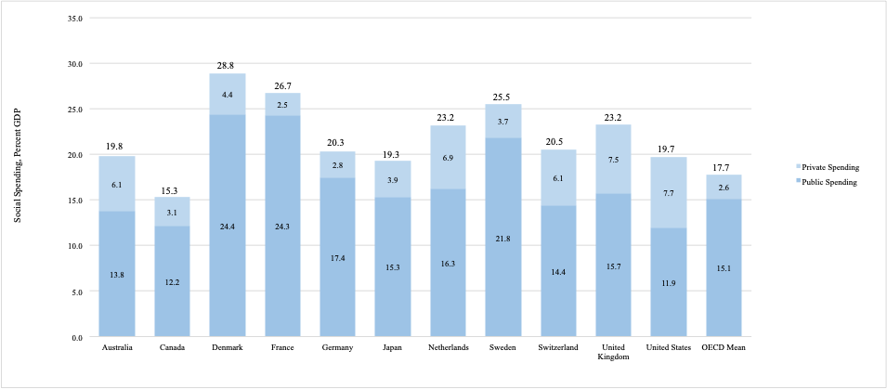
Caption: Percentages of selected countries’ gross domestic products devoted to social spending, including education per capita in 2015, from private and public sources
Sources/Notes: SOURCE Authors’ analysis of data on social spending from the Social Expenditure Database of the Organization for Economic Cooperation and Development (OECD) and of data on educational spending from the OECD’s educational finance indicators data set. NOTES Health-related social spending and spending on early childhood, or preschool, education are accounted for in social spending, and so excluded from educational spending to avoid double counting. Percentages may not sum to 100 due to rounding.

Exhibit 3 (figure)

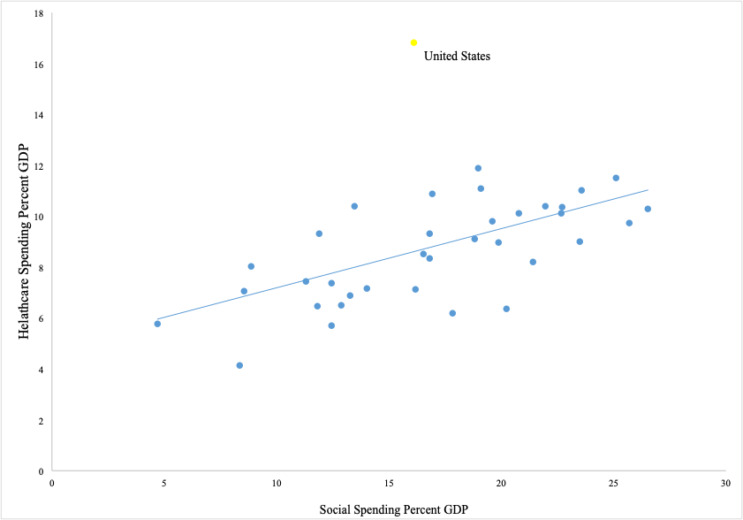
Caption: Percentages of gross domestic products (GDPs) devoted to social and health care spending, US and other countries in the Organization for Economic Cooperation and Development (OECD)
Source/Notes: SOURCE Authors’ analysis of data from the OECD’s Social Expenditure Database. NOTES Health-related social spending is excluded. Data are from 2015 for all countries apart from Poland. The line of best fit shows that countries that spend more on health tend to spend more on social spending (Pearson’s r: = 0.54; p = 0.00).

Exhibit 4 (figure)

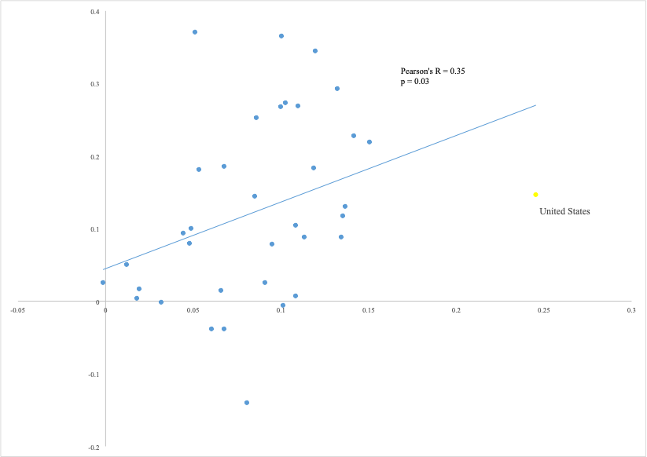

Caption: Changes from 1980 to 2015 in percentages of gross domestic products (GDPs) devoted to social and health care spending, US and other countries in the Organization for Economic Cooperation and Development (OECD)
Sources/Notes: SOURCE Authors’ analysis of data on social spending from the Social Expenditure Database of the OECD and of data on health care spending from the OECD’s Health Expenditure Database. NOTES Health-related social spending is excluded. The straight line (the line of best fit) shows that changes in the two types of expenditure, adjusted for changes in GDP per capita, are positively associated (Pearson’s r: 0.35; p < 0.03).

Bios for 2018-05187_Papanicolas
Bio 1: Irene Papanicolas (i.n.papanicolas@lse.ac.uk) is an associate professor of health economics in the Department of Health Policy at the London School of Economics, in London, England.
Bio 2: Liana R. Woskie is a PhD candidate in the Department of Health Policy at the London School of Economics and Political Science.
Bio 3: Duncan Orlander is a project coordinator in the Department of Health Policy and Management, Harvard T. H. Chan School of Public Health, in Boston, Massachusetts.
Bio 4: E. John Orav is an associate professor of biostatistics at the Harvard T. H. Chan School of Public Health.
Bio 5: Ashish K. Jha is dean of global strategy, K.T. Li Professor of Global Health, and director of the Harvard Global Health Institute at the Harvard T. H. Chan School of Public Health.

