The effects of copayment in primary health care: evidence from a natural experiment.
Laia Maynou^{1,2,3,4} Gabriel Coll-de-Tuero^{4,5,6}, Marc Saez^{2,3,4}

¹Department of Health Policy, London School of Economics and Political Science (LSE), London, UK
²Center for Research in Health and Economics (CRES), Universitat Pompeu Fabra, Barcelona, Spain
³Research Group on Statistics, Econometrics and Health (GRECS), University of Girona, Girona, Spain
⁴CIBER of Epidemiology and Public Health (CIBERESP), Barcelona, Spain
⁵MEHTARISC Group. Unitat de Suport a la Recerca Girona, Institut Universitari d'Investigació en Atenció Primària Jordi Gol (IDIAP Jordi Gol), Girona, Spain
⁶Department of Medical Sciences, University of Girona, Girona, Spain

Received: 20 December 2018 / Accepted: 12 July 2019

Abstract

Objective: Evaluate the effects of the ‘euro per prescription’ on primary health care services (number of doctor visits), through a retrospective cohort study of health care users in Catalonia (Spain). This policy, implemented in Catalonia on 23 June 2012, only lasted six months. This policy was introduced to improve budgetary imbalances in Spain and boost the regional and national governments’ budgets.
Methods: We used a retrospective cohort, composed of individuals who had had contact with primary healthcare services between January 1, 2005 and December 31, 2012. The econometric specification followed is a hurdle model.
Results: Our results show that from October 2012 onwards there was a decrease in the average number of overall visits, particularly for individuals aged 65 years or more. However, this decline cannot be entirely attributed to the introduction of the euro per prescription policy as in October of that same year the Spanish government introduced its pharmaceutical copayment for pensioners.
Conclusions: The policies appraised in this paper reveal a clear deterrent effect among vulnerable individuals such as those with the highest probability of being unemployed and/or those individuals with chronic conditions.

Keywords: ‘Euro per prescription’, cohorts, hurdle model, mixed models.
JEL: I18, C50, C11, H71
1.- Introduction

The Spanish economy sank into recession in the first quarter of 2009 following a fall in the gross domestic product (GDP) for two consecutive quarters. Although the Spanish economy emerged from this first recession in the first quarter of 2010, when GDP showed positive growth rates, it slipped back into recession in the last quarter of 2011 (double dip) and did not move out of recession until the third quarter of 2013. During the recession both the Spanish and Catalan governments implemented fiscal adjustment policies, especially for budgetary reasons.

In this paper we are interested in one of these policies in particular, colloquially known and henceforth referred to as, the ‘Euro per Prescription’ (Law 5/2012 of March 20 [12]) policy. On 23 June, 2012 the Catalan government adopted the ‘euro per prescription’ which would continue until 31 December 2012, when it was suspended after the Spanish government appealed against it in the Spanish Constitutional Court.

Previous to this new policy, prescriptions had always been free; however, this new policy established and implemented a fee of one euro per prescription. The fee was applicable to all prescription-only medicines (NB: each prescription can only contain one medicine) which cost more than €1.67. An annual limit of €62 per person was set and the ‘euro per prescription’ did not apply to anyone receiving non-contributory subsidies or the minimum guaranteed income, to those in unsubsidized unemployed, to the disabled or to any treatments resulting from workplace accidents or occupational disease.

This policy was, in fact, a ‘natural experiment’ since (1) the intervention is not undertaken for the purposes of research, and (2) the variation in exposure and outcomes is analyzed using methods that attempt to make causal inferences [3].

While there is existing literature analysing the effect of pharmaceutical copayment on health care demand, i.e. consumption and prescriptions (for review, [11]; and e.g. [1, 6, 7, 17]), little has been done on the effect of pharmaceutical copayment on the number of visits to primary care doctors (e.g. [28]). Papers looking at number of visits, usually takes into account copayment in insurance, not only medicines (e.g. [20, 26, 27]). A recent paper by García-Gomez et al [6] examined the same policy as we are looking at, the ‘Euro per Prescription’, and they found that consumption increased in the 2 months previous to the introduction of the measure, and fell with the introduction of the ‘co-payment policy. Puig-Junoy et al [17] found similar results, i.e. an increase in prescriptions in the short-term, but they did not use individual patient data. Regarding visits to doctors, Winkelmann [28] analised the 1997 German health care reform and the differences-in-differences estimates indicated that increased co-payments reduced the number of doctor visits by about 10% on an average.

Our objective in this paper is to evaluate the effects of the ‘euro per prescription’ in primary health care services (number of doctor visits), through a retrospective cohort study of health care users in Catalonia (Spain). Our main contribution to the existing literature is firstly, the outcome of interest, i.e. number of doctor visits, as little has been done on the relationship between this outcome and pharmaceutical copayment. Secondly, the specific copayment policy which we are analysing, the ‘Euro per Prescription’. Thirdly, the use of individual monthly data for January 2005 to December 2012.

The article is organized as follows. First, we explain the method. Then, we explain and discuss the results of the model. Finally, we present our conclusions.

2.- Methods

Data setting

To evaluate the effects of the ‘euro per prescription’ we used a (general population) retrospective cohort, composed of individuals who had had contact with primary healthcare services between January 1, 2005 and December 31, 2012. The individuals were assigned to one of three Basic Areas of Health (ABS, acronym in Catalan) managed by the Institute of Health Care (IAS, Institut d’Assistència Sanitària in Catalan).

The Catalan public healthcare system guarantees universal and free healthcare to all the citizens of Catalonia. The system is characterized by a separation of the funding (from the Catalan public budget) and the provision and management of healthcare services. Catalonia is divided into seven health regions of which an ABS is a territorial division. All the residents of the area covered by the ABS are assigned to the provider responsible for that particular ABS.

The IAS manages all the ABSs that provide health care to the region of ‘La Selva Interior’, Girona (ABS Anglès; ABS Breda-Hostalric; and ABS Cassà de la Selva). According to the Catalan Institute of Statistics (IDESCAT [8]), in 2012 the region’s population was made up of 32,860 men and 32,702 women (0.87% and 0.85%, respectively, of the entire Catalan population). The area is mainly rural (or semi-urban), with many towns scattered throughout the district as well as having a number of farms, estates and small far away villages. While the region has 144 municipalities (3.70% of all Catalonia), it only has 5 municipalities of more than 5,000 inhabitants and only one with a little more than 10,000. The median of the population density was 85.5 hab/km2 in 2012, and the average population density 176.2 hab/km2 (compare with 235.8 in in the whole of Catalonia) (IDESCAT).
Statistical methods

The methods that study natural experiments have the same validity threats that experimental methods (i.e. randomized controlled trials) do. The main difference is the absence of randomization. In fact, in natural experiment studies there is no general solution for the presence of selection bias i.e. the problem of confounding. As such, all natural experiments studies require a comparative group (i.e. control group or ‘counterfactual’) to provide an indication of what would have happened in the absence of the intervention (Craig et al, 2011).

In our case, however, we did not have a control group (unlike [26, 28]) as all the individuals in the cohorts were exposed to the intervention. For this reason, we used a quasi-experimental design (time-interrupted time series) organized as a mixed design (panel data), with the individuals observed repeatedly over time. With this design, the history of each individual prior to the intervention is used to construct the counterfactual. In other words, each individual becomes their own control. In fact, this type of design is equivalent to a difference-in-difference method [10] (a method which deals with unobserved factors, or ‘selection on unobservables’).

In particular we specified the following two generalized linear models (GLM):

(1)

where the subscript i denoted individual and t month (from January 2005 to December 2012), Y the dependent variable (doctor visits), μ the (conditional) mean, g() and h() (appropriate) link and variance functions, respectively, and φ a dispersion parameter. We considered visits to both prescribers, the only potentially affected by the prescriptions’ copayment, and to non-prescribers.

With η we denoted an additive linear predictor composed of D, a dummy variable, equal to 0 until the time of the intervention and thereafter 1; α was a time effect (constructed from t, t=1,…,96) in order to control for a long-term trend. Month K denoted one of eleven seasonal dummies (k=2,…,12 – January was taken as reference category) in order to control for seasonality, and up to nine explanatory variables: sex (men – reference category - women); age group (under 15 years of age – reference category -; 15-34 years, 35-44, 45-54, 55-64, 65-74, 75 and older); the presence of chronic conditions: hypertension, diabetes mellitus type II, obesity, dyslipidemia-hypercholesterolemia and hypertriglyceridemia, and the quintiles of the probability of being unemployed (and also of being unemployed for more than a year). Chronic conditions were coded as 0 without the chronic condition (reference category) 1 with the chronic condition. δ, y and β’s denoted unknown parameters associated with the dummy, the seasonal dummies and the explanatory variables, respectively.

Note that with the exception of gender, all the explanatory variables were time-varying. In addition to age, individuals can enter hypertensive status and/or develop diabetes, and may enter or exit the status of being obese, dyslipidemic, etc. In addition, the probability of being unemployed varied, logically, during the study period.

It is known that besides being modulated by sex and age, health care utilization is related not only to need variables (which ought to affect use i.e. health status), and approached here by the set chronic conditions, but also to non-need variables (which ought not to affect use i.e. socioeconomic conditions) [13, 23]. For this reason, we included, as explanatory variable in the models (1), the probability of being unemployed (and unemployed for over a year).

Estimation of the probabilities of being unemployed
Using data from the Spanish and the Catalan Health Surveys (ENSE and ESCA, respectively) corresponding to 2006 and 2011, the probability for an individual of being unemployed (or unemployed for over a year) was estimated using the following GLM with a binomial response (i.e. logistic regression):
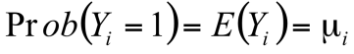

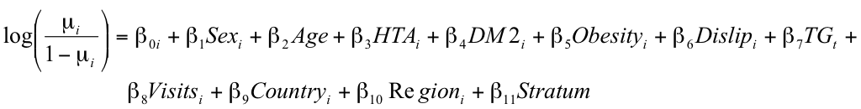
(2)

where Y denoted the event of being unemployed (or unemployed for over a year).

Model (2) included the same explanatory variables as the previous model (with the exception of age introduced here as a continuous variable) along with four more variables: the number of doctor visits (Visits) made by an individual in the past twelve months (in the ESCA) or in the past three months (in the ENSE), the country of birth of the individual (Country), the ‘county’ of residence (Region) (only in the ESCA), and the size of the municipality of residence (Stratum) (only in the ENSE).

Following the previous approach, we estimated two vectors of probabilities for each of the periods considered (2006 and 2011) one corresponding to ESCA and another one corresponding to ENSE and assumed that an individual, with the characteristics defined by the explanatory variables in (2), was unemployed (or unemployed for over a year).

Then, using the linear predictor estimated in (2) (i.e. the right-hand side of (2)), we predicted these two sets of probabilities (for being unemployed and for being unemployed for over a year) that would correspond to the individuals in the IAS cohort. To do this, we first divided the cohort into two sub-periods: 2005-2009 and 2010-2012. We used the first sub-period to predict the probabilities associated with the ESCA and ENSE 2006 and the second to predict those associated with the ESCA and ENSE 2011. We assigned a zero probability to individuals under 16 and to those over 65 or to those who were over 65 during the study period. Then we stacked the probabilities corresponding to the two sub-periods and estimated the following GLM with Gaussian response (i.e. a linear regression):

(3)

where Prob_ESCA denoted the predicted probability of being unemployed (or unemployed for over a year) corresponding to ESCA for the individual i in the month t. Prob_ENSE denoted the predicted probability corresponding to ENSE and Unempl_rate the unemployment rate of the municipality where the individual i resided, for the sex of the individual i, and for the year corresponding to the month t (these rates were obtained from IDESCAT).

Thus, we lastly calibrated the probability of being unemployed (and unemployed for over a year), obtaining a single time-varying variable per individual.

Hurdle model

In fact, the use of medical care involves a twofold decision process [4] i.e. the decision to seek care (made by the individual or the ‘principal’, in a principal agent framework) and the frequency of visits (determined by the physician; the ‘agent’, in a principal agent framework [4, 9, 15, 25]).

For these reasons, model (1) was estimated using a two-part econometric model, known as a hurdle model [4 ,15 ,25], specified in such a way as to gather together the two decision processes theoretically involved in the use of medical care.

The first part of the decision process was modeled using a binomial link (a logistic regression, in particular):

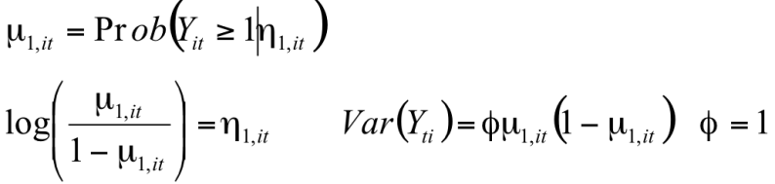 (4a)

where the subscript i denoted individual and t month, μ denoted the (conditional) mean, the subscript 1 denoted the first part of the decision process, Y the dependent variable, φ was a dispersion parameter and η denoted the additive linear predictor of (1).

Note that we assumed that the dispersion parameter was equal to the unit. This assumption was made because the information available in this first part did not allow the simultaneous identification of the parameters associated to the conditional mean and the parameters associated to the conditional variance [4].

In the second part, the distribution of use (conditional to some use) was modeled as a truncated negative binomial:
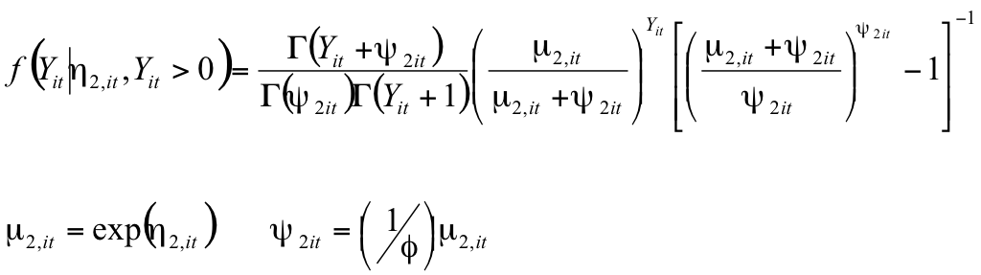
(4b)

where Γ(.) denoted the gamma function and the subscript 2 denoted the second part of the decision-making process.

It is important to point out that although we specified model (4) into two parts, these entered the likelihood function multiplicatively and, therefore, we estimated the two parts jointly.

Random effects

Note that some of the coefficients in (1), (2) and (3) had subscripts. In fact, we specified a random coefficient panel data models. In mixed-models terminology, we allowed (some of the) coefficients to be random effects [14] i.e. to be different for the various levels we have considered. Thus, we allowed the intercept to be different for each individual, β_{0i}, capturing characteristics that were individual specific (i.e. individual heterogeneity). In this case, we assumed random effects were identical and independent Gaussian random variables with constant variance. The time effect varied by year-month, assuming a random walk of order 1 (i.e. independent increments) for the Gaussian random effects vector (although we also assumed a constant variance) (R-INLA project [19]). Finally, the coefficient of interest, i.e. the effect of the intervention, varied per month and also per sex, age group, chronic conditions and quintiles of probability of being unemployed. Here, we also assumed identical and independent Gaussian random effects with constant variance.

For the estimation of the models, we followed the Integrated Nested Laplace Approximation (INLA) approach (Rue et al. [22]) within a (pure) Bayesian framework. All analyses have been made with the free software R (version 3.0.2) [18], available through the INLA library (R-INLA project [22]).
3.- Results

In Fig. 1 we show the temporal evolution of the total visits to prescribers in the IAS cohort (Fig. 1). Note that the decrease in the number of visits began in March 2009 (maximum 27,973 visits March 2009, and 23,865 June 2012), long before the introduction of the euro per prescription policy.

This decline actually occurred as a result of the implementation of the ‘electronic prescription’, a rationalizing measure for primary health care utilization and, therefore, for health expenditure. This rationalizing measure had been introduced throughout 2009. There had been an increase in the number of visits a few months earlier, in May 2012, following a reduction in April 2012 (22,951 visits).

Since the evolution of the number of individuals who received health care (by prescribers) was very similar to the (total) visits (19,291 in March 2009, and 16,755 in April 2012), the evolution of the average number of visits to prescribers is also very similar (Fi. 2).

The results of estimating the effect of the intervention are shown in Table 1 (visits to prescribers) and 2 (visits to non-prescribers). In the case of the visits to prescribers, the implementation of the ‘euro per prescription’ showed a 4.44% reduction in the average number of visits per individual, although it was not statistically significant until December 2012. Note that, in fact the effect was only statistically significant for women, with a reduction in the range of 2.81%-4.67% between July and September 2012, and with a sharper reduction from November 2012 (a 5.49% drop in November and 7.52% in December). We found differences among the age groups. In particular, the effect was only significant for those individuals over 55 years of age. Individuals who were 65 years or more experienced the greatest reduction, largely in October and November 2012. In December of 2012 the reduction was significant only for the 55 to 64-year-old age group. In individuals under the age of 55 the effect was not statistically significant (Table 1).

It seems that the reduction in the average number of visits per individual occurred only in those with chronic conditions, with October 2012 being the exception although not statistically significant (Table 1). Note that while for hypertensive individuals the decline in visits occurred mainly from July (4.15%) to September 2012 (4.69%), for the remainder of those with chronic conditions it had remained about the same from July 2012 onwards, albeit with peaks in September 2012, but was also much more moderated than that of hypertension (maximum of 3.08% for obese).

When stratifying by quintiles for the probability of being unemployed (Table 1), only for individuals located in the fifth quintile, (i.e. those who were more likely to be unemployed), was there a statistically significant reduction in the average number of visits. Nevertheless, this was only from July to September 2012 and the decline was very similar in that three-month period. We also found that the decrease was very similar for the fifth quintile of the probability of being unemployed for over a year.

With respect to the visits to non-prescribers (Table 2), the implementation of the ‘euro per prescription’ significantly reduced the average number of visits per individual, in September (10.43%) and again in December (14.12%) 2012 (Table 2). This reduction is greater than the average visits by individual to the prescriber. Note that, in fact, the effect was only statistically significant for women in September 2012 (14.42%), whereas in December 2012 it was statistically significant for both males and females (12.85% and 15.81%, respectively). However, there was a significant increase in individual visits (both male and female) to the non-prescriber in October 2012 (19.13%). We also found differences among the age groups. In particular, the effect was significant for those individuals between 15 to 34 years old who reduced their visits by 29.05% in September 2012 and 35.32% in December 2012. On the other hand, there was a significant increase (32.37%) in the number of visits in October 2012 mainly coming from the 65 to 74-year-old age group

Disaggregating the results by condition, we find a different pattern with visits to the prescriber. In this case, the decrease in the average number of visits per individual occurred only for those suffering from chronic conditions in September and December 2012 (10.39% and 13.73%, respectively (Table 2), although in October 2012, there was actually a significant increase in the number of visits by those with chronic conditions (19.79%). In September 2012, the significant reduction was noted in the hypertensive non-diabetes mellitus type II groups. Finally, in October an increase in the number of visits can be attributed to all of the chronic condition groups and to a lesser extent the non-diabetes mellitus type II group.

When stratifying by quintiles for the probability of being unemployed (Table 2), for individuals located in the fifth quintile (i.e. those who were more likely to be unemployed) there was a statistically significant reduction in the average number of visits in September and December 2012 (25.53% and 26.65%, respectively). However, for the individuals located in the third quintile, there was a significant reduction of 24.99% in December 2012. In terms of the probability of being unemployed for over a year, in October 2012, there was a significant increase in the number of visits by individuals located in the fourth and fifth quintile (28.03% and 20.40%, respectively). Moreover, in this last probability, there was an increase in the number of visits in November 2012 (29.66%) for individuals located on the third quintile.

4.- Discussion

Taking all the results into consideration, it would seem that the 'euro per prescription' had no obvious effect. Despite the average number of visits dropping in July 2012 just after the policy’s introduction, this seems to have been a short-term effect which lasted for up to three months and was then replaced by another effect (maybe the effect of the copayment promulgated by the Spanish government) with greater reductions from October 2012 and was most evident in individuals 65 years or more.

Our results are in line with Winkelmann [28], as he found that increased pharmaceutical co-payments reduced the number of doctor visits. As in our case, in Roemer et al. [20] only short-term effects could be observed. According to Schreyoegg and Grabka [26], imposing user charges of approximately USD$1 for the first two doctor’s visits initially reduced the demand for physician’s services, but over the long-term led to levels higher than those observed in the control group, thus offsetting any savings. Likewise, Scitovsky and McCall [27] also found that the reduction in visits to a physician (as a consequence of the introduction of a coinsurance provision) was potentially a transitory effect that would diminish over time.

We believe that the most significant reductions from October 2012 were a consequence of the policies of the Spanish Government which were almost simultaneously implemented (Royal Decree-Law 16/2012, [21] of 20 April), in particular those pertinent to pharmaceutical copayment, and which came into force for pensioners (individuals 65 years or over) in September 2012 (NB: This was later than for the rest of the population who had begun paying in July 2012). Pensioners, who previously paid no medication fees (except for civil servant retirees) had to pay 10% of the cost of their medication, with ceilings set at €8.00 per month for those with earnings less than €18,000per year, €18 per month for those with earnings between €18,000 and €100,000, and €60 per month for those with earnings more than €100,000per year.

In fact, according to figures from the Catalan Government thanks to the application of the ‘Euro per Prescription’ in just six months the Government had earned EUR 45.7m and reduced expenditure on drugs by 5.9%. More in detail, while during the two months before the policy implementation there was a monthly increase of 7.79€ daily doses, once the policy was introduced there was a significant monthly reduction of 7.54€ daily doses for the 7 months that was in place [16].

However, official data from the Government of Spain’s Ministry of Health show that Catalonia’s decrease in pharmaceutical expenditure was in fact less than other communities despite the supposed moderating effect of the ‘Euro per Prescription’.

Catalonia managed to save 23.82% but only ranked fifth in savings after the communities of Galicia, Murcia, Madrid and Castilla-La Mancha (in that order). The Spanish Ministry of Health believes that the widespread savings (21.6% on average) were due to domestic action and policies and that the Catalan measure not only had no impact but created 'inequality' between regions. In fact, the order from the Constitutional Court to temporarily suspend the 'Euro per Prescription' argued that 'by adding the euro contribution to the national sales price of medicine in Spain, a citizen resident in Catalonia would be exceeded out cheaper to buy it without prescription'.

It is worth noting that the other significant policy, which came into force in April 2012, was the exclusion of the provision of those drugs indicated for the treatment of minor symptoms which included mucolytics, antitussives, decongestants, antidiarrheal drugs and artificial tears and that the introduction of this measure coincides in time with the most significant decrease observed in April 2012 in both cohorts.

In our case, it seems that we have found a deterrent effect among vulnerable individuals, those with the highest probability of being unemployed and/or those individuals suffering chronic conditions.

Between 1968 and 1971, the Province of Saskatchewan, Canada, imposed user charges of approximately 33% for members of a universal public medical care and hospital insurance program. Although this reduced the number of doctor visits, Beck and Horne [2] point out that it was primarily the elderly and low-income individuals who were affected.

Taking into account it was a randomized controlled trial, in a Swedish study Elofsson et al. [5] found that for those who assessed their financial situation to be poor, the probability of foregoing care was 10 times greater than among those who assessed their financial situation to be fair or good. However, among women avoiding physician visits was also associated with chronic disease.

This paper could have several limitations. First, as explained above, several political measures coincide over time, so it is difficult to attribute the effects we have found to only one of them. However, we believe that by allowing the time effect to vary by year-month, it allowed us to identify in which month the measures took effect. This could make it possible to attribute the effect to those policies that are temporarily closest to it.

A second limitation was a threat of selection bias. Some individuals could have a higher probability of having used primary health care, implying that the potential result, 'contact registration', was overrepresented in the sample observed [24]. However, in the first three years of the follow-up of the cohort, 78.33% of the assigned adult population (15 years and older), had contact with primary care services managed by the IAS, and throughout the entire follow-up (2005-2012) 94.41% of the population had contact with these services. In addition, in fact, the Hurdle model we have used already corrects this possible selection bias (see [24] for details).

A third limitation is related to data availability. The study is performed on a region of Girona province as, at that time, it was the only population-based cohort (i.e. constituted by the entire population) that existed in Catalonia. Moreover, post-policy data was not available as the cohort was closed in 2012. The IAS was absorbed by another health provider (the ICS) and the database feed was discontinued.

Conflicts of Interest

There are no conflicts of interest for any of the authors. All authors freely disclose any actual or potential conflict of interest including any financial, personal or other relationships with other people or organizations within three years of beginning the submitted work that could inappropriately influence, or be perceived to influence, their work.

Acknowledgements

The authors would like to thank Josep Maria Roca (Computing Service, IAS) for providing the IAS data; and Anna Mompart, of the ‘Servei del Pla de Salut’, ‘Subdirecció General de Planificació Sanitària’, ‘Direcció General de Planificació i Avaluació’, ‘Departament de Salut’, ‘Generalitat de Catalunya’, for having facilitated the information of the Catalan Health Survey, ESCA 2006 and 2011. We appreciate the comments of the attendees at the XXXIII Conference on Health Economics (AES) 2013, June 18-21, 2013, in Santander, Spain and at the III Research Workshop on Policy Evaluation and Health Services, the EvaluAES Group, where a very preliminary version of this work was presented. We thank the comments of Ricard Meneu that undoubtedly helped us to improve our work. Finally, we would like to thank the comments of two anonymous reviewers of a previous version of this paper who, without doubt, helped us to improve our work.

References

- Aznar-Lou, I., Pottegård, A., Fernández, A., Peñarrubia-María, M.T., Serrano-Blanco, A., Sabés-Figuera, R., Gil-Girbau, M., Fajó-Pascual, M., Moreno-Peral, P., Rubio-Valera, M.: Effect of copayment policies on initial medication non-adherence according to income: a population-based study. BMJ Qual. Saf. 27, 878–891 (2018)

- Beck, R.G., Horne, J.M.: Utilization of publicly insured health services in Saskatchewan before, during and after copayment. Med. Care 18, 787–806 (1980)

- Craig, P., Cooper, C., Gunnell, D., Haw, S., Lawson, K., Macintyre, M., Ogilvie, D., Petticrew, M., Reeves, B., Sutton, M., Thompson, S: Using natural experiments to evaluate population health interventions: Guidance for producers and users of evidence. MRC, Medical Research Council (2011). http://www.mrc.ac.uk/Utilities/Documentrecord/index.htm?d=MRC00 8043. Accessed 28 Dec 2013

- Deb, P., Trivedi, P.K.: The structure of demand for health care:latent class versus two-part models. J. Health Econ. 21, 601–625 (2002)

- Elofsson, S., Unden, A.L., Krakau, I.: Patient charges—a hindrance to financially and psychosocially disadvantaged groups seeking care. Soc. Sci. Med. 46, 1375–1380 (1998)

- García-Gómez, P., Mora, T., Puig-Junoy, J.: Does €1 per prescription make a difference? Impact of a capped low-intensity pharmaceutical co-payment. Appl. Health Econ. Health Policy 16(3), 407–414 (2018)

- Hernández-Izquierdo, C., González López-Valcárcel, B., Morris, S., Melnychuk, M., Abásolo-Alessón, I.: The effect of a change in co-payment on prescription drug demand in a National Health System: the case of 15 drug families by price elasticity of demand. PLoS One 14, 3 (2019). https ://doi.org/10.1371/journal.pone.02134 03

- IDESCAT. http://www.idesc at.cat/. Accessed 28 Dec 2013

- Jiménez-Martín, S., Labeaga, J.M., Martinez-Granado, M.: Latent class versus two-part models in the demand for physician services across the European Union. Health Econ. 11(4), 301–321 (2002)

- Jones, A.M., Rice, N.: Econometric evaluation of Health Policies. HEDG Working Paper 09/09, University of York (2009). http://www.york.ac.uk/media /econo mics/docum ents/herc/wp/09_09.pdf. Accessed 28 Dec 2013

- Kiil, A., Houlberg, K.: How does copayment for health care services affect demand, health and redistribution? A systematic review of the empirical evidence from 1990 to 2011. Eur. J. Health Econ. 15, 813–828 (2014)

- Law 5/2012 of March 20, on Tax, Financial and Administrative Measures and Implementation of the Tax on Stays in Tourist Accommodations [in Catalan] DOGC 6094, March 23, 2012

- Morris, S., Sutton, M., Gravelle, H.: Inequity and inequality in the use of health care in England: an empirical investigation. Soc. Sci. Med. 60(6), 1251–1266 (2005)

- Pinheiro, J.C., Bates, D.: Mixed-Effects Models in S and S-Plus. Springer, New York (2000)

- Pohlmeier, W., Ulrich, V.: An econometric model of the two-part decision-making process in the demand for health care. J. Hum. Resour. 30, 339–361 (1995)

- Puig-Junoy, J., García-Gómez, P., Mora, T.: Impacte de l’euro per recepta sobre els medicaments dispensats a les oficines de farmàcia de Catalunya segons grups de medicaments. Monogràfics de la Central de Resultats, núm. 27. Barcelona: Agència de Qualitat i Avaluació Sanitàries de Catalunya. Departament de Salut. Generalitat de Catalunya (2017)

- Puig-Junoy, J., García-Gómez, P., Casado-Marín, D.: Free medicines thanks to retirement: impact of coinsurance exemption on pharmaceutical expenditures and hospitalization offsets in a national health service. Health Econ. 25(6), 750–767 (2016)

- R Core Team. R: A Language and Environment for Statistical Computing. R Vienna, Austria: Foundation for Statistical Computing (2013). http://www.R-proje ct.org/. Accessed 29 Dec 2013

- R-INLA Project: Random Walk Model of Order 1 (RW1). http://www.math.ntnu.no/inla/r-inla.org/doc/laten t/rw1.pdf. Accessed 29 Dec 2013

- Roemer, M.I., Hopkins, C.E., Carr, L., Gartside, F.: Copayments for ambulatory care: Penny-Wise and Pound-Foolish. Med. Care 13, 457–466 (1975)

- Royal Decree-Law 16/2012, of 20 April, on Urgent Measures to Ensure the Sustainability of the National Health System and Improve the Quality and Safety of Its Benefits [in Spanish] BOE 98, April 25, 2012

- Rue, H., Martino, S., Chopin, N.: Approximate Bayesian Inference for Latent Gaussian Models by Using Integrated Nested Laplace Approximations (with Discussion). J. R. Stat. Soc. Ser. B 71:319–392 (2009). http://www.math.ntnu.no/~hrue/r-inla.org/ paper s/inla-rss.pdf. Accessed 29 Dec 2013

- Saez, M.: Factors conditioning primary care services utilization. Empirical evidence and methodological inconsistencies” [in Spanish]. Gaceta Sanit. 17(5), 412–449 (2003)

- Saez, M., Barceló, M.A., Coll de Tuero, G.: A selection-bias free method to estimate the prevalence of hypertension from an administrative primary health care database in the Girona Health Region, Spain. Comput. Methods Programs Biomed. 93(3), 228–240 (2009)

- 25. Saez, M., Saurina, C., Coenders, G., González-Raya, S.: Use of primary health care services according to the different degrees of obesity in the Girona Health Region, Spain. Health Econ. 15(2), 173–193 (2006)

- Schreyoegg, G., Grabka, MM: Copayments for Ambulatory Care in Germany: A Natural Experiment Using a Difference-in-Difference Approach. Discussion Papers of DIW Berlin, German Institute for Economic Research (2008). http://mpra.ub.uni-muenchen.de/23035 /1/MPRA_paper 23035.pdf. Accessed 29 Dec 2013

- Scitovsky, A.A., McCall, N.: Coinsurance and the demand for physician services: four years later. Soc. Secur. Bull. 35, 4019–4027 (1977)

- Winkelmann, R.: Co-payments for prescription drugs and the demand for doctor visits—evidence from a natural experiment. Health Econ. 13, 1081–1089 (2004)

Table 1.- Visits to prescribers. Percentage of variation of the average number of visits per individual and month (95% Credibility Interval)
IAS Girona | July 2012 | August 2012 | September 2012 | October 2012 | November 2012 | December 2012
All individuals | -2.16 (-5.71, 1.50) | -1.98 (-5.81,1.99) | -2.71 (-6.90,1.64) | -1.50 (-6.29,3.50) | -2.97 ( -8.67,3.02) | -4.44 (-12.35, -1.04)
Males | -0.44 (-5.55, 4.91) | -0.92 (-6.43, 4.87) | -0.77 (-6.84, 5.63) | -0.65 (-6.31, 8.05) | -0.41 (-8.71, 8.50) | -1.34 (-12.72, 11.23)
Females | -3.78 (-4.41, -1.20) | -2.81 (-7.73, -0.83) | -4.67 ( -6.25, -2.30) | -2.70 (-5.98, 1.05) | -5.49 (-14.29, -2.46) | -7.52 (-15.00, -3.15)
Age group
< 15 y. | -7.90 (-31.26, 21.44) | -5.30 (-31.23, 27.99) | -6.76 (-34.95, 30.53) | -7.71 (-38.78, 34.96) | -4.32 (-42.70, 52.34) | 26.61 (-34.47,128.64)
≥ 15 y | -2.47 ( -6.09, -0.27) | -2.19 (-6.10, -0.87) | -3.11 (-7.38, -1.32) | -1.74 ( -6.63, 3.37) | -3.62 (-9.42, -1.49) | -5.47 (-13.50, -2.15)
15-34 y. | 3.47 (-6.65, 14.50) | 3.66 (-7.37, 15.76) | 1.81 (-10.18, 15.08) | 0.94 (-12.59, 16.13) | -2.29 (-18.64, 16.60) | -1.86 (-24.72, 26.23)
35-44 y. | 5.92 (-3.02, 15.54) | 6.75 (-3.00, 17.32) | 5.44 (-5.19, 17.05) | 6.58 (-5.60, 20.02) | -0.09 (-14.18, 15.82) | -2.23 (-21.87, 21.20(
45-54 y. | 2.85 (-5.11, 11.37) | 4.24 (-4.47, 13.61) | 3.82 (-5.80, 14.24) | 8.77 (-2.50, 21.11) | -1.83 (-3.74, 24.94) | -0.65 (-16.97, 21.21)
55.64 y. | -1.46 (-6.44, -0.11) | -1.38 (-7.17, -0.08) | -2.40 (-8.07, -0.66) | -2.49 (-8.37, 14.41) | -2.45 (-12.42, -1.48) | -3.24 (-17.94, -0.46)
65-74 y. | -3.02 (-6.30, -1.24) | -2.27 (-6.95, -0.31) | -3.21 (-7.10, -1.33) | -10.31 (-22.96, -1.20) | -8.36 (-23.40, -5.10) | 9.44 (-9.34, 31.39)
≥ 75 y. | -2.15 (-6.04, -0.93) | -2.21 (-5.23, -0.20) | -3.54 (-7.12, -1.66) | -18.98 (-43.45, -1.95) | -7.24 ( -46.67, -2.18) | 14.57 (-17.82, 56.66)
Table 1.- Visits to prescribers. Percentage of variation of the average number of visits per individual and month (95% Credibility Interval)
IAS Girona | July 2012 | August 2012 | September 2012 | October 2012 | November 2012 | December 2012
No chronic | -0.56 (-25.35, 4.95) | -0.53 (-24.46, 3.89) | -1.63 (-25.24, 6.14) | 7.69 (-9.01, 26.80) | 6.93 (-12.96, 30.33) | 7.11 (-20.04, 41.21)
Chronic | -2.87 (-5.59, -0.98) | -2.11 ( -5.54, -0.66) | -3.29 (-6.69, -1.29) | -0.88 (-5.92, 4.38) | -2.46 (-8.45, -0.85) | -4.07 (-12.38, -1.87)
Non HTA | -2.85 (-7.67, 2.20) | -2.95 (-8.16, 2.52) | -4.50 (-10.17, 1.46) | 3.33 (-9.82, 9.54) | 4.93 (-12.62, 3.31) | 5.99 (-16.64, 8.74)
HTA | -4.15 (-9.74, -1.19) | -4.52 (-10.59, -1.27) | -4.69 (-11.42, -1.69) | -5.79 (-1.49, 13.52) | -4.53 (-13.87, -1.17) | -2.22 (-9.77, -1.48)
Non DM2 | -1.58 (-6.36, 3.40) | -1.53 (-6.69, 3.88) | -1.86 (-7.53, 4.10) | 1.15 ( -7.61, 5.68) | 1.31 (-9.04, 6.96) | 3.75 (-13.43, 8.99)
DM2 | -2.24 (-7.88, -0.88) | -2.47 (-8.36, -0.59) | -3.08 (-7.77, -1.17) | -1.76 (-4.52, 10.50) | -2.50 (-9.08, -0.74) | -2.20 (-14.08, -1.00)
Non-Obese | 0.80 (-4.13, 5.94) | 1.08 (-4.27, 6.67) | 0.59 (-5.26, 6.75) | 1.11 (-5.56, 8.17) | 0.03 (-7.92, 8.55) | -2.32 (-13.26, 9.72)
Obese | -2.48 (-5.68, -0.95) | -2.56 (-6.16, -1.32) | -2.77 ( -7.87, - 1.68) | -0.10 (-6.92, 7.55) | -2.01 (-10.31, -0.91) | -2.61 (-14.17, -1.20)
Non Dislip or Tg | 0.16 (-4.77, 5.31) | -0.75 (-6.05, 4.79) | -1.84 (-7.62, 4.24) | 1.07 (-7.67, 5.92) | 1.07 (-10.89, 5.30) | -2.39 (-13.36, 9.69)
Dislip or Tg | -2.16 (-5.02, -0.58) | -2.42 (-4.24, -0.76) | -2.93 (-5.26, -1.46) | -1.51 (-4.59, 10.05) | -2.47 (-7.01, -0.58) | -2.62 (-14.13, -1.13)

Table 1.- Visits to prescribers. Percentage of variation of the average number of visits per individual and month (95% Credibility Interval)
IAS Girona | July 2012 | August 2012 | September 2012 | October 2012 | November 2012 | December 2012
Quintiles of the probability of being unemployed
First Quintile | 5.54 (-4.71, 16.74) | 4.52 (-6.42, 16.55) | 3.12 (-8.81, 16.36) | 5.24 (-8.47, 20.67) | 3.31 (-12.82, 21.88) | -5.05 (-26.11, 20.75)
Second Quintile | 3.86 (-3.95, 12.20) | 3.98 (-4.46, 13.06) | 3.45 (-5.81, 13.46) | 7.71 (-3.15, 19.57) | 1.76 (-10.82, 15.79) | -2.49 (-19.50, 17.39)
Third Quintile | -1.34 (-9.90, 7.90) | -0.35 (-9.02, 10.53) | -0.83 (-11.07, 10.38) | -0.27 (-11.92, 12.65) | 0.29 (-13.76, 16.18) | -3.45 (-22.35, 19.04)
Fourth Quintile | -2.70 (-11.48, 6.81) | -2.29 (-11.85, 8.13) | -3.99 (-14.38, 7.42) | -5.25 (-16.91, 7.73) | 0.67 (-19.61, 24.92) | -2.54 (-16.89, 13.77)
Fifth Quintile | -4.99 (-14.35, -2.10) | -5.30 (-16.29, -2.29) | -5.30 (-16.29, -2.79) | -5.60 (-17.72, 5.44) | 2.98 (-11.59, 19.47) | -3.89 (-16.46, 28.10)
Quintiles of the probability of being unemployed more than one year
First Quintile | 3.65 (-8.30, 16.90) | 1.34 (-11.30, 15.49) | -1.81 (-15.43, 13.62) | -1.32 (-16.76, 16.47) | 0.66 (-18.12, 22.91) | -2.89 (-26.00, 16.65)
Second Quintile | 0.65 (-7.84, 9.81) | 2.63 (-6.67, 12.71) | -2.58 (-7.68, 13.79) | -3.17 (-8.54, 16.12) | 2.71 (-11.47, 18.72) | -3.88 (-22.54, 18.30)
Third Quintile | -2.38 (-6.17, 11.58) | -3.75 (-5.65, 13.93) | -0.80 (-9.35, 11.88) | -1.65 (-9.88, 14.39 | 1.69 (-15.08, 13.38) | -5.22 (-23.54, 16.50)
Fourth Quintile | -2.62 (-7.36, 9.19) | -2.18 (-6.58, 11.62) | -3.09 (-8.40, 11.40) | -4.70 (-9.15, 13.60) | 1.52 (-11.51, 16.09) | -6.43 (-12.15, 28.13)
Fifth Quintile | -4.00 (-10.48, -0.91) | -4.69 (-10.88, -0.84) | -5.40 (-11.54, -2.94) | -2.13 (-8.48, 13.75) | 2.50 (-10.34, 16.83) | -3.90 (-16.08, 22.93)
Percentage of variation of the average number of visits per individual and month (95% credibility interval)
Probability that the coefficient estimator is nonzero, greater than 95% are in bold
Chronic chronic disease, HTA hypertension, DM2 diabetes mellitus type II, Obes obesity, Dislip dyslipidemia or hypercholesterolemia, Tg hypertriglyceridemia
Table 2.- Visits to non-prescribers. Percentage of variation of the average number of visits per individual and month (95% Credibility Interval)
IAS Girona | July 2012 | August 2012 | September 2012 | October 2012 | November 2012 | December 2012
All individuals | 2.00 (-7.30, 12.06) | -3.41 (-12.52, 6.45) | -10.43 (-19.14, -0.96) | 19.13 (8.72, 30.38) | 3.04 (-6.54, 13.43) | -14.12 (-22.77, -4.67)
Males | 8.71 (-4.59, 23.46) | 1.54 (-11.34, 15.89) | -8.07 (-20.22, 5.52) | 19.10 (4.98, 34.76) | 2.77 (-10.19, 1.72) | -12.85 (-24.67, -0.43)
Females | -5.32 (-17.60, 8.42) | -10.78 (-22.69, 2.57) | -14.42 (-25.93, -1.50) | 16.72 (2.94, 32.03) | 1.23 (-11.46, 15.39) | -15.81 (-27.31, -2.87)
Age group
< 15 y. | -3.79 (-52.30, 75.68) | -34.51 (-73.63, 39.86) | -43.39 (-78.78, 27.41) | 1.35 (-48.48, 81.57) | 15.64 (-39.83, 103.5) | -26.96 (-67.24, 43.91)
≥ 15 y | 2.19 (-7.26, 12.40) | -2.82 (-12.09, 7.24) | -9.69 (-18.59, -0.01) | 19.69 (9.05, 31.21) | 3.14 ( -6.64, 13.76) | -13.57 (-22.43, -3.88)
15-34 y. | -4.26 (-28.95, 26.67) | -11.94 (-35.91, 18.50) | -29.05 (-49.98, -1.89) | 3.30 (-22.08, 34.87) | -24.56 (-46.89, 4.47) | -35.32 (-56.03. -7.80)
35-44 y. | 1.90 (-19.54, 27.73) | -18.37 (-37.19, 4.65) | -20.67 (-39.55, 2.56) | 13.57 (-9.69, 41.53) | -18.77 (-37.43, 4.06) | -14.26 (-34.17, 10.17)
45-54 y. | -6.03 (-25.27, 16.87) | -1.57 (-21.09, 21.54) | -6.90 (-25.86, 15.65) | 5.71 (-15.07, 30.27) | 2.01 (-18.21, 25.97) | -17.86 (-35.39, 3.14)
55.64 y. | 0.96 (-18.41, 23.78) | -11.17 (-29.00, 9.9) | -9.30 (-27.44, 12.19) | 18.55 (-2.57, 43.17) | 6.44 (-13.40, 29.73) | -11.88 (-29.83, 9.48)
65-74 y. | 4.97 (-13.34, 26.24) | 6.26 (-12.54, 28.16) | -5.76 (-22.73, 14.06) | 32.37 (11.55, 56.29) | 15.02 ( -3.95, 36.96) | -10.70 (-27.11, 8.37)
≥ 75 y. | 6.28 (-20.95, 40.39) | -0.24 (-26.48, 32.84) | -6.50 (-31.76, 25.55) | 16.64 (-12.20, 52.53) | 5.59 (-21.60, 39.73) | -6.52 (-31.82, 25.61)

Table 2.- Visits to non-prescribers. Percentage of variation of the average number of visits per individual and month (95% Credibility Interval)
IAS Girona | July 2012 | August 2012 | September 2012 | October 2012 | November 2012 | December 2012
No chronic | -4.61 (-35.78, 37.21) | -13.37 (-42.80, 26.59) | -12.97 (-42.87, 27.77) | 5.27 (-28.23, 4.90) | -9.71 (-40.28, 31.76) | -21.89 (-49.92,18.86)
Chronic | 2.22 (-7.32, 12.55) | -2.97 (-12.30, 7.17) | -10.39 (-19.28, -0.71) | 19.79 (9.19, 31.27) | 3.69 (-6.06, 14.30) | -13.73 (-22.54, -4.09)
Non HTA | 6.79 (-6.18, 21.18) | 0.52 (-12.12, 14.60) | -6.82 (-18.80, 6.54) | 15.22 (1.67, 30.24) | 2.91 (-9.70, 16.93) | -13.79 (-25.22, -0.98)
HTA | -3.91 (-16.20, 9.79) | -8.45 (-20.43, 4.92) | -15.26 (-26.74, -2.39) | 21.87 (7.68, 37.57) | 2.03 (-10.85, 16.39) | -15.39 (-27.02, -2.33)
Non DM2 | 1.26 (-12.26, 16.40) | -4.53 (-17.64, 10.20) | -15.74 (-28.00, -1.87) | 14.67 (-0.10, 31.18) | 0.85 (-12.80, 16.20) | -13.39 (-25.89, -0.76)
DM2 | 1.60 (-10.30, 14.74) | -3.46 (-15.10, 9.43) | -7.47 (-18.70, 4.98) | 20.99 (7.95, 35.33) | 3.54 (-8.42. 16.76) | -15.49 (-26.23, -3.52)
Non-Obese | 5.22 (-7.54, 19.35) | 2.16 (-10.55, 16.27) | -11.77 (-23.32, 1.14) | 17.36 (3.78, 32.38) | 4.03 (-8.66, 18.13) | -16.89 (-28.09, -4.33)
Obese | -2.53 (-14.99, 11.34) | -9.99 (-21.87, 3.29) | -10.15 (-22.04, 3.16) | 19.32 (5.27, 34.89) | 0.74 (-11.98, 14.92) | -12.33 (-24.13, -0.91)
Non Dislip or Tg | 0.06 (-12.21, 13.67) | -3.05 (-15.11, 10.35) | -9.83 (-21.40, 3.07) | 17.02 (3.51, 31.95) | 2.22 (-10.26, 16.09) | -12.80 (-24.22, -0.03)
Dislip or Tg | 2.80 (-10.17, 17.25) | -5.05 (-17.58, 8.96) | -12.43 (-24.28, 0.86) | 19.78 (5.641, 35.45) | 2.59 (-10.36, 17.02) | -16.85 (-28.39, -3.86)

Table 2.- Visits to non-prescribers. Percentage of variation of the average number of visits per individual and month (95% Credibility Interval)
IAS Girona | July 2012 | August 2012 | September 2012 | October 2012 | November 2012 | December 2012
Quintiles of the probability of being unemployed
First Quintile | -14.51 (-36.91, 13.76) | -10.78 (-33.74, 18.12) | -17.40 (-38.60, 9.28) | 13.81 (-12.57,46.41) | 15.67 (-10.72, 48.23) | -5.07 (-28.91, 24.85)
Second Quintile | -11.76 (-31.21, 11.57) | -17.81 (-36.60, 4.89) | -17.03 (-36.13, 6.08) | 14.54 (-7.81, 40.79) | -17.70 (-36.27, 4.68) | -16.45 (-35.52, 6.58)
Third Quintile | -2.00 (-19.85, 18.82) | -7.01 (-24.37, 13.34) | -7.92 (-25.06, 12.17) | 17.48 (-2.30, 40.34) | 5.98 (-12.28, 27.17) | -24.99 (-39.97, -7.26)
Fourth Quintile | 4.63 (17.70, 31.20) | -5.68 (-26.51, 19.28) | -0.70 (-22.24, 25.02) | 16.42 (-7.06, 44.10) | 7.22 (-15.55, 34.31) | -5.30 (-26.69, 20.43)
Fifth Quintile | 13.40 (-9.35, 40.20) | 13.68 (-9.40, 40.93) | -25.53 (-43.69, -3.33) | 16.23 (-6.98, 43.55) | -14.32 (-34.01, 9.47) | -26.65 (-44.70, -4.54)
Quintiles of the probability of being unemployed more than one year
First Quintile | 25.48 (-5.69, 64.48) | -12.82 (-37.24, 18.56) | -23.64 (-45.86, 5.21) | 9.51 (-17.78, 43.75) | 5.04 (-21.82, 38.94) | 8.16 (-19.41, 42.96)
Second Quintile | -10.74 (-29.84, 12.03) | -12.63 (-31.61, 10.06) | -17.32 (-35.80, 4.89) | 15.18 (-6.44, 40.41) | -16.44 (-34.80, 5.55) | -20.38 (-38.38, 1.29)
Third Quintile | -18.01 (-37.29, 5.66) | -1.80 (-23.63, 24.75) | -12.05 (-32.54, 13.11) | 14.74 (-9.24, 43.66) | 29.66 (4.35, 59.90) | -6.04 (-27.38, 20.08)
Fourth Quintile | -7.03 (-25.67, 15.07) | -3.36 (-23.39, 20.52) | -2.86 (-21.72, 19.41) | 28.03 (5.62, 54.13) | 7.77 (-12.95, 32.21) | 5.54 (-14.76, 29.49)
Fifth Quintile | 12.02 (-10.05, 38.26) | 1.87 (-18.98, 26.84) | -11.79 (-30.78, 11.16) | 20.40 (2.26, 47.26) | 1.36 (-19.49, 26.42) | -21.15 (-39.16, 0.90)
Percentage of variation of the average number of visits per individual and month (95% credibility interval)
Probability that the coefficient estimator is nonzero, greater than 95% are in bold
Chronic chronic disease, HTA hypertension, DM2 diabetes mellitus type II, Obes obesity, Dislip dyslipidemia or hypercholesterolemia, Tg hypertriglyceridemia
Figure 1.- Total visits to prescribers. IAS, Girona.

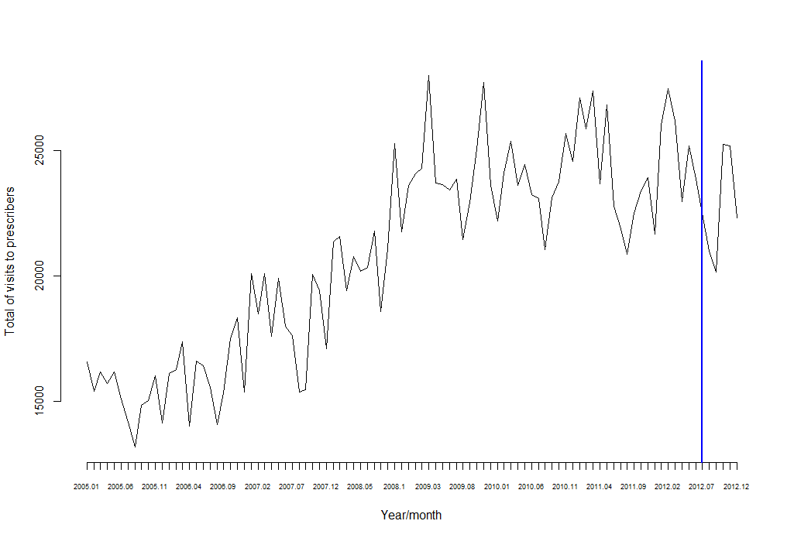

23rd June 2012 (introduction of the ‘Euro per prescription’)

Figure 2.- Average number of visits to prescribers per individual. IAS Girona.
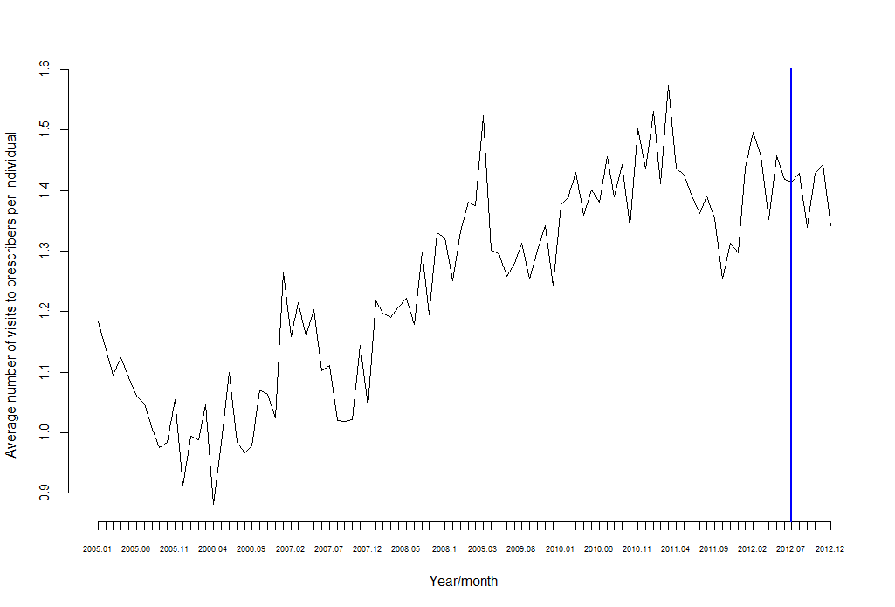

23 June 2012 (introduction of the ‘Euro per prescription’)

Excluding those individuals under 16 and over 65, inactive, and therefore with a zero probability of being unemployed.

