Protest in Electoral Autocracies: A New Dataset

Abstract
A growing literature explores the causes and consequences of dramatic political protests in electoral autocracies. Yet, we know comparatively little about other forms of protests in these regimes. Nuanced analysis of protest going beyond the singular event requires systematic understanding of the wider mobilization picture in time and space. The Lankina Russian Protest-Event Dataset (LAruPED), a new protest-event dataset, facilitates the investigation of protest dynamics in Russia, a classic example of an electoral authoritarian regime. The data, which are human-coded and rely on evidence from Russian-language opposition websites, identify, in wave one, protests across Russia’s regions from March 2007 until 2016. Unlike other datasets, which focus on political, or electoral protests, LAruPED covers a wide range of social and economic protests and imposes no limitations on the minimum number of protesters involved in events as a pre-requisite for inclusion in the dataset. We introduce LAruPED and discuss how it differs from currently available data. We also present a number of examples from work that leverages the dataset to show how the new data could be used to explore questions of authoritarian stability and resilience, highlighting important variation in the type of violently suppressed events in electoral autocracies.

Word Count: 7096 words

Introduction
The first two decades of the XXI century witnessed a global wave of democratic backsliding, regression into authoritarianism and authoritarian consolidation. Shrinking opportunities for institutionalised forms of political participation and absence, or the erosion of, meaningful checks on political power have coincided with rising popular contention in geographic and national contexts as diverse as Hungary and Argentina, Ukraine, Russia and China (Frye and Borisova 2019; Onuch 2015, 2014; Lorentzen 2013; King et al. 2013). Comparative data on protest events in autocracies around the world also suggest a surge in political protests at the start of this decade (Weidmann and Rød 2019). In a growing body of literature, protests are regarded as the most consequential action that individuals can undertake to challenge the stability of authoritarian rule and influence the political system.

Accordingly, as scholars are turning their gaze away from democratization to democratic death, from democratic strength to authoritarian resilience (Levitsky and Ziblatt 2018; Lorentzen 2014; Koesel and Bunce 2013; Pei 2012), research has increasingly sought to understand the dynamics of protests in autocracies. Protest-event analysis, involving the creation of datasets that allow researchers to study the occurrence and features of protest events, has greatly advanced the theoretical and empirical understanding of politics in authoritarian states. Occupying centre stage in existing research is the analysis of political protest events in general (Weidmann and Rød 2019), and protest events taking place at times of elections in particular. New datasets providing detailed, disaggregated data on electoral contention around national elections, have advanced our understanding of the effect of fraudulent elections on protest for example and have drawn scholarly attention to subnational variation in electoral violence (Daxecker et al. 2019). Yet, compared to a wealth of studies investigating electoral and political protests more broadly, we still know relatively little about the dynamics of other acts of contention that may narrowly concern economic or civic issues and that could be intricately connected to the wider processes of the mobilization of contention in space and across time in illiberal regimes.

Filling this gap in our understanding of protest dynamics in electoral autocracies is important for a number of reasons. First, while studies of protests around focal events, such as elections, can reveal invaluable insights for explaining a particular case, it is difficult to generalise these insights to other settings (Beissinger 2013; Little et al. 2013; Tucker 2007). Dramatic, large-scale political events are often less representative, or are indicative of the slow germination of grievances, networks, and, importantly, patterns of participation in activism. Small-scale provincial events, which often escape media attention, may be just as significant as an indicator of wider temporal dynamics of mobilization leading up to an uprising. Second, when scholarly analysis of protest follows, rather than precedes the eruption of a revolutionary event, scholars are forced into the straight-jacked of ex-post explanations focusing on the micro-dynamics of mobilization within a compressed time frame of the uprising. Researchers and journalists therefore tend to misread the nature of events that often represent continuation of long-standing trends that had been previously neglected (Robertson 2013, p.2). Lack of systematic over-time baseline data that would encompass a longer time period spanning both the event and the non-event, the occurrence and the non-occurrence of events that are not exclusively political in nature risks biasing not only our analysis, but also our prediction of, the future event. Whether large or small, protests are also often attuned to citizen activism transcending the national context (Beissinger 2007; Bunce and Wolchik 2011). Protests in electoral autocracies may be confined to a handful of large cities, but they may also routinely occur across the national landmass (Tertytchnaya and Lankina 2019). Protests across a wide range of sub-national localities are often concerned with various issues—from those related to environment or other civic causes to bread and butter type concerns leading to strikes and industrial walk-outs (Robertson 2007; Lankina 2015; Javeline and Lindemann-Komarova 2010). Nuanced analysis of protest going beyond dramatic, or political events, requires a systematic understanding of the wider picture in time, across space, and across the various protesting constituencies. Such data do not come by very easily for autocracies.

We introduce a new dataset that makes possible the investigation of protest dynamics in Russia, a classic example of an electoral authoritarian regime. LAruPED complements extant data gathering efforts, allowing scholars to nuance analyses and theorizing into protest dynamics in non-democratic polities. The data, which are human-coded, identify the occurrence and features of protests across Russia’s regions, from March 2007 onwards. We also discuss how LAruPED differs from currently available data. In examples that demonstrate possible applications of the data, and in what differs from earlier data-gathering efforts, we demonstrate important variation in the type of violently suppressed protests. The Russian government, we show, is more likely to use violence against citizens engaged in political protests, as opposed to events in which protesters advance social or economic demands. The insights that LAruPED provides could be just as valuable as a reference point for comparative analysis of protests in contexts as different as Nigeria, China or Argentina.

Describing the LAruPED
Sources
LAruPED provides scholars with an opportunity to analyse various dimensions of protest across Russia’s subnational units. Information on protests comes from the ‘Novosti protesta – protest news section’ of the namarsh.ru website, a protest website harvesting protest news from sources across Russia. The website has been funded by the opposition politician Garry Kasparov. It is run by a team of journalists, activists and ordinary citizens supplying news reports on protest, and increasingly serving as a crowd-source dedicated solely to street contention and other forms of citizen protest—from strikes to walk-outs to suicide as a protest act. The website aggregates dispatches from a network of regional correspondents, press and online reports, from other online websites such as kasparov.ru, as well as increasingly in recent years social media, such as Facebook, Twitter and VKontakte.

The dataset, for which protest events are defined as citizens’ “public expression of dissent or critique” (Rucht et al. 1982, p. 9), uses the event-day-location as the unit of analysis. This means that events occurring in multiple locations—even within the same region or district—are coded as separate entries. An event lasting several days is coded as one single event. Additional information on the duration of each of the event (in days) is provided in the dataset. The first version of the LAruPED, released in September 2018, identifies protest events taking place across Russia from the spring of 2007 until December 2016. The data for this period, which cover a period of democratic erosion and authoritarian consolidation, are in the form of 5,824 entries that identify the timing, location and nature of protests, as well as the state’s response—in the form of preventive actions or repression. Figure 1, which shades regions experiencing greater number of protests in darker colour, presents the geographic distribution of protests as covered in the data. Put together, events in Moscow and St Petersburg, the two cities with federal status, make up approximately 40 percent of all protests. However, a number of other regions outside of these major cities featured significant volumes of protest activism. It is noteworthy that no region (oblast; republic) from Russia’s Southern, or North Caucasus federal districts is represented in the list of regions experiencing the largest share of protests in the dataset.
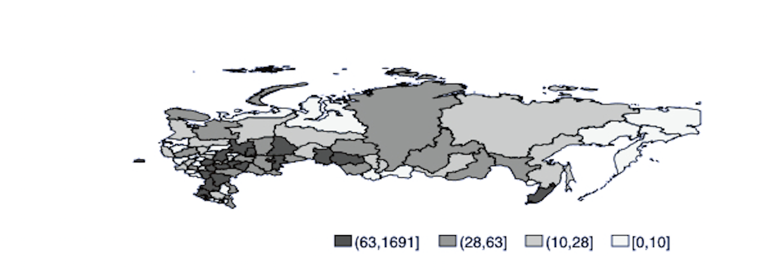
Figure 1: Geographic distribution of protest events (2007-2016)

Scope and Coding Procedure
The project relied exclusively on human coders, and all coding took place under the supervision of the lead author. Event data coding involved two steps. First, and in line with the definition of protest events in the article, coders were asked to identify whether a story appearing in the ‘novosti protesta’ section of the website provided information on protest events. The focus of interest in the dataset is an event defined as a public gathering, of one or multiple participants. Human coders were instructed to disregard entries that described intentions to mobilize, other forms of political participation, such as petitions, as well as stories that presented information on general sources of citizen grievances or discontent. Similarly, the dataset does not consider events organized by the ruling United Russia party or pro-government youth movements, such as Nashi. The website also includes multiple reports on various sources of citizen discontent that did not necessarily translate into protests. Approximately 66 percent of all stories reported on the ‘novosti protesta’ section of the website are included in LAruPeED. Second, for stories that did describe protest events taking place, coders were asked to extract additional information. Since articles could contain information on multiple event-day-locations, coders were instructed to create separate entries on all of the event-day-locations in the article. We describe the variables assembled below.

Variables
The dataset includes several variables for each event-day-location, described in detail in the codebook released with the data and in the online Appendix. All entries are accompanied by a web link to the original “raw” news article in which the protest was described. A separate file containing all text entries was created as the various protests were being coded. This was done to maintain a copy of the original source of the entries, in case the protest dataset was to be taken down by the government, or be discontinued. Data for some variables are only available beginning in 2012-2013 or later. However, researchers using the dataset would be able to refer to the web-links to protest stories to extract data for the other years, as required for a specific research project.

The first set of variables collected for each event provides identifying information, including the date and nature of the event—whether political, economic, social, cultural, environmental or legal. The count of each protest-event type is also provided in Figure 2 below, while a detailed description of each protest type is provided in Table A1 in the Appendix. Altogether, 2382 events are classified as political, 1328 as social and 1048 as economic. And 801 events are classified as legal, 550 as environmental and 155 as cultural. As several events are coded as belonging to two protest type categories - in many events, protesters do not limit demands to one cause but embrace a host of causes that could be under the social and economic rubric - the sum of all events classified in each category does not add up to the total number of events. To partly address this concern, LAruPED introduced two additional protest categories – “civic” and “civic+”. The “civic” protest category – not reported below - is an aggregate category; it includes any protest which is also registered as a legal, cultural or environmental protest, while the “civic+” protest variable is another aggregate category. It includes any protest which is also coded as a legal, cultural, environmental or social protest event. For instance, in a protest that took place in Samara on 18 June 2009, protesters advanced demands related to the preservation of recreation parks, causes also couched in legal and environmental terms. In total, 12 percent of all entries in the dataset are classified as belonging to two of the political, economic, social and civic protest categories (see also, Table A2 in the Appendix).
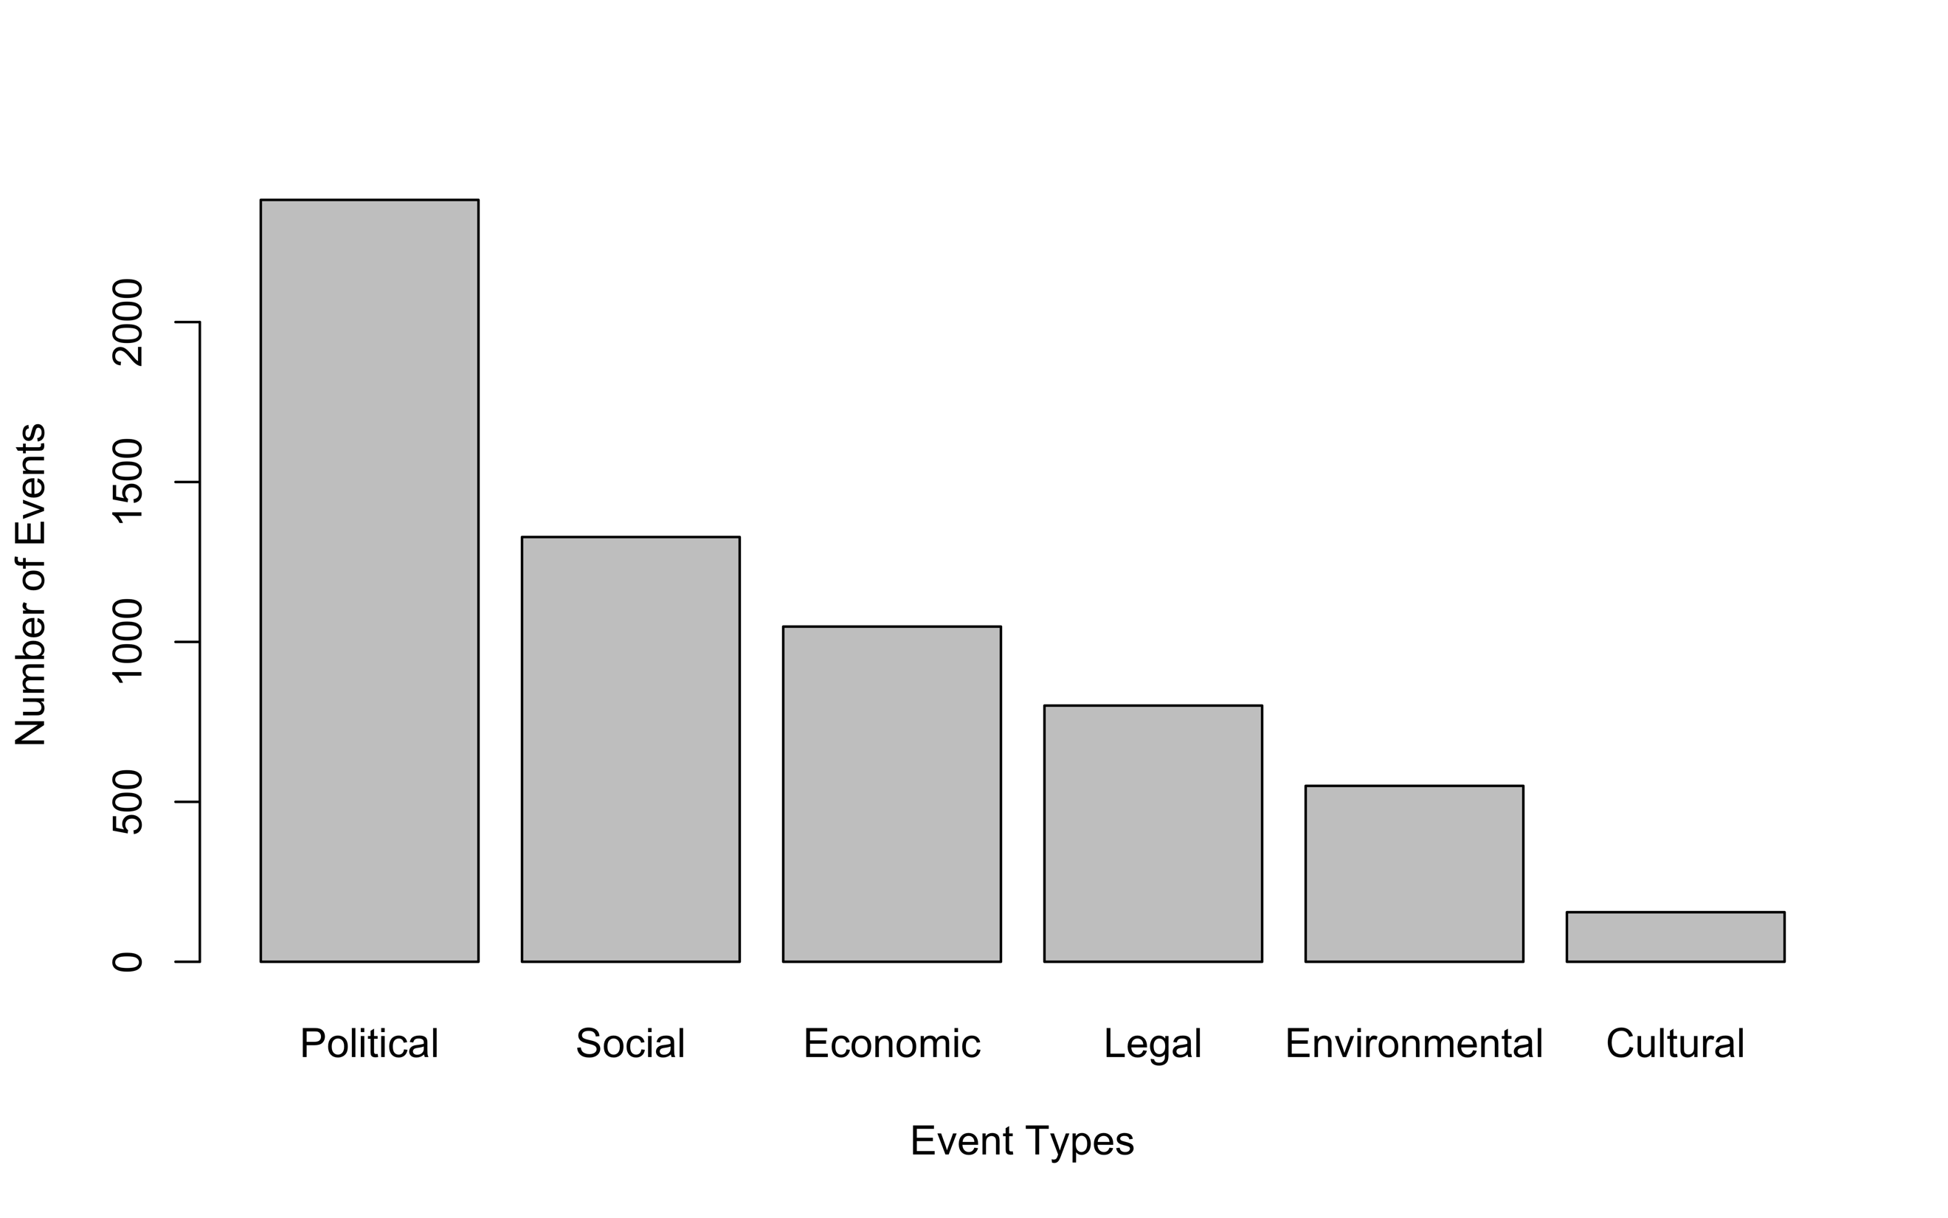
Figure 2: Count of protest events by category (2007-2016).

Additional information on the location, and where such information is available—the number of participants involved in the protest—is also collected at this stage. The dataset also distinguishes between a range of repertoires, which social movement scholars have highlighted as essential for understanding protest effectiveness and success (Tarrow 1996; McAdam 1983; Tilly 2004), such as demonstration; march; strike; other symbolic act; hunger strike; railway block; road block; occupation; suicide; and other disruptive acts. Additionally, the dataset reports information on the number of protesters, and the location of the event. While entries are not geo-located, information on the city where events take place is provided from January 2014 onwards. The “repertoire” entry, introduced in 2013, captures variation in the type of events—demonstrations, strikes, occupations, marches, etc. This category builds on earlier work on Russian protests, notably by Graeme Robertson (2013). Where available, we also report information on the name of the party that staged the protest. Finally, the dataset allows researchers to capture over time trends not only in activism itself but in the repressive and manipulative tactics of national, regional and municipal officials and political leaders. Two repression indicators capture attempts by the public authorities, police or pro-government groups to disrupt a protest and carry out repressive activities, including arrests. Active disruption implies that we do not simply record a suppression event when police are present at an event, simply observing participants. For suppression to occur, protesters have to be disrupted either through forced dispersal, physical attacks or arrest. Another variable reports the number of arrested activists. The category “pre-emptive suppression” covers instances when there is information regarding a protest being thwarted before it takes place.

Limitations
That the dataset relies solely on one crowd-sourced platform—namarsh.ru—constitutes an asset and a limitation. The key limitation of these data is potential over-reporting of particular issues or protest locations, while under-reporting others. Thus, run as it is by activists associated with the political opposition, it may well contain a liberal bias in favour of pro-democracy activism, while being less attuned to labour mobilization particularly industrial strikes staged by left-wing parties and activists (Robertson 2011, 2007). Moreover, 35 percent of all protest entries do not report information on the number of protesters; such information is not reported in many stories that appear on namarsh.ru.

More broadly, data collection bias, and missingness in the dataset may stem from several inter-related causes. The first may stem from the fact that namarsh.ru reporters did not cover certain types of protests – such as socio-economic protest organised by the KPRF, for example, or indeed smaller protests that take place in the provinces. This may reflect either ideological bias, or indeed reflect capacity constraints – for example, distant localities may be more difficult, or costly to reach. Reporting bias, resulting in events from some regions being under-represented, may stem from less active, or the absence of, web-correspondents (see also: Lankina and Savrasov 2009, p.6; Lankina 2015). Next, data collection bias can occur from the decision to limit analysis to events that appear in the “novosti protesta” section of the website. For example, it is possible that protest-related stories appear in different sections of the website, such as the general news section, or elsewhere. If events are mentioned, even briefly, in any of the articles that appear under the “novosti protesta” section, then the events in question will be included in the dataset. For these events some types of information may be missing, such as information on the number for arrests, for example. This may lead to measurement bias, stemming from the fact that information on some of the variables of interest is poorly collected and measured. Yet, inevitably, events that are neither mentioned, nor covered in any of the stories that appear under the “novosti protesta” section of the website would not be part of the protest dataset.

We have tried to cross-validate the namarsh.ru dataset with additional protest archives, mainly sourced from the website of the left-leaning Institute of Collective Action (IKD) for the period from December 2011 to May 2012. When restricting protest events in both sources to political protests alone, an additional 90 events, not initially reported in namarsh.ru were identified. Political protests in four regions reported by the institute of Collective Action (IKD) (Ivanovo, Kaliningrad, Komi and Novgorod) were not covered in namarsh.ru (see Tertytchnaya and Lankina 2019; Tertytchnaya 2019). It is therefore important to note that LAruPED does not provide an exhaustive account of protest events. We are explicit about these limitations and highlight that the data should be regarded as complementary to other data sources (Robertson 2007, 2011), and not as an exclusive and comprehensive repository of information on protests in Russia. Yet, as is the case with all protest-event datasets, without access to the universe of events, it is impossible to assess the extent of reporting bias in LAruPED (see, for example: Daxecker et al. 2019). By discussing various possible sources of bias, however, we would like to invite empirical researchers to assess whether data collection and measurement bias in LAruPED could lead to the causal effect of interest being either over-, or under-estimated.

Moreover, as Figure 3 below illustrates, and in line with expectations, reporting on the “novosti protesta” section of the namarsh.ru website (smoothed grey line) increases at times of elections – around the 2007-8 and 2011-12 electoral protest cycle, and around the September 2016 Duma (Parliamentary election). Both—the reporting of stories, and the number of protests coded in LAruPED (black smoothed line) decline over time. A notable increase in protest activity is also observed around 2008-2009, the period coinciding with the global economic crisis. Protests over wage arrears, strikes and hunger strikes, associated with the repercussions of the global financial crisis in Russia were particularly prominent during this time. In conclusion, while one crowd-sourced data repository like namarsh.ru is a valuable source of systematic data, further data gathering efforts should encompass information from alternative sources within the same national setting to minimise potential bias.
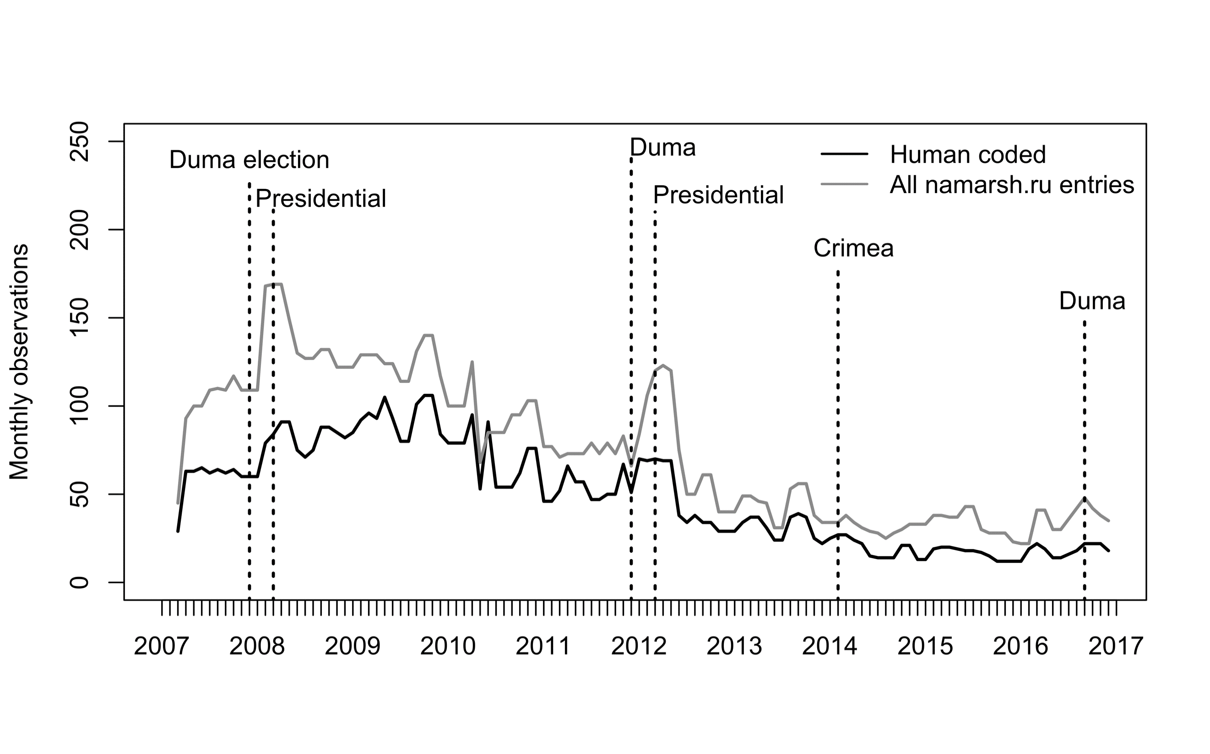
Figure 3: Monthly stories reported on namarsh.ru (grey line) and events included in the LAruPED

Comparing LAruPED to other datasets
We here highlight how LAruPED fills important gaps in extant data on protest in illiberal regimes. There are several excellent publicly available data repositories with cross-sectional data, which likewise rely on human coding and allow protest comparisons over time and across space. The Electoral Contention and Violence Dataset (ECAV) by Daxecker, Amicarelli and Jung (2019); the Mass Mobilization in Autocracies Dataset by Weidmann and Rød 2019; and the Cross-National Time-Series Data Archive by Banks (Banks et al. 2018), are just three prominent examples. LAruPED complements these data gathering efforts, allowing scholars to further nuance analyses and theorizing into protest dynamics in electoral autocracies.

The first dimension on which the LAruPED, differs from existing, cross-sectional, datasets concerns the nature of source of the protest data. Instead of relying on traditional newspaper articles, in local, national, or international outlets—mainly in English or French media sources—LAruPED leverages evidence from Russian-language opposition websites. In authoritarian contexts, protest reports collected by local opposition activists may be a helpful source of additional insights into protest dynamics. Reports collected by a dense network of activists across subnational territories provide additional information leverage. Together with other social media platforms, online blogs and websites allow individuals to act as correspondents; opposition activists to disseminate information on a large scale; and harvest protest news from sources across the national territory (see, for example: Zhang and Pan 2019). Reports by dense networks of protest activists provide new opportunities for scholars to learn about collective action in electoral autocracies, and to complement what we already know from reports in traditional media (see also, Zhang and Pan 2019).

Second, in contrast to datasets that collect information on political, or specifically electoral, protests, LAruPED is very broad in its thematic scope, as it covers events that are not exclusively political in nature, or centred around national elections (see for example, Daxecker et al. 2019; Weidmann and Rød 2019). As already noted, LAruPED provides information regarding the nature of each event, whether political, economic, social, cultural, legal or environmental. Figure 4, which relies on monthly protest data from the LAruPED, plots the monthly percentage of political protests included in the dataset. As highlighted below, from June to September 2009, for example, political protests make up 12, 11, 22 and 21 percent of all protest events respectively. Protests taking place after the onset of the “great recession,” and associated with the repercussions of the global financial crisis in Russia, were mainly socio-economic in nature. Political protests reach or surpass 50 percent of events (red line) during electoral cycles: in late 2007-2008 and up to the first quarter of 2009, during the 2011-12 electoral protest cycle, as well as ahead and around the September 2016 Duma election. The percentage of political protests also increased in the first quarter of 2014, the period surrounding Russia’s annexation of Crimea.

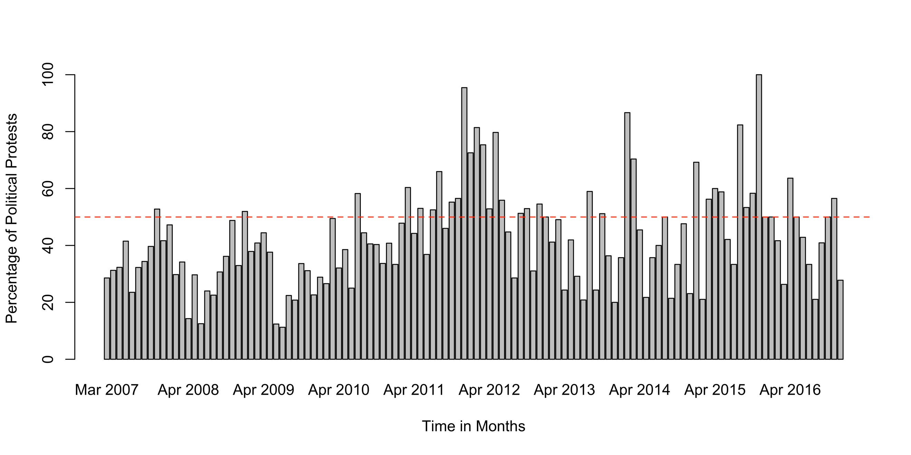
Figure 4: Monthly percentage of political protest events included in the dataset

While political, anti-regime protests are the ones posing the greatest threat to autocrats, ignoring other types of protests may be problematic (see also Trejo, 2014; Greene 2013, 2014). Civic or social forms of activism may over time morph into overtly political contention with blame attributed squarely on national leadership and not the local developer, mayor or street-level corrupt bureaucrats. The same individuals who had nurtured skills and networks while participating in acts of contention targeting actors other than national leaders, may well join anti-regime political protests when political opportunities change.

Finally, in contrast to other datasets, such as the Mass Mobilization in Autocracies Project (see, for example Weidmann and Rød 2019), LAruPED, imposes no limitations on the minimum number of protesters involved in each protest event, as a pre-requisite for the event to be included in the dataset. The condition that a mass mobilization event has to involve at least 25 people may be particularly restrictive, given that autocracies often deny authorization for a protest event to take place if it involves more than a certain number of people. In such circumstances, a small-scale event where more than 25 protesters take turns appearing in a public place with a placard becomes an interesting tactic—and a repertoire in itself—worthy of recording and study. In Russia, it is indeed often the case that protest participants take turns to hold a single banner during a one-person protest, to avoid breaching laws concerning assembly in public places. In our data, 30 percent of all events for which information on protest participants is available have less than 25 participants. As autocrats impose greater restrictions on citizens’ right to protest, multiple events with one or two participants could become all the more frequent. Citizens are also more likely to engage in spontaneous, “one-person” protests in response to sudden, unprecedented attacks on civil society. In Russia, this was the case in early June 2019 for example, when in response to news about the arrest of Meduza investigative journalist Ivan Golunov, hundreds of Russians in Moscow, St Petersburg, Perm and other regions took turns to stage one-person protests in support of Golunov and free press more broadly. Acknowledging these trends could be important for how we think about protest event analysis in autocracies more broadly.

Application: Differentiation in suppression
Existing research shows that illiberal regimes often feature pronounced geographic variation in political openness (Gervasoni 2010; Giraudy 2013; Behrend and Whitehead 2016; Gel'man and Ross 2010), and generates the expectation that the degree of repression can vary considerably across the national territory (Lankina and Getachew 2006; Lankina, Libman and Obydenkova 2016). Earlier studies of protests using LAruPED have documented such variation in the geography of protest repression. In an analysis of protest dynamics between 2007 and 2012, Lankina and Voznaya (2015), for example, have shown that regions with entrenched subnational authoritarian regimes are less likely to tolerate any form of protests. This continued to be the case beyond 2012 as well. From 2012 to 2016, three regions in the North Caucasus—Dagestan, Chechnya and Karachay-Cherkessia—had the second largest protest suppression rates across Russia.

Existing literature, however, provides little systematic information about differentiation in the type of repression. Detailed data on the nature of protests, and how this correlates with the use of violence against protesters, are not easily available for electoral autocracies. Using evidence from LAruPED, we are able, for the first time, to empirically document important over-time differences in the type of violently suppressed protests. Consider the following differences, illustrated in Figure 5. In the period covered in the data, one in five protests included in the dataset (around 23 percent of all events) was subject to some form of police-led violence. The suppression of protest events was, however, higher in years of federal elections, as opposed to years without federal elections. In 2007-8, 2011-12 and 2016, the years of parliamentary and presidential elections, one in four protests included in the dataset was subject to some form of police violence. In years without federal elections, in 2009-10 and 2013-15, one in five events faced some form of disruption.

The percentage of suppressed events was, however, higher for protests classified as political: across all years, 30 percent of political protests faced some type of disruption. One in three (around 33 percent of all events) and one in four political protests were met with violence in years with and without federal elections respectively. Across all years, 21 percent of protests coded as civic, that is as either environmental, cultural or legal, were subject to police violence, while this percentage was lower for economic and social protests respectively. In election years, around 23, 22 and 19 percent of civic, economic and social protests respectively faced violent suppression. Approximately 18 percent of all civic events, 14 percent of all economic and 15 percent of all social events were met with violence in non-election years.
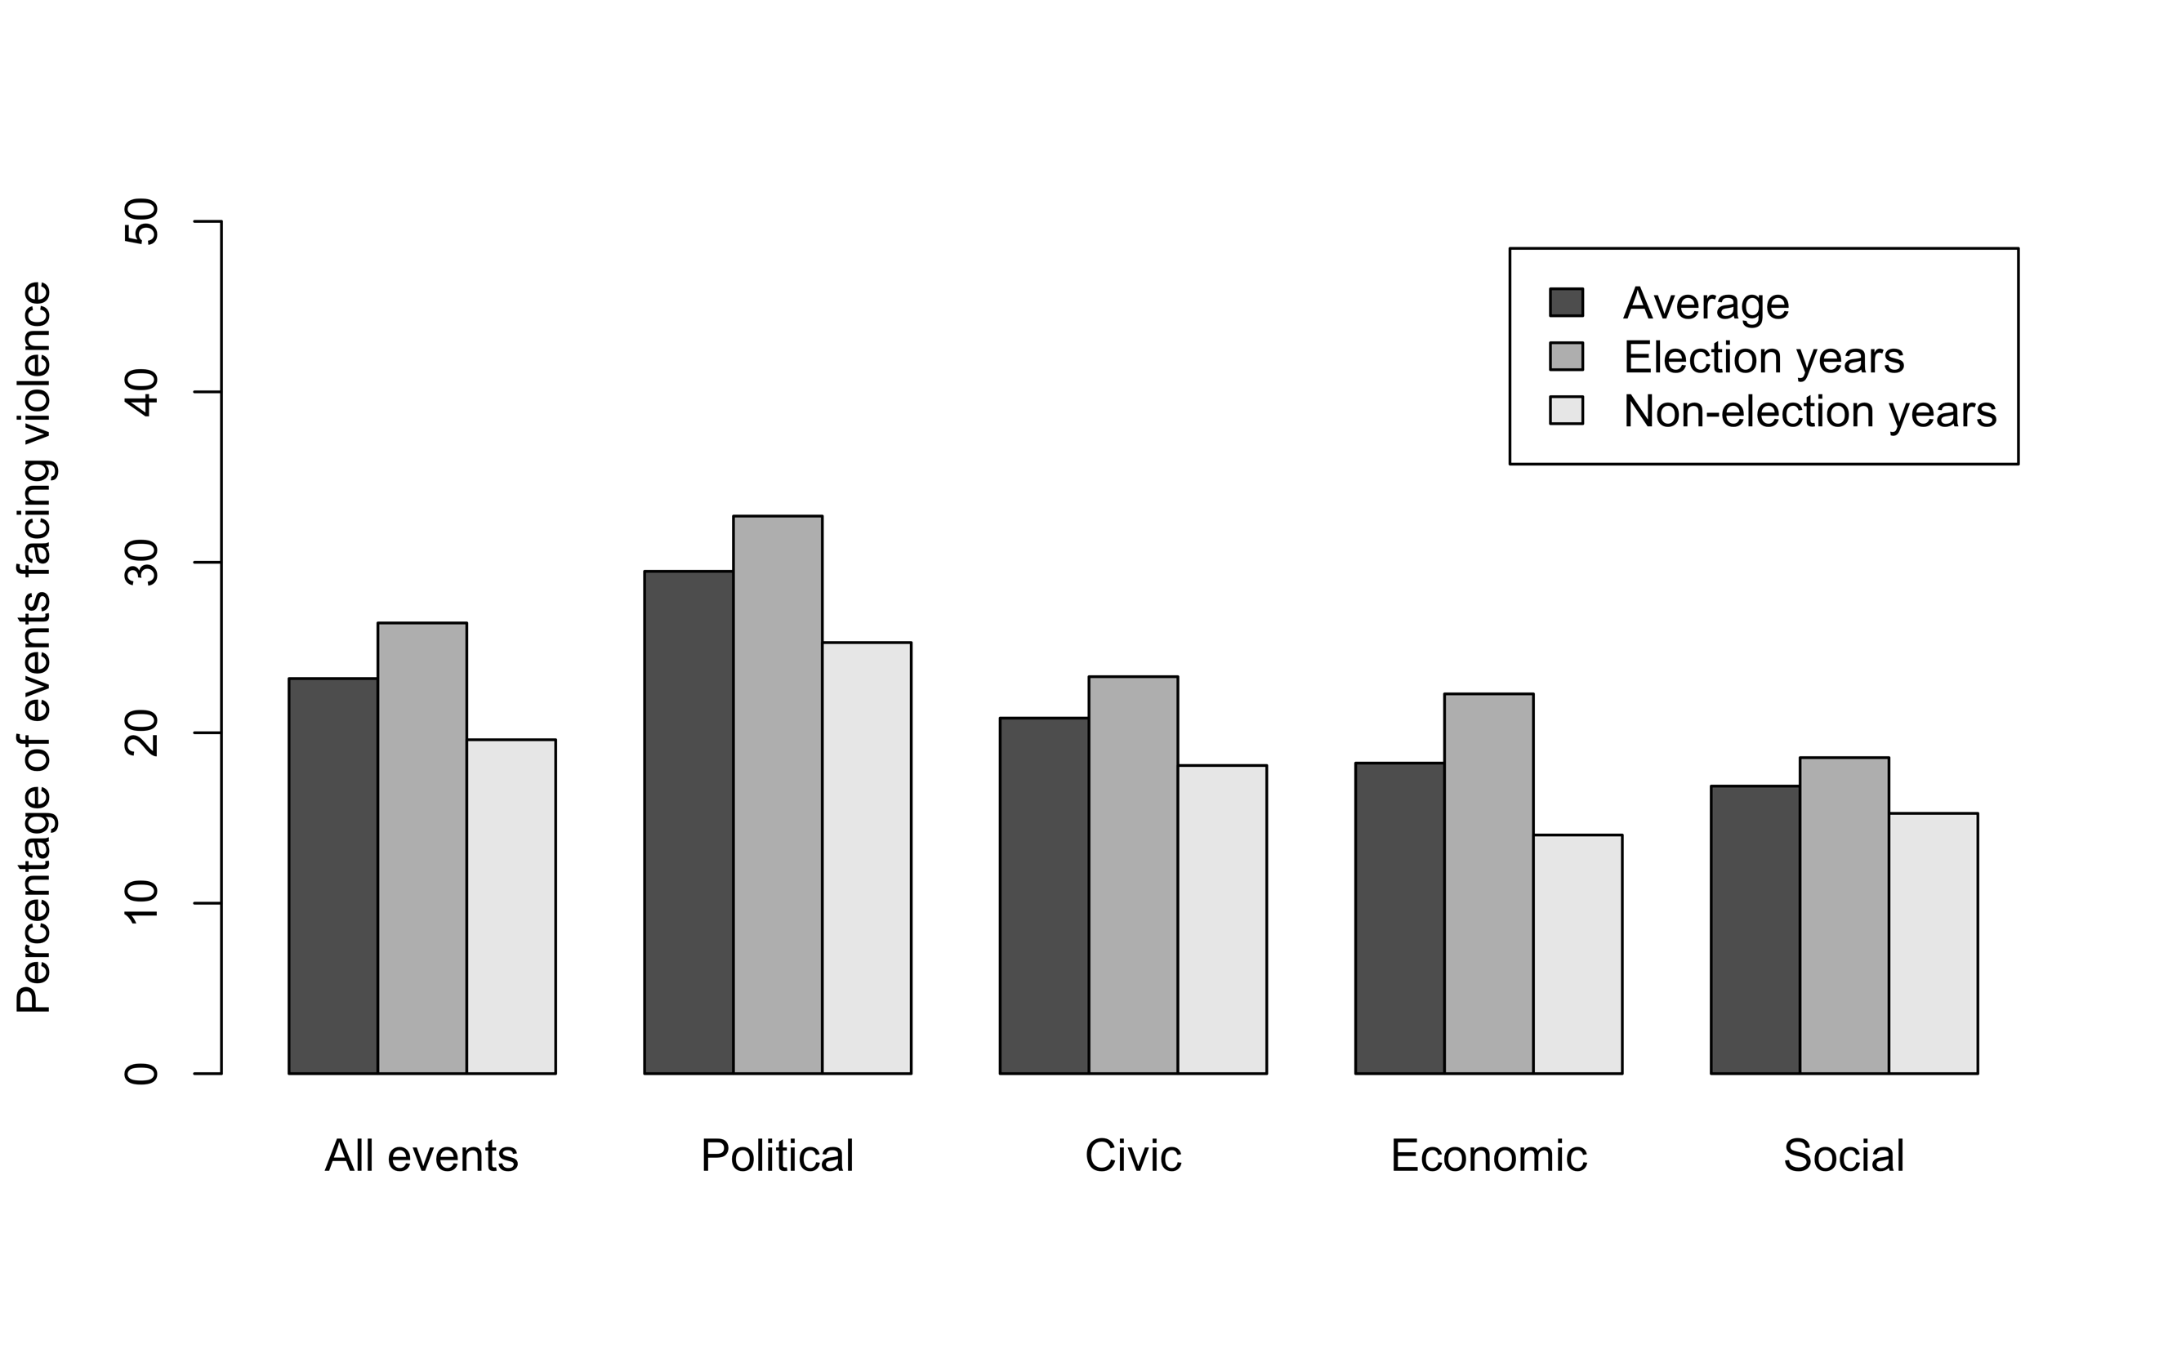
Figure 5: Differentiation in types of violently suppressed protest events.
Table 1 probes this relationship between event type and repression further. Entries are probit coefficients, with robust standard errors, clustered by regions (oblasts) in parenthesis. The outcome variable is a dummy coded as 1 if a protest event was subject to police violence and zero if otherwise. The main independent variable, protest type, is a categorical indicator that describes the type of each protest event, with each entry assigned to one category alone. To ensure that results are not sensitive to the specification of the ‘protest type’ item, Table A5 in the Appendix probes robustness using an alternative classification of the protest type variable. In Table 1 political protests are set as the baseline, so coefficients show how the probability of economic, social and civic protests facing repression compares to that of political protests facing violence. The analysis below is restricted to those events for which information on the number of rally participants is available, yet results do not change if we use the full dataset instead (see Table A3 in the Appendix). Federal district and year fixed effects introduced in Models 2-4 help control for unobserved political and economic factors that differ across districts yet are constant over time, as well as for factors like federal elections, or foreign policy events that change across years, yet are constant across subnational regions. Across all models reported in Table 1, results remain consistent and suggest that the probability of social, or economic events facing violence is approximately .3 points lower than that of political protests facing repression. The probability that civic, compared to political, protests will face suppression, is also lower. Focusing on model 4, for example, which includes both federal district and year fixed effects, we see that holding the other variables in their empirical means, the predicted probability of political protests facing disruption is around .3 (95% CI: .26, .32). The same probability is around .20 for economic (95% CI: .16, .23) and social (95% CI: .17, .23) events respectively, and .19 (95% CI: .16, .21) for civic events. Across all models, the protesters coefficient is positive. Yet, its direction depends on the specification of this variable. Using a logarithmically transformed indicator of protesters, as we do in the Appendix (Table A4) the sign of the variable flips. Investigating the relationship between protest size, type and suppression is a fruitful avenue for future research.
Table 1: Differentiation in suppression.
 | (1) | (2) | (3) | (4)
Economic | -0.321*** | -0.343*** | -0.296*** | -0.318***
 | (0.061) | (0.062) | (0.058) | (0.064)
Social | -0.345*** | -0.332*** | -0.322*** | -0.311***
 | (0.070) | (0.064) | (0.068) | (0.062)
Civic | -0.261*** | -0.318*** | -0.299*** | -0.355***
 | (0.069) | (0.064) | (0.065) | (0.060)
Protesters | 0.000*** | 0.000*** | 0.000*** | 0.000***
 | (0.000) | (0.000) | (0.000) | (0.000)
District FE | No | No | Yes | Yes
Year FE | No | Yes | No | Yes
Constant | -0.518*** | -0.189*** | -0.358*** | -0.005
 | (0.101) | (0.069) | (0.062) | (0.071)
Protest-events | 3,784 | 3,784 | 3,784 | 3,784
Notes: Probit coefficients with robust standard errors, clustered by federal regions, in parentheses, *** p<0.01, ** p<0.05, * p<0.1.

More broadly, results suggest that the Russian government is more tolerant of socio-economic, or civic, as opposed to political protest events. In a forthcoming book chapter, Lankina et al. (2020) demonstrate that the government could be in fact quite forthcoming in providing media coverage of protests in which targets other than the national government or regime feature—as would be the case with anti-migrant protests and riots in which the local authorities and businesses are accused of turning a blind eye to alleged criminal acts and corruption perpetrated by particular individuals or groups. These findings also broadly dovetail with evidence on the differential responses of the Chinese state to protests whereby the regime is quite tolerant of some types of contention while seeking to nip others in the bud. Huang et al. (2019), for example, found that the Chinese government is more likely to allow the media to report social protests targeting local governments. Allowing social protests and their coverage in state-led media, governments are able to identify and address more social grievances. Local officials are blamed for issues like corruption, mismanaged or poor governance and are publicly named and shamed into reducing misbehaviour. We believe that, despite differences in the nature of political activism in Russia and China, similar dynamics may be at play in Russia as well.

In the period covered in the data (2007-2016), participants of socio-economic or civic protests did not generally attribute blame vis-a-vis the national government, while those attending political protests against electoral fraud, or corruption did. Socio-economic protests, often led by systemic opposition parties, such as the Communist Party (KPRF) and grassroot movements, remained local, mainly targeting employers, developers, local business groups or regional authorities. In several cases, protesters even addressed their grievances to federal authorities in order to find solutions to specific problems; that does not necessarily mean that protesters regarded the regime as part of the problem, however. In March 2016, for example, farmers from Krasnodar declared that they would stage a march on Moscow to communicate their demands to the President himself, who would be able to help them. Children protesting in support of the Dubki park in Moscow in March 2016 also made headlines for addressing their demands to “Uncle Volodya” (Vladimir Putin) (see Tertytchnaya and Lankina 2016).

We also know that for state-led violence to achieve a deterrence effect, it must be targeted (Mason and Krane 1989, p.181). Perhaps the broader message that the Russian government wishes to put across is that as long as ordinary Russians shy away from joining political protests, they should be less concerned about coercive sanctions. As earlier research reminds us, Russians, while generally supportive of street action, are particularly critical of unsanctioned—and perhaps for this reason more likely to be violently interrupted—protests (Smyth et al. 2013). The selective targeting of political protests, therefore, may form part of authoritarian governments’ efforts to deter anti-regime mobilization from spreading.

More broadly, the evidence presented here highlights how it may be challenging to generalise insights from political, or electoral protests – the key focus of current cross-national and comparative protest datasets – to other settings. Political protests are starkly different, not least in the probability that they will face police violence. Implications follow for our understanding of protest participation and protest effects. The types of citizens who are willing to participate in political, as opposed to social protest events for example, may also be different – as risk averse citizens could shy away from protests that advance political demands. In a similar vein, the ability of the parliamentary and non-parliamentary opposition parties and activists to attract broader support may also be compromised if they only stage or participate in political, and by definition more likely to feature police violence, protests.

Conclusion
The LAruPED dataset allows researchers to examine variation in subnational protests in Russia, a classic example of contemporary electoral authoritarian regime. The first release version of LAruPED covers 10 years, from March 2007 to December 2016, and includes more than 5,824 political, economic, social and civic protest events. Findings on variation in the use of suppression across types of protests illustrate the importance of considering how political and non-political protests differ in electoral autocracies.

More broadly, LAruPED is a resource that scholars could continue to build on to explore wider temporal trends in citizen activism in Russia and to compare findings with protests elsewhere. It also represents a resource for comparative analysis of protest dynamics and authoritarian regime resilience-building strategies in other autocracies. The data have been already leveraged in conjunction with analyses of semantic manipulation of discourse on protest; the connection between protests and attitudes, analyses of electoral competition (Lankina et al. 2016; Tertytchnaya and Lankina 2019; Gorokhovskaia 2017); as well as links between foreign policy and domestic rallies (Lankina and Watanabe 2017). The data also contribute to larger projects on mobilization, conflict and violence (Zhukov et al. 2019). The utility of the dataset thus goes beyond analyses of protest to encompass systematic attempts to analyse cross-national dynamics of conflict in democracies and non-democracies alike; and to explore the underlying trends behind the continued vibrancy, or, alternatively, the death of democracy as we know it.

References
Banks, Arthur S., Wilson, Kenneth A. 2018. Cross-National Time-Series Data Archive. Databanks International. Jerusalem, Israel; see https://www.cntsdata.com/
Behrend, Jacqueline, and Laurence Whitehead. 2016. Illiberal Practices: Territorial Variance within Large Federal Democracies. Baltimore: Johns Hopkins University Press.
Beissinger, Mark R. 2007. "Structure and Example in Modular Political Phenomena: The diffusion of Bulldozer/Rose/Orange/Tulip Revolutions." Perspectives on Politics 4 (2):259-76.
Beissinger, Mark, R. 2013. "The Semblance of Democratic Revolution: Coalitions in Ukraine's Orange Revolution." The American Political Science Review 107 (3):574.
Beissinger, Mark R. 2007. "Structure and Example in Modular Political Phenomena: The diffusion of Bulldozer/Rose/Orange/Tulip Revolutions." Perspectives on Politics 4 (2):259-76.
Bunce, Valerie, and Sharon L. Wolchik. 2011. Defeating Authoritarian Leaders in Postcommunist Countries. New York: Cambridge University Press.
Daxecker, Ursula., Amicarelly, Elio and Jung, Alexander. 2019. Electoral contention and violence (ECAV): A new dataset. Journal of Peace Research. Doi: https://doi.org/10.1177/0022343318823870
Frye, Timothy, and Ekaterina, Borisova, "Elections, Protest, and Trust in Government: A Natural Experiment from Russia," The Journal of Politics 0, no. 0 (-Not available-): 000. https://doi.org/10.1086/702944
Gel'man, Vladimir, and Cameron Ross, eds. 2010. The Politics of Subnational Authoritarianism in Russia. Edited by N. Robinson. Farnham: Ashgate.
Gervasoni, Carlos. 2010. "A Rentier Theory of Subnational Regimes: Fiscal Federalism, Democracy, and Authoritarianism in the Argentine Provinces." World Politics 62 (2):302-40.
Giraudy, Agustina. 2013. "Varieties of Subnational Undemocratic Regimes: Evidence from Argentina and Mexico." Studies in Comparative International Development 48:51-80.
Greene, Samuel. 2013. "Beyond Bolotnaia." Problems of Post-Communism 60 (2):40-52.
Greene, Samuel A. 2014. Moscow in Movement: Power and Opposition in Putin's Russia. Stanford, California: Stanford University Press.
Gorokhovskaia, Yana. 2017. Testing for sources of electoral competition under authoritarianism: an analysis of Russia’s gubernatorial elections. Post-Soviet Affairs, 33:5, 356-369.
Harris, A. S., & Hern, E. (2018). Taking to the Streets: Protest as an Expression of Political Preference in Africa. Comparative Political Studies. 52(8), pp.1169-1199.
Huang, Haifeng, Boranbay-Akan, Serra and Huang, Ling. 2019. Media, Protest Diffusion and Authoritarian Resilience. Political Science Research and Methods. 7(1). pp.23-42.
Javeline, Debra. 2003. " The Role of Blame in Collective Action: Evidence from Russia." The American Political Science Review 97 (1):107-21.
Javeline, Debra, and Sarah Lindemann-Komarova. 2010. "A Balanced Assessment of Russian Civic Society." Journal of International Affairs 63 (2):171.
King, Gary, Jennifer Pan, and Margaret E. Roberts. 2013. "How Censorship in China Allows Government Criticism but Silences Collective Expression." American Political Science Review 107 (2):326-43.
Koesel, Karrie J., and Valerie J. Bunce. 2013. "Diffusion-Proofing: Russian and Chinese Responses to Waves of Popular Mobilizations against Authoritarian Rulers." Perspectives on Politics 11 (3):753-68.
Lankina, Tomila. 2014. "Daring to Protest: When, Why and How Russia's Citizens Engage in Street Protest." PONARS Eurasia Policy Memo. Washington, DC: New Approaches to Research and Security in Eurasia.
Lankina, Tomila, and Lullit Getachew. 2012. “Mission or Empire, Word or Sword? The Human Capital Legacy in Postcolonial Democratic Development.” American Journal of Political Science 56(2): 465–83.
Lankina, Tomila V., and Lullit Getachew. 2006. "A Geographic Incremental Theory of Democratization: Territory, Aid, and Democracy in Post-Communist Regions." World Politics 58 (4):536-82.
———. 2008. "The Virtuous Circles of Western Exposure in Russian Regions: A Case for Micro-Polity Analysis of Democratic Change." The Journal of Communist Studies and Transition Politics 24 (3):338-64.
Lankina, Tomila, Alexander Libman, and Anastassia Obydenkova. 2016. “Appropriation and Subversion: Pre-Communist Literacy, Communist Party Saturation, and Post-Communist Democratic Outcomes.” World Politics 68(2).
Lankina, Tomila. 2015. "The Dynamics of Regional and National Contentious Politics in Russia: Evidence from a New Dataset." Problems of Post-Communism 62 (1):26-44.
Lankina, Tomila, and Alexey Savrasov. 2009. "Growing Social Protest in Russia." Russian Analytical Digest 60.
Lankina, Tomila V., and Rodion Skovoroda. 2017. "Regional Protest and Electoral Fraud: Evidence from Analysis of New Data on Russian Protest."
Lankina, Tomila and Alisa Voznaya (2015) New Data on Protest Trends in Russia's Regions, Europe-Asia Studies, 67:2, 327-342.
Lankina, Tomila, and Kohei Watanabe. 2017. "“Russian Spring” or “Spring Betrayal”? The Media as a Mirror of Putin’s Evolving Strategy in Ukraine." Europe-Asia Studies 69 (10):1526-56.
Lankina, Tomila, Kohei Watanabe, and Yulia Netesova. 2020. "How Russian Media Control, Manipulate and Leverage Public Discontent: Framing Protest in Autocracies." In Citizens and the State in Authoritarian Regimes: Comparing China and Russia, ed. V. Bunce, K. Koesel and J. C. Weiss. Oxford: Oxford University Press. Forthcoming.
Levitsky, Steven, and Daniel Ziblatt. 2018. How Democracies Die: What History Reveals about Our Future. London: Viking, an imprint of Penguin Books.
Little, Andrew T., Joshua A. Tucker, and Tom LaGatta. 2013. "Elections, Protest, and Alternation of Power." Journal of Politics 77 (4):1142-56.
Lorentzen, Peter. 2013. "Regularizing Rioting: Permitting Protest in an Authoritarian Regime." Quarterly Journal of Political Science 8:127–58.
———. 2014. "China's Strategic Censorship." American Journal of Political Science 58 (2):402-14.
Mason, David T. and Krane, Dale A. 1989. The Political Economy of Death Squads: Toward a Theory of the Impact of State-Sanctioned Terror. 33(2). pp. 175-198.
McAdam, Doug. 1983. "Tactical Innovation and the Pace of Insurgency." American Sociological Review 48:735-54.
———. 1996. "The Framing Function of Movement Tactics: Strategic Dramaturgy in the American Civil Rights Movement." In Comparative Perspectives on Social Movements, ed. D. McAdam, J. D. McCarthy and M. N. Zald. Cambridge: Cambridge University Press.
McMann, Kelly M., and Nikolai V. Petrov. 2000. "A Survey of Democracy in Russia's Regions." Post-Soviet Geography and Economics 41 (3):155-82.
O'Donnell, Guillermo. 1999. Counterpoints: Selected Essays on Authoritarianism and Democratisation. Notre Dame: University of Notre Dame Press.
Onuch, Olga. 2014. Mapping Mass Mobilization: Understanding Revolutionary Moments in Argentina (2001) and Ukraine (2004). New York: Palgrave Macmillan.
———. 2015. "EuroMaidan Protests in Ukraine: Social Media Versus Social Networks." Problems of Post-Communism 62 (4):217-35.
Pei, Minxin. 2012. "Is CCP Rule Fragile or Resilient?" Journal of Democracy 23 (1):27-41.
Robertson, Graeme B. 2007. "Strikes and Labor Organization in Hybrid Regimes." American Political Science Review 101 (4):781-98.
———. 2011. The Politics of Protest in Hybrid Regimes: Managing Dissent in Post-communist Russia. Cambridge: Cambridge University Press.
Robertson, Graeme. 2013. Protesting Putinism: The Election Protests of 2011-12 in Broader Perspective. Problems of Post-Communism. 60(2), pp. 11-23.
Rucht, D., Koopmans, R. & Neidhardt, F. (1999) Acts of Dissent: New Developments in the Study of Protest (Lanham, MD, Rowman & Littlefield).
Skovoroda, Rodion, and Tomila Lankina. 2017. "Fabricating Votes for Putin: New Tests of Fraud and Electoral Manipulations from Russia." Post-Soviet Affairs 33 (2):100-23.
Smyth, Regina, Anton Sobolev, and Irina Soboleva. 2013. "A Well-Organized Play." Problems of Post-Communism 60 (2):24-39.
Snyder, Richard. 2001. "Scaling Down: The Subnational Comparative Method." Studies in Comparative International Development 36 (1):93-110.
Tarrow, Sidney. 1996. Power in Movement: Social Movements, Collective Action and Politics. Cambridge: Cambridge University Press.
Tertytchnaya, Katerina, and Tomila V. Lankina. 2016. Whom do Russian protesters blame (and why it matters)? Political Mobilization and Democracy Blog Post. https://popularmobilization.net/2016/09/20/whom-do-russian-protesters-blame-and-why-it-matters/
Tertytchnaya, Katerina, and Tomila V. Lankina. 2019. "Electoral Protests and Political Attitudes under Electoral Authoritarianism." Forthcoming in the Journal of Politics.
Tertytchnaya, Katerina. 2019. Protests and Voter Defections in Electoral Autocracies: Evidence from Russia. Comparative Political Studies.doi: https://doi.org/10.1177/0010414019843556
Tilly, Charles. 2004. Contention and Democracy in Europe, 1650 2000. New York Cambridge University Press.
Trejo, Guillermo. 2014. The Ballot and the Street: An Electoral Theory of Social Protest in Autocracies. Perspectives on Politics. 12(2), pp.332-352.
Tucker, Joshua A. 2007. "Enough! Electoral Fraud, Collective Action Problems, and Post-Communist Colored Revolutions." Perspectives on Politics 5 (3):535-51.
Wahman, Michael. 2015. "Demand and Capacity in African Sub-national Election Manipulation: New Evidence and Data from Malawi." In Annual Meeting of the American Political Science Association San Francisco.
Weidmann, Nils B. and Espen Geelmuyden Rød. 2019 The Internet and Political Protest in Autocracies. Chapter 4. Oxford University Press.
Zhang, Han and Jennifer Pan. 2018. “CASM: A Deep-Learning Approach for Identifying Collective Action Events with Text and Image Data from Social Media.”
Sociological Methodology. 1-57. doi: 10.1177/0081175019860244
Zhukov, Yuri M., Christian Davenport and Nadiya Kostyuk. 2019. “Introducing xSub: A new portal for cross-national data on subnational violence.” Journal of Peace Research 56 (4): 604-614.

http://namarsh.ru/materials/4A3A2EE6A4187.html
We are grateful to Sasha de Vogel for alerting us to this potential issue in coverage of protests beyond the “novosti protesta” section of the namarsh.ru website.

