Public discomfort at the prospect of autonomous vehicles: Building on previous surveys to measure attitudes in 11 countries
Chris Tennant, Sally Stares Susan Howard

Accepted for publication in Transportation Research Part F, 13 April 2019.

Abstract:
There have been many surveys of public responses to Autonomous Vehicles (AVs), both reported in peer-reviewed journals and in the mainstream media.
People anchor their representations of novel technological objects within their existing experience. What elements of such experience anchor AVs? We review academic English language survey studies from 2015 to 2017 and surveys publicised in UK National newspapers which typically reveal discomfort about the prospect of AVs. Against this background we report the results of our own survey of 11,827 drivers across 11 European countries, addressing attitudes to driving alongside AVs as well as to riding in them. We establish a composite indicator of perceptions of AVs that combines responses on using AVs and sharing the road with them, and analyse its relationship with a set of covariate measures. Respondents’ technological optimism and uptake of driving technology was associated with more positive perceptions of AVs, and measures of respondents’ enjoyment of driving, and how ‘sociable’ they were towards fellow road users, was associated with more negative perceptions. The negative association between driving ‘sociability’ and enthusiasm for AVs was attenuated by levels of general technological optimism. We discuss the difficulties in researching public responses to novel technological objects and make suggestions for improvement in future survey research on AVs.

- Introduction

There has been a rapid proliferation of announced trials of Autonomous Vehicle (AV) technology and targeted product launch dates (e.g. Ford, 2016; Milne & Hook, 2016; Waymo, 2017). Questions about the public response to this programme has led to an expanding body of survey evidence addressing this issue, prompting several literature reviews (Becker & Axhausen, 2017; Cohen, Jones, Cavoli, & Phillips, 2017; Gkartzonikas & Gkritza, 2017).
Cohen, Jones, Cavoli, et al. (2017, p.28) offer a challenge: ‘‘A variety of research into attitudes has already been carried out but it is of mixed quality and, in order to extract full value from it, some additional analysis is required: how have participants been sampled? How have topics and questions been presented? What has been done to understand what image(s) of automation the participant has in mind when answering?” We use a wider review of existing surveys to address some of these questions and an analysis of original survey data to make a first step towards answering the challenge to improve the survey data available.

- Attitudes to novel technological objects

Before reviewing the survey literature, we consider first how public attitudes towards novel technological objects develop, and whether it makes sense to survey these attitudes before the public has actually experienced the technology. Do attitudes to a hypothetical object tell us anything about how the public will respond when confronted by the technology itself? Simulation and real world studies demonstrate how fast users adapt their behaviour when exposed to new technolo- gies, in ways they themselves are unlikely to anticipate prior to exposure (Sharples, Moore, Moran, Burnett, Meng, Galea, & McAuley, 2016). Nevertheless, there are both economic and moral reasons why public views of a new technology need to be addressed, as the case of biotechnology, among others, demonstrates (Bauer, 2015).
Previous studies have found that people use prior experience and knowledge to contextualise novel objects. Social rep- resentations theory offers the psychological mechanisms of anchoring and objectification to explain how new ideas become connected to existing representations in order to ‘make familiar the unfamiliar’ (Moscovici, 2007). Through anchoring a new idea with an old – e.g. GM food with older forms of agriculture – previous knowledge provides a scaffold onto which the unfamiliar becomes concrete (objectified) and this allows people to orient themselves to the novel object. The resources that form this scaffolding have been theorised in diverse ways, including ‘cognitive heuristics’ (Lee, Scheufele, & Lewenstein, 2005), emotions (Höijer, 2010), worldviews (De Witt, Osseweijer, & Pierce, 2015), cultural values (Gaskell, Eyck, Jackson, & Veltri, 2005), ‘general attitudes’ (Grunert, Bredahl, & Scholderer, 2003), and many hypotheses about the relationship between scientific knowledge and attitudes to science, technology, engineering and mathematics (Simis, Madden, Cacciatore, & Yeo, 2016). Social representations theory offers the explanation that anchoring can assign meaning in a variety of ways: through association with declarative knowledge, beliefs, attitudes, imagery and any of these held by the individual and expressed and developed in social groups (Duveen & Lloyd, 1990).
This then raises the question of what previous knowledge or experience will be used to anchor representations of AVs. If AVs are anchored to technology as a whole, then positions taken on AVs may echo representations of technology as a whole (one’s knowledge of, feelings about, values and worldviews regarding technology). If AVs are anchored to personal experi- ences of the road and of driving, then they will need to fit into expectations of how the road should be. Alternatively, refram- ing AVs as a mobility solution, as most immediate launch plans do, (e.g. Ford, 2016; Randall, 2018) encourages people to anchor the technology within the framework of their routine mobility needs. This paper focusses on the first two of these possible anchors.

- Previous surveys

We have reviewed a total of 58 surveys reported in English language journals and newspapers covering the period from 2014 to January 2018. An initial search of Google Scholar for papers including ‘‘public opinion” or ‘‘survey” and ‘‘driverless car” or ‘‘autonomous vehicle” was supplemented by ‘backward snowballing’ (per Becker & Axhausen, 2017, p. 1294) the ref- erences within those articles. To the above we added numerous commercially sponsored surveys reported in the mainstream UK media. Surveys have been identified by using the Nexis UK database and searching national newspaper titles from 2015 to January 15th 2018 for public opinion or survey and autonomous vehicle or driverless car. The intention has been to provide reasonably comprehensive coverage of all such surveys between 2014 and January 2018: a few commercial surveys refer- enced in the literature have not been included since these were only accessible as high value purchases.
Table 1 below provides details of these surveys in three categories: (1) those appearing in peer-reviewed journals, (2) aca- demic publications presented as institutional reports or conference papers, and (3) commercially sponsored surveys. Infor- mation available for some surveys is limited, but where possible we have identified the survey medium (face to face ‘‘F2F”, telephone "Tel", or online ‘‘Net”) together with the survey company or platform. Most surveys situate the topic of AVs within a particular context, whether, as in the case of many academic surveys, by focusing on particular independent variables as predictors of attitudes to AVs or, as in the case of many commercial surveys, by framing AVs in a newsworthy way. Since we have argued that respondents are likely to anchor their attitudes towards AVs within their attitudes to new technology gen- erally, or to their experiences of driving, we highlight two specific topics which we note as present or absent in the surveys: first, the possible relevance of respondents’ overall attitudes to technology along with their attitudes to, or experience of, new technology such as advanced driver assistance systems in their existing car. Second, the issue of how AVs may affect the road environment whether in general terms as part of a mixed fleet with human driven vehicles or in specific terms addressing interactions between AVs and human drivers.

Table 1
Surveys reported in English language journals and newspapers from 2014 to 2018.

What was measured

Author/organisation Date ’n’ Sample source Location Responses to
technology
AVs and others

 | Published |  |  |  |  | Tech Attitudes | Tech Experience |  | General environment | Interactions with HDVs
Academic surveys in peer-reviewed journals
Payre et al. | 2014 | 421 |  | Net: specialist lists | France | No | Yes | No |  | No
Owens et al. | 2015 | 1,019 |  | Tel: Random # dial | US | Yes | Yes | NM |  | NM
Kyriakidis et al. | 2015 | 4,886 |  | Net: Crowdflower | 109 countries | No | Yes | No |  | No
Bansal and Kockelman | 2016 | 347 |  | Net: lists via Qualtrics | Austin, Texas | Yes 1 | Yes | Yes |  | Yes
Krueger et al. | 2016 | 435 |  | Net: Qualtrics | Australia | No | No | No |  | No
Hohenberger | 2016 | 1,603 |  | Net: social media | Germany | NM | Yes | NM |  | NM
König and Neumayr | 2017 | 489 |  | Net: snowball | 75% Austria | No | Yes | Yes |  | Yes
Bansal and Kockelman | 2017 | 2,167 |  | Net: Qualtrics | US | NM 1 | Yes | NM 1 |  | NM 1
Haboucha et al. | 2017 | 721 |  | Net: social media | Isr, US, Can | Yes | No | Yes |  | No
Lustgarten and Le Vine | 2018 | 370 |  | Net: Qualtrics | US | No | No | No |  | No
Daziano et al. | 2017 | 1,260 |  | Net: Mturk | US | - - - | Yes | - - - |  | - - -
Deb et al. | 2017 | 482 |  | Net: Macromil Embrain | US | Yes | No | Yes |  | Yes
Ro and Ha | 2017 | 1,506 |  | Net: Qualtrics | Korea | NM | NM | Yes |  | Yes 2
Hulse et al | 2018 | 916 |  | Net: social media, lists | UK | NM | NM | NM |  | Yes 3
Sanbonmatsu et al. | 2018 | 114 |  | Net: Mturk ’masters’ | US | Yes | NM | NM |  | NM
Academic surveys published as reports or conference proceedings
Schoettle and Sivak | 2014a | 1,533 |  | Net: surveymonkey | UK US Aus | No | No | Yes |  | Yes
Schoettle and Sivak | 2014b | 1,722 |  | Net: surveymonkey | China India | No | No | Yes |  | Yes
 |  |  |  |  | Jpn
Rödel et al. | 2014 | 336 |  | Net: lists | Austria | NM | Yes | NM |  | NM
Cyganski et al. | 2014 | 1,000 |  | Net: market panel | Germany | No | Yes | No |  | No
Schoettle and Sivak | 2015 | 505 |  | Net: surveymonkey | US | No | No | No |  | No
Eurobarometer | 2015 | 27,801 |  | F2F: TNS prob sample | EU | No | No | Yes 4 |  | No
Zmud et al. | 2016 | 556 |  | Net: ResearchNow | Texas, US | Yes | No | No |  | Yes
Kockelman et al. | 2017 | 1,364 |  | Net: Qualtrics/SSI | Texas, US | NM 1 | Yes | NM 1 |  | NM 1
Ernst and Reinelt | 2017 | 100 |  | Net: Auto websites | Germany | NM | NM | Yes |  | NM
Langdon and Ruggeri | 2017 | 2,850 |  | Net: Qualtrics | UK | Yes | No | No |  | No
Eurobarometer | 2017 | 27,901 |  | F2F: TNS prob sample | EU | No | No | Yes 4 |  | No
Hyde, Dalton, and Stevens | 2017 | 233 |  | Net: list, social media | UK | No | Yes | Yes |  | Yes 3
Pew Research (Smith) | 2017 | 4,135 |  | Net: Pew Panel | US | Yes | No | Yes |  | Yes
Commercial surveys
Observer/Opinium | 2015 | N/D |  | N/D: Opinium | UK | NM | NM | NM |  | NM
Goodyear/ThinkYoung | 2015 | 2,564 |  | Net: N/D | Europe | No | No | Yes |  | No
Adrian Flux (Insurance) | 2015 | c 1,800 |  | N/D | UK | NM | NM | NM |  | NM
uSwitch | 2015 | 3,497 |  | Net: customers | UK | No | No | Yes |  | Yes
YouGov (Moore) | 2016 | 996 |  | Net: YouGov | US | No | No | No |  | No
WhatCar | 2016 | N/D |  | N/D | N/D | NM | NM | NM |  | NM
Co-op/ICM | 2016 | 1,000 |  | N/D: ICM | UK | NM | NM | NM |  | Yes
AA/Populus | 2016 | N/D |  | N/D: Populus | Ireland | - - - | - - - | - - - |  | - - -
IAMRoadsmart/Opinium | 2016 | 1,000+ |  | N/D: Opinium | UK | NM | NM | Yes |  | NM
YouGov (Smith) | 2016 | 1,661 |  | YouGov | UK | No | No | No |  | No
uSwitch - July | 2016 | 4,779 |  | N/D: customers | UK | No | No | No |  | No
uSwitch - Aug | 2016 | 2,074 |  | Net: Censuswide | UK | No | No | No |  | Yes
Varooma | 2016 | 1,591 |  | Net: Google surveys | UK | NM | NM | NM |  | NM
Axa | 2016 | 2,000 |  | N/D: Axa | UK | NM | NM | NM |  | NM
Nissan | 2016 | c60,00 |  | N/D | Europe | Yes | NM | NM |  | NM
Ford | 2016 | 5,004 |  | Net: Penn Schoen | Europe | NM | NM | NM |  | NM
 |  |  |  | Berland
Direct Line | 2016 | 2,000 |  | N/D | UK | NM | NM | NM |  | NM
SMMT/PwC | 2017 | 3,641 |  | N/D: PWC | UK | NM | NM | NM |  | NM
Institute of the Motor | 2017 | N/D |  | N/D | N/D | NM | NM | NM |  | NM
Industry
AAA | 2017 | 1,012 |  | Tel: Random # dial | US | NM | NM | NM |  | Yes
Kennedy’s | 2017 | 1,000 |  | Net: Cicero Research | UK | NM | NM | NM |  | Yes
RAC | 2017 | 2,194 |  | Net: RAC panel | UK | No | No | Yes |  | Yes
Institution of Mech | 2017 | 2,053 |  | N/D: ICM | UK | No | No | No |  | No
Engineers
Fujitsu | 2017 | 2,145 |  | Net: Censuswide | UK | Yes | NM | NM |  | NM
Deloitte et al. | 2017 | 22,078 |  | N/D | 17 countries | NM | NM | NM |  | NM
Continental Tyres | 2017 | 2,000 |  | N/D | UK | NM | NM | NM |  | Yes
Servicingstop | 2017 | 1,100+ |  | N/D | UK | NM | NM | NM |  | NM

Table 1 (continued)
What was measured
Author/organisation Date ’n’ Sample source Location Responses to technology AVs and others
 | Published |  | Tech | Tech |  | General Interactions
 |  |  | Attitudes | Experience |  | environment with HDVs
Mazda/Ipsos Mori 2017 11,008 Net: Ipsos Mori Europe NM NM NM NM Comparethemarket 2017 N/D N/D UK NM NM Yes NM Deloitte et al. 2018 22,177 N/D 17 countries NM NM NM NM

References AA/Populus – no information available beyond original news article, The Sun (2016) Comparethemarket – press release obtained direct from company: news article, Ellson (2018) SMMT: Society of Motor Manufacturers and Traders
Abbreviations Net: sample accessed and data collected over the internet
Tel: sample accessed and data collected over the telephone N/D: no determined how sample accessed/data collected HDV: Human Driven Vehicle
Key – what was measured:
Tech attitudes: attitudes towards new technology generally Yes 1: Mix of reported behaviour and awareness Tech experience: responses re existing in car technology Yes 2: AVs as moral agents on the road
Yes: addressed in the survey, No: not addressed Yes 3: Pedestrians sharing road with AVs
AVs and others: responses about the shared road Yes 4: Using AVs for freight
NM: Not mentioned, presumed not measured NM 1: Not mentioned in paper, but survey instrument probably similar to another by same authors which does include topic
- - -: Not enough information to judge

Where we could not identify this information from the data available, we have marked this as ‘‘N/D”. In some cases we did not have access to the full questionnaire, but the academic paper, or the data set provided, did not mention the topic and we considered it fair to judge that the topic was not a focus of the survey (‘‘NM”).
25 out of the 28 academic surveys were distributed online, through crowdsourcing, marketing panels or convenience and snowball samples. For example, Payre et al. used ‘‘mailing lists dealing with ergonomics, psychology, engineering as well as people unfamiliar with driving automation field” (p257) which the authors acknowledge (p261) may have created sampling bias. By contrast many of the commercial surveys are fielded by professional polling companies from their panels. Frequently these surveys include a direct question such as ‘How comfortable would you be if [possessing your own driverless vehicle] were allowed?’ (Kennedys, 2017, p. 18). This facilitates public relations efforts since the media can present a clearly framed dilemma: thus the newspaper article referencing this report by a law firm was titled ‘Are we ready for driverless vehicles?’ (Williams, 2017). Typically, more people express a negative than a positive attitude in the commercial surveys: this was the case in 13 of the 17 commercial surveys where sufficient data was available to make a judgement. This negative balance is consistent with the findings of the Eurobarometer surveys, to which we attribute particular credence given their wider sam- pling frames of the general publics in all EU countries, probability-based sampling strategies and face-to-face interviews (European Commission, 2015, 2017).
Some of the commercially sponsored surveys are less fastidious about clarifying what level of automation is being asked about and whether the respondent understands the concept. Most academic surveys take steps to brief respondents regard- ing the attitude object, whether spelling out the levels (e.g. Rödel, Stadler, Meschtscherjakov, & Tscheligi, 2014; Schoettle & Sivak, 2014a), providing a video link (Zmud, Sener, & Wagner, 2016) or a very short description (e.g. König & Neumayr, 2017). These briefings risk providing a particular framing to the topic and thereby priming responses: for example, Zmud, Sener, & Wagner (2016) use a Googlecar video which promotes the technology rather than presenting it neutrally. A further difficulty is that even amongst the academic surveys there is no agreed name for the referent to which respondents hold an attitude – are they vehicles or cars, autonomous, automated, connected and autonomous, driverless or self-driving? These terms mean different things (Shladover, 2017), and studies are needed to determine whether this affects survey results (see Boersma, Poortvliet, & Gremmen, 2018).

  - Correlates of attitudes towards AVs

We focus in this paper on two potential correlates of attitudes towards AVs that reflect our interest in the process of anchoring and objectifying, namely attitudes to new technology generally, and attitudes to the prospect of mixing AVs with human driven vehicles (HDVs). Academic surveys have considered many other correlates, including personality traits (Kyriakidis, Happee, & de Winter, 2015), travel habits (Haboucha, Ishaq, & Shiftan, 2017; Kockelman, Boyles, Stone, Fagnanat, Patel, Levin, & Li, 2017), diverse related attitudes (Lustgarten & Le Vine, 2018) as well as typical sociodemographic variables (Becker & Axhausen, 2017; Cohen, Jones, Cavoli, et al., 2017).

  - Attitudes to technology

Previous surveys have found both awareness of AV technology and experience of advance driver assistance systems within current vehicles to be associated with positive views on AVs (Becker & Axhausen, 2017). Only a few have includedgeneral attitudes towards technology. Haboucha et al. (2017) created a scale of ‘Technology Interest’ but did not find that it played a significant role in long term vehicle choice decisions. Deb et al. (2017) created a measure of ‘personal innovative- ness’ and found this positively associated with pedestrian receptivity towards AVs. Zmud, Sener, & Wagner (2016) measure frequency of use of various technologies but do not mention any association with views on AVs. Since the theoretical liter- ature has associated ‘worldviews’ or ‘general attitudes’ with attitudes to specific novel technologies, the role of such general orientations merits further investigation.

  - Sharing the road with AVs

AV surveys typically research willingness to ride in, and possibly purchase, an AV. Only a few address how respondents feel about the prospect of AVs in broader terms (e.g. their presence on the road (Schoettle & Sivak, 2014b); their impact on driver behaviour (uSwitch, 2016), or AVs as moral agents (Ro & Ha, 2017)).
Forecasts of the levels of vehicle fleet penetration by AVs encourage the view that the public’s attitudes are likely to be more strongly shaped by interaction from outside the AV by those sharing the roads with them. Bansal and Kockelman (2017) present a range of different adoption scenarios. In their ‘mid-range’ models such as their scenario 5, penetration of Level 4 automation vehicles in the US vehicle fleet is 27.2% at 2035, and 43.2% at 2045. These scenarios include regulation requiring the mandatory inclusion of connectivity in all new vehicles sold after 2020 (p. 57). These penetration levels imply that for the first ten years at least, the great majority of the public’s experiences of AVs will be based on their interactions with them as drivers or passengers in conventional vehicles, or as pedestrians or cyclists, rather than as users. Such experi- ences can be expected to play a key role in people’s attitudes towards AVs – along with media exposure, information cam- paigns, and so on – and therefore warrant particular attention in research in this field.
The public’s views on sharing the road with AVs are not a focus of the survey literature, with rare exceptions (e.g. Tennant, Stares, Howard, Franks, et al., 2015; Bansal, Kockelman, & Singh, 2016; uSwitch, 2016, see Table 1). Consideration of how AVs and human driven vehicles would interact in a shared environment tends to focus on the AV rather than the human driver, framing the problem as how to set up the AV, for example, how to set up the AV to act ethically (Bonnefon, Shariff, & Rahwan, 2016; Greene, 2016), a topic picked up by some surveys (e.g. YouGov, 2016). In this context, the role of attitudes to the task of driving also warrants further investigation, because existing experience interacting with other drivers may shape attitudes towards AVs as they emerge.

- Literature review – conclusion

There are difficulties in researching attitudes towards an unfamiliar technology, but there is scope to improve the data available. There is no ‘best practice’ in terms of how to brief respondents without priming responses, and no consensus on what to name the attitude object. Wide reliance on online survey panels is also likely to impact data quality (Tourangeau, 2013). The many concerns expressed by survey respondents over AVs demand that researchers persist with efforts to meet the challenges to survey public opinion effectively. We have also shown that it is yet unclear how general attitudes to technology relate to attitudes to AVs, and also that few of the surveys discussed focus on the public’s willingness to share the road with AVs as opposed to their willingness to use them, despite the fact that for most the first encounter will be sharing the road with rather than using an AV.

- Research questions

Against this backdrop, we have used our own survey research to address the following questions:

- What is the balance of opinion among drivers in European countries regarding levels of comfort around the prospect of AVs on the road? Does our survey echo the sense of unease evident in our review of other surveys?
- How, if at all, do our survey respondents differentially rate the prospects of driving alongside AVs and riding in AVs?
- Using composite scale measures of ‘Perceptions of AVs’ (‘PAV’) and technological optimism, how are attitudes towards AVs associated with attitudes towards new technology in general?
- Using a composite measure of ‘Driving sociability’ and the PAV scale, how are attitudes towards AVs associated with atti- tudes towards the task of driving and of interacting with other drivers?
- Do drivers anticipate interacting differently with AVs in an imagined interaction scenario?

- Methods

  - Survey

We conducted a cross-national survey of drivers in eleven European countries: Belgium, Czech Republic, France, Ger- many, Italy, Netherlands, Poland, Serbia, Spain, Sweden and UK. Sample sizes are approximately 1000 in all countries except Germany and the UK, where n = 1500. The survey was funded by the Goodyear Tyre and Rubber Company as part of their

‘Good Mobility’ corporate social responsibility activities, and the countries chosen to be sampled were determined by their market interests. As explained in the acknowledgements Goodyear had no involvement in the preparation of this paper. The online self-completion questionnaire was fielded by the market research company Toluna to a sample of their panel of respondents (who receive points redeemable for retail products such as gift vouchers for high street or online shops) between 19th July and 2nd August 2016. Respondents were required to answer all questions (the items were programmed to be ‘forced response’), but ‘Don’t Know’ (or equivalent non-committal) options were available for attitude items except as noted further below.
The full text of the questionnaire is provided at Appendix A, since its length precludes including the full text here. The questionnaire contained an early filter question asking if the respondent had a valid driving license, so our samples are of drivers specifically. In sampling, hard quotas were employed to match each country’s sample to its general (driving and non-driving) adult population in terms of the distribution of age and gender, and a soft quota was applied to ensure a good spread of more and less experienced drivers (gauged in terms of how long respondents had held their driving license). A weighting variable (mean = 1.00, median = 0.99, min. = 0.78, max. = 2.12) is applied in our analyses to make small adjust- ments to our sample to reflect these quotas.
The core part of the questionnaire was formed by two questions asking how comfortable respondents felt with the pro- spect of (1) driving alongside AVs, and (2) using AVs. Each of these was followed by a group of statements posed as possible reasons for the respondent’s level of comfort, seeking their agreement or disagreement. Preceding this core were questions relating to the participants’ general views on technology, and their views on the task of driving amongst other drivers. Fol- lowing the core section were additional questions addressing other views on AVs, together with a series of four diagrams representing traffic scenarios and questions asking how respondents believed they would behave. Next were questions on use of navigation systems and attitudes to traffic management systems; seven suggested driving situations in which the respondent might wish to take over control of the vehicle; seven suggested desirable characteristics of an AV; and these were followed by questions about the driver assistance systems in the respondent’s current vehicle. Before finishing with two socio-demographic questions the survey asked respondents, ‘Having thought about autonomous cars by answering the ques- tions in this survey’, to again answer the question on their comfort with driving alongside or using AVs.
Most question formats were a variety of 4 point, 5 point and 7 point Likert-type items, soliciting agreement/disagreement or alternatively asking how frequently respondents experienced certain things or behaved in certain ways. One bank of ques- tions was formatted as a semantic differential scale, and all but one of the Likert-type items offered additionally a ‘Don’t Know’ option.
Question wording built upon a similar survey fielded by the authors in 2015 (Tennant, Stares, Howard, Hall, et al., 2015). Question 2, covering general attitudes to technology adapted some questions from Gaskell et al. (2010). Questions 10 and 12 overall attitudes to AVs, ‘‘How would you feel about using an autonomous (driverless) car instead of driving a traditional car?”, was a variation of the question used in the Eurobarometer AV surveys: our survey offered a 7 point Likert scale of com- fort level as answer options, whereas Eurobarometer used an unlabelled 10 point scale. All surveys were fielded in local lan- guages including preferred language choices in Belgium. Testing and re-testing of translations was done by the survey company Toluna and local Goodyear representatives. The authors also utilised local contacts in Poland, Germany and Spain.

  - Analysis

The full questionnaire is contained in Appendix A, annotated to indicate which items we combined into composite vari- ables to capture the concepts named in our research questions. Where we report descriptive statistics we include Don’t Know answers, particularly since these represent an interesting substantive response with respect to unfamiliar technology. Where we have combined answers to create scale measures we have necessarily excluded Don’t Know responses from these calculations (respondents’ scores are calculated just from the items to which they provided non-Don’t Know responses). We used principal components analyses to select items with large loadings for these scales (or conversely, drop items with small loadings). For the sake of simplicity, the final scales used in the analyses reported here are, however, simple arithmetic means of the response scores (with Don’t Know responses treated as missing). Cronbach’s alpha coefficients (reported in the results section) indicate that the scales have adequate reliability.
Our measure of ‘driving sociability’ merits some further explanation. We wish to compare how drivers imagine interact- ing with AVs with how they view the existing task of driving, and of interacting with other drivers, which we refer to as ‘driv- ing sociability’. In previous work, (Tennant, Stares, Howard, Hall, et al., 2015) we operationalised this concept with separate composite measures of considerateness and combativeness, using a slightly larger set of survey items. For this study, we adopt the more parsimonious approach of operationalising driving sociability as a bipolar scale, with high values assigned to those respondents who agree strongly with items reflecting sentiments of considerate (sociable) driving while disagreeing strongly with items reflecting combative (unsociable) sentiments – and vice versa at the other end of the scale. The scale therefore reflects relative levels of sociability or unsociability – respondents who, for example, agree similarly with all of the items are assigned values around the middle of the scale.
In addition to asking for opinions and perceptions in general, we presented respondents with a set of four driving vign- ettes, each illustrated with a diagram, and asked them how they would respond in that situation. The vignettes asked how traffic flow should be negotiated in the scenario where a truck had parked and blocked a lane in a single-carriageway road. We asked respondents to imagine that they were (a) in the stream of moving traffic the opposite side of the blockage, as well

as (b) stuck behind the truck, and then asked them to consider the same scenarios but imagining (c) being stuck, when the oncoming car in the flow of traffic is an AV and (d) being in the stream of moving traffic, the car stuck immediately behind the truck being an AV.
We also employed two split-ballot experiments in the questionnaire, to test for the possibility that the ordering of our questions might influence people’s survey responses: context effects are a well-known challenge for survey methods (see,
e.g. Tourangeau, Rips, & Rasinski, 2000), and we might expect to see them heightened for unfamiliar topics, where people might not yet hold stable opinions:

    - In relation to the vignettes, we wanted to explore whether first imagining one’s own progress being compromised would make one more or less likely to decide to help others later on. For a random half of respondents, therefore, we presented the diagrams in the order (b), (a), (d), (c).
    - In relation to our particular interest in driving sociability, we wanted to test whether the positioning of those ques- tions within the questionnaire (a) affected people’s responses to them, and (b) affected their responses to the items on perceptions of AVs, having ‘primed’ the respondents to think about driving as an activity in which social interaction is inherent. Appendix A indicates where we posed the ‘sociability’ questions for our second split ballot. This experi- ment was only applied to our (larger) British and German samples, to avoid varying too many elements of the survey at once.

  - Panel survey data quality issues and steps taken to address them

Disclaimers of caution apply to generalising results of panel surveys like this to broader populations (Callegaro, 2014): these are not strict probability samples of general populations, even if respondents are sampled randomly from a list of panel members. Within the constraints of the sampling frame used by Toluna, we took the following measures to maximise the quality of our data. During the fieldwork period we reviewed the data to identify extreme satisficing and therefore poor qual- ity responses: Toluna had excluded from the data a few ‘speeders’, defined as respondents who completed the survey in less than a third of the median response time, but we increased this cut off to exclude any respondents who took less than 5 min- utes to complete the survey, which removed 175 respondents.
In the interests of maintaining respondent attention we varied the terms used to refer to AVs, using autonomous cars and autonomous vehicles. Briefing introductions also included the term driverless cars, and Questions 10, 12, 29 and 30 ask for the overall attitude to ‘‘autonomous (driverless) cars”.
Another challenge we faced in the questionnaire design was to navigate a difficult balance between briefing respondents regarding the novel attitude object being explored, and priming responses by the framing presented in the briefing content, as discussed in Section 3. The briefing regarding AVs provided read as follows:
Now we’d like to ask you next for your opinion on autonomous cars, sometimes also called driverless cars. Autonomous cars are cars which drive themselves with little or no intervention by the human user. Already, many cars have advanced driver assistance systems such as lane departure warning intended to increase safety. Now, making the car fully auton- omous could be the next step.
Question sequencing may also have framing effects (Krosnick & Presser, 2010). Preceding questions may prime respon- dents to anchor subsequent questions about novel technological objects to the concepts presented in them. In our main sur- vey we asked people about their attitudes towards AVs after asking them about their attitudes to the social task of driving. In our larger samples (in Germany and the UK) we used a split ballot experiment to assign half of respondents to a condition where they were asked the questions about driving sociability only much later on in the survey.

- Results

  - Research question 1: what is the balance of opinion among drivers in European countries regarding levels of comfort around the prospect of AVs on the road?

In answer to Research Question (RQ) 1: more respondents were uncomfortable (totally, very or quite: 44%) with the pro- spect of using a driverless car than were comfortable (totally, very or quite: 26%) with them. This gap narrowed when respondents were asked how they felt about driving alongside driverless cars: 41% expressed some level of discomfort, while 29% said they were comfortable to varying degrees (Fig. 1).
Broadly, this balance of more people being uncomfortable with AVs than comfortable repeated the findings in our own survey a year earlier (Tennant, Stares, Howard, Hall, et al., 2015) and the Eurobarometer surveys (European Commission, 2015, 2017) as well as those reported in the UK national media and discussed above.
These results, together with those from our own 2015 survey and from the Eurobarometer surveys for comparison pur- poses, are summarised in Table 2 (the Eurobarometer surveys address ‘other AVs’ with questions concerning the use of AVs for parcel carrying, which is different from our focus on sharing the road with ‘other AVs’).

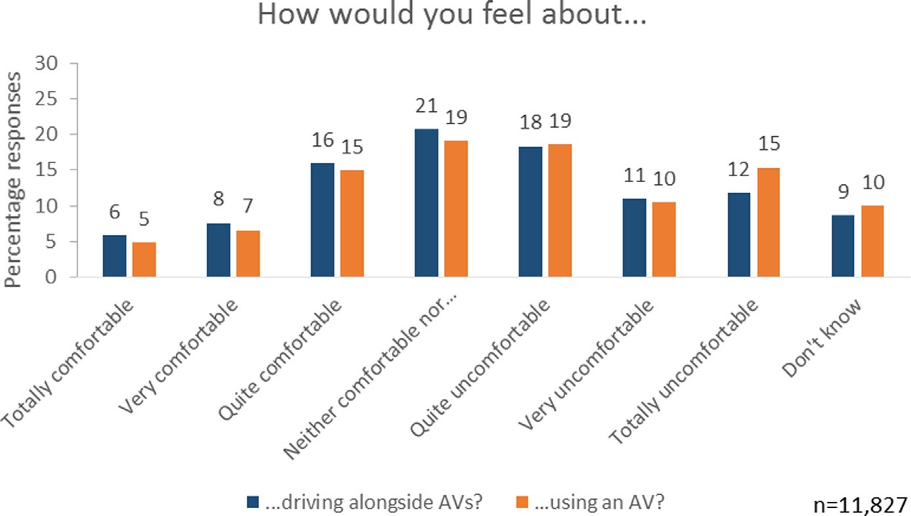

Fig. 1. Responses to summary questions about levels of comfort driving alongside AVs or using an AV (aggregated from 11 European countries).

Despite some variation in results, notably between surveys using 4 point response scales versus surveys using 7 point scales, there is a clear picture that more respondents expressed discomfort than comfort for both conditions, but discomfort with the prospect of ‘other AVs’ on the road was less marked.
Mindful of the possibility that anxieties about a new technology may be a function of its unfamiliarity (Allum, Sturgis, Tabourazi, & Brunton-Smith, 2008), we invited respondents to our main survey to reflect on their sentiments towards AVs at the end of the questionnaire, asking, ‘‘Having thought about autonomous cars by answering the questions in this sur- vey, how would you now say you feel.. .”, and repeating these two items relating to driving alongside or riding in AVs. Fig. 2 shows that distributions of responses changed little, but became slightly more positive, overall. Paired-samples t-tests (excluding Don’t Know responses and treating the variables as interval-level, with 1 denoting greatest discomfort and 7 greatest comfort) indicate increases in average levels of comfort for both scenarios, both significantly different from 0 with p < 0.001. For ‘driving alongside AVs’, the mean increased from 3.71 to 3.98, t = 24.5 (df = 10,421). For ‘using an AV’, the mean increased from 3.54 to 3.74, t = 22.0 (df = 10,249). These averages only give a rough indication of how people’s individual positions change. In relation to driving alongside AVs (and excluding from the base those saying ‘‘Don’t Know” to either question) 53% respondents gave the same response to both questions, 33% gave more positive responses and 14% more neg- ative responses. In relation to using AVs, 61% gave the same response to both questions, 26% gave a more positive responses and 13% a more negative response. Our last survey question asked, ‘‘how (if at all) have your opinions about autonomous cars changed since answering the questions in this survey?” We found nearly half of respondents (49%) said that their opinion hadn’t changed, 27% saying they felt they need more information to decide what they think, 20% saying they felt more pos- itive, and only 4% said they felt more negative.

  - Research question 2: how, if at all, do our survey respondents differentially rate the prospects of driving alongside AVs and riding in AVs?

For RQ2, comparing responses to the two scenarios of driving alongside and riding in AVs, the chart reveals these are very similar: indeed, responses to the two items are very strongly statistically associated with each other (treating the items as interval-level and excluding Don’t Know responses, Pearson’s correlation = 0.82; treating the items as nominal and including Don’t Know responses, chi-sq = 25121, df = 49, p < 0.001).

  - Research questions 3 & 4: relating a composite scale of perceptions of AVs with attitudes towards technology in general and towards the task of driving

Turning to RQ3: in our surveys these ‘comfort’ questions were followed by a set of statements that might represent pos- sible reasons for comfort/discomfort, and respondents were asked how much they agreed with these statements after each of the two questions about comfort, first driving alongside, then using an AV. The preamble to these statements was: ‘‘Thinking about your choice in the previous question, how much do you agree or disagree with the following statements?” In this sur- vey, respondents were first asked to think about the scenario of driving alongside an AV, and then about riding in an AV. We have documented elsewhere (Tennant et al., In preparation) the development of our Perceptions of AV (PAV) scale, based on these items, with a detailed discussion of the item functioning within the scale. The items in the scale are indicated in the annotated questionnaire in Appendix A, and Fig. 3 shows the distributions of responses to them.

Table 2
Responses to questions regarding comfort with AVs.

Comfort with the prospect of AVs |  | Euro-barometer | Authors | Authors | Euro-barometer | Authors | Authors
 |  | UK | UK | UK | 27 EU ex UK | 14 ex UK | 10 Eu ex UK
 |  | Dec-14 | Aug-15 | Jul-16 | Dec-14 | Aug-15 | Jul-16
Scale points |  | 10 | 4 | 7 | 10 | 4 | 7
Using an AV as passenger | Comfortable | 21% | 28% | 25% | 21% | 30% | 27%
 | ’Neither’ | 17% | 0% | 14% | 14% | 0% | 20%
 | Uncomfortable | 59% | 60% | 55% | 61% | 57% | 43%
 | Don’t know | 3% | 12% | 6% | 5% | 13% | 11%
N |  | 1,312 | 1,071 | 1,450 | 26,489 | 8,175 | 10,377
’Other’ AVs | Comfortable | 24% | 33% | 28% | 26% | 35% | 30%
 | ’Neither’ | 18% | 0% | 13% | 16% | 0% | 22%
 | Uncomfortable | 55% | 56% | 55% | 61% | 52% | 39%
 | Don’t Know | 3% | 10% | 4% | 5% | 13% | 9%
n |  | 1,311 | 1,071 | 1,450 | 26,491 | 8,175 | 10,377

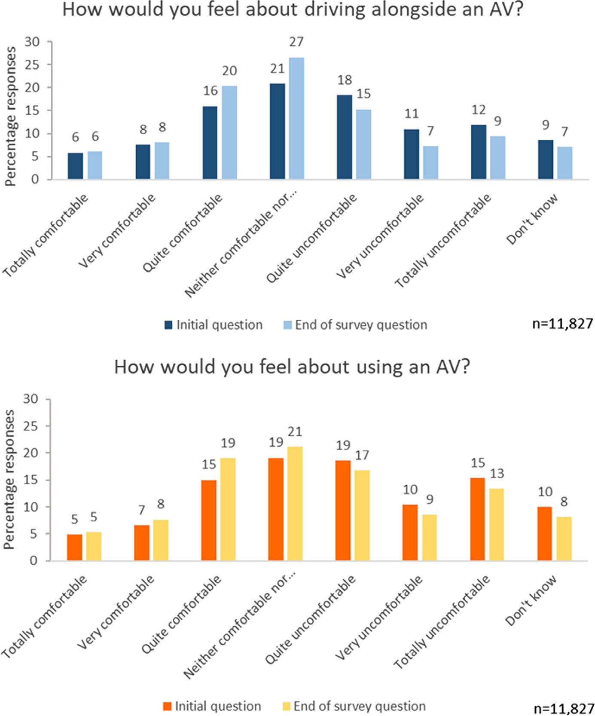

Fig. 2. Responses to summary questions about levels of comfort driving alongside AVs or using an AV, initially and later on in the survey (aggregated from 11 European countries).

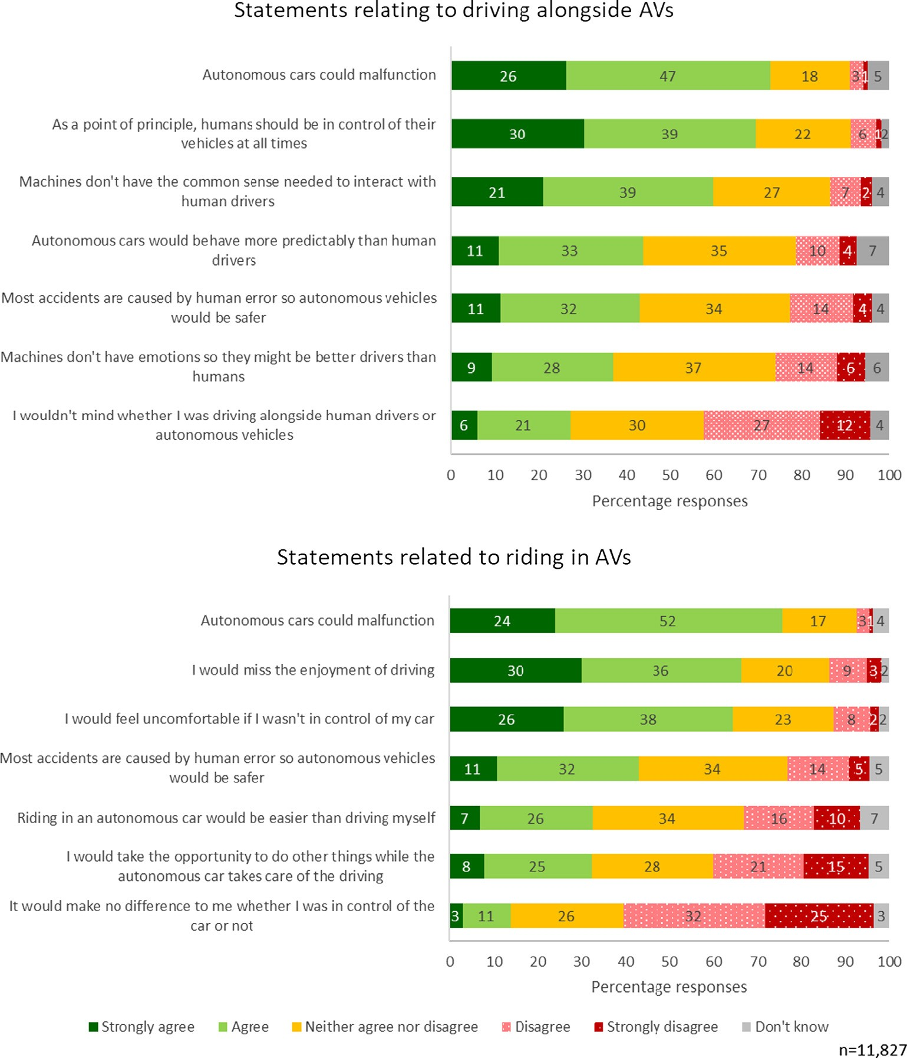

Fig. 3. Responses to PAV scale items (aggregated from 11 European countries).

Deploying the other scales described in the Methods section we then used linear regression models with our PAV scale as the response variable, and explanatory variables as indicated in the research questions. We provide summary data for all of the scales used in Table 3 below (the varying sample sizes are due to the fact that for some sets of items, a handful of respon- dents answered Don’t Know to every item, and thus could not be assigned a scale score).
Since the literature (e.g. Schoettle & Sivak, 2014a) identifies substantial cross-national differences in dispositions towards AVs we did not assume that we would see the same patterns of associations in different countries; we therefore ran these regression models separately within each country. The estimated coefficients for these models are presented in Table 4.
We explored the following socio-demographic variables: gender, age, typical annual driving distance, and relative amounts of driving time spent on different kinds of roads (motorways, main roads in cities or towns, smaller roads in towns and villages, rural country roads). The models revealed small but (conventionally) statistically significant differences in aver- age PAV scores between men and women, with men expressing slightly higher levels of enthusiasm towards AVs in all coun- tries except Italy. Age was negatively associated with more positive perceptions of AVs in some countries, but not others. The models suggested no notable differences in PAV scores between those who drive few or many kilometres over the course of a typical year. Similarly, there were no systematic associations for time spent driving on different types of roads.
In addition to these basic socio-demographic variables, we included measures of ‘technological optimism’ and ‘technol- ogy in the car’ as predictors, in order to address RQ3. In each of the eleven countries, both variables were positively partially

Table 3
Descriptive statistics for composite scales used in regression models.

Scale name | Cronbach’s alpha | Mean | Standard deviation | Min. | Max. | n
Perceptions of AVs (PAV) | 0.88 | 2.60 | 0.64 | 1 (sceptical) | 5 (enthusiastic) | 11,745
Technological optimism | 0.70 | 3.10 | 0.62 | 1 (low optimism) | 5 (high optimism) | 11,790
Use of technology in the car | 0.82 | 9.10 | 5.44 | 0 (low use/enthusiasm) | 30 (high use/enthusiasm) | 11,825
Enjoyment of driving | 0.71 | 3.70 | 0.99 | 1 (low enjoyment) | 5 (high enjoyment) | 11,825
Driving sociability | 0.69 | 4.00 | 0.48 | 2 (relatively unsociable) | 5 (relatively sociable) | 11,780

Table 4
Estimated regression coefficients for country-by-country linear regressions of PAV scores on socio-demographic variables, predispositions towards (advanced) technology, and sentiments towards driving.
Variable Belgium Czech Rep. France Germany Italy Netherlands Poland Serbia

Gender (ref: female) 0.195*** 0.147*** 0.131*** 0.212*** 0.077 0.156*** 0.115** 0.209*** Age (years) -0.005*** -0.002 -0.001 -0.002 -0.002 -0.002 0.001 -0.004**
Typical annual driving distance in km (ref: <5 k)

5–10 k -0.008 0.018 0.056*
10–20 k -0.008 -0.062 0.114
0.050 0.007 -0.021 0.026 0.016
0.066 0.075 -0.036 -0.021 -0.063

20–40 k -0.032 0.065 0.056 0.052 0.089 -0.071 -0.008 0.003
40 k+ 0.107 * -0.097 0.212 0.151 0.065 -0.028 0.039 0.152
Don’t know -0.214 -0.104 -0.039 0.057 -0.036 -0.051 -0.116 -0.113
Amount of time spent driving on these roads in a typical year (1 = none of my driving time, 5 = all of my driving time):
Motorways 0.001 -0.010 -0.014 -0.033 -0.002 0.049* 0.017 -0.020
Cities/towns -0.035 -0.025 0.032 -0.056** 0.023 -0.040 -0.028 -0.017
Town/village -0.021 -0.034 -0.010 0.023 -0.038 -0.010 -0.070** -0.029
Rural -0.023 0.001 -0.012 -0.036 0.065* 0.010 0.002 -0.020
Technological optimism 0.360*** 0.237*** 0.307*** 0.335*** 0.198*** 0.293*** 0.162*** 0.230*** Technology in car 0.015*** 0.018*** 0.016*** 0.021*** 0.025*** 0.013*** 0.016*** 0.021*** Enjoyment of driving 0.153*** 0.149*** 0.151*** 0.129*** 0.120*** 0.110*** 0.092*** 0.095*** Sociability 0.298*** 0.068 0.215*** 0.234*** 0.043 0.246*** 0.156*** 0.072
- - - - - - - -
- - - - - - - -
Constant 3.446*** 2.836*** 2.880*** 2.938*** 2.464*** 3.009*** 3.260*** 2.779*** R-squared 0.305 0.211 0.227 0.227 0.128 0.228 0.143 0.127
n 928 941 948 1421 931 950 827 937
Key:
* p < 0.05.
** p < 0.01.
*** p < 0.001

associated with PAV scores (and significantly at p < 0.001). In other words, those who expressed more positive attitudes towards new technology in general, and those who had or would have liked to have advanced technology features in their cars, tended to express more positive perceptions of AVs. Another element of current driving experience is enjoyment of driving. Our measure of ‘enjoyment of driving’ was negatively partially associated with PAV scores (again significantly at p < 0.001) in all countries.
Addressing RQ4, we included our ‘driving sociability’ variable in the models. Driving sociability was negatively partially associated with PAV scores (again significantly at p < 0.001) in all countries apart from in Czech Republic, Italy and Serbia. In other words, in most countries in our study, those for whom human interaction and cooperation was a salient aspect of driv- ing tend to be less enthusiastic about the prospect of AVs.
These results may appear intuitive. However, the associations between some of our scales are potentially counterintu- itive, and prompted us to test one more model modification. Table 5 gives correlations between the scales for the complete data set, pooled across countries for simplicity (country-by-country correlation tables are similar to this summary, correla-

Table 5
Correlations among attitude scale measures (pooled across countries).
Correlations PAV Technological optimism Enjoy driving Driving sociability Tech in car Perceptions of AVs (PAV) 1
Technological optimism 0.255** 1
Enjoyment of driving -0.174** 0.160** 1
Driving sociability -0.201** 0.133** 0.173** 1
Use of technology in car 0.238** 0.134** 0.020* -0.154** 1
** Correlation is significant at the 0.01 level (2-tailed).
* Correlation is significant at the 0.05 level (2-tailed).

tions having the same signs with only a few exceptions). It demonstrates, for example, that enjoyment of driving was only very weakly correlated with use of/desire for technology in the car, and it was positively correlated with driving sociability. Most remarkably, driving sociability was positively correlated with technological optimism. Since driving sociability and technological optimism have opposite-signed effects in our regression model, we developed the model further by including an interaction term for technological optimism and driving sociability.
For most countries in our study (other than Czech Republic, Serbia and Spain), levels of technological optimism attenu- ated the relationship between driving sociability and PAV scores (interaction terms significantly different from 0 at p < 0.05). In other words, higher levels of driving sociability were associated with lower PAV scores, but this relationship was weaker for those with higher technological optimism – optimism about technology flattened the effect of sociability on attitudes to PAV. Since the interpretation of the interaction is symmetrical, we could also say that the positive relationship between tech- nological optimism and enthusiasm for AVs was attenuated by driving sociability. Table 6 gives details of these models, and Fig. 4 shows for each country a set of estimated average PAV scores as technological optimism increases, for low levels of driving sociability (sociability = 2, the lowest observed score in the data set) through to the highest levels of driving socia- bility (sociability = 5). The figure illustrates the country-by-country variation in how the interaction plays out in practice. The slopes of the regression lines are clearly steeper and/or more varied in some countries than in others. The ‘whiskers’ in the plots, indicating the 95% confidence intervals around the predicted PAV scores for different levels of sociability, can be used to gauge for which levels of sociability the PAV scores are actually predicted to be significantly different from each other.
We conducted an additional exploration of the effects of driving sociability on sentiments towards AVs in one of our split ballot experiments (for British and German respondents). We were interested in whether giving respondents a preliminary set of items highlighting the social-interactive nature of driving would affect, or prime, their stated views on AVs. The results suggest not: we found no statistically significant differences in PAV scores between those respondents who answered the ‘sociability’ questions earlier or later in the questionnaire (two-tailed independent samples t-test returns t = 0.713, df = 2,917, p = 0.476), and moreover, no significant differences in sociability scale scores between these groups (t = 1.432, df = 2,918, p = 0.152).

  - Research question 5: do drivers anticipate interacting differently with AVs in an imagined interaction scenario?

Turning finally to RQ5, we asked respondents direct questions in the context of our vignettes about negotiating progress around a truck blocking the road.
Fig. 5 demonstrates that a clear majority of respondents said that if an AV was stuck behind an obstacle and they were travelling in the other direction on the free stretch of road, they would behave in just the same way as with any other car, and that only a small minority said that they would not help an autonomous car. In the reverse scenario where the AV was in the oncoming flow of traffic and respondent was imagined to be stuck behind the truck, few respondents felt that it would be easier for them to get around the truck.
Our split ballot experiment revealed small statistically significant differences on these items depending on the sequence in which they were seen. However, this may be a reflection of more general framing effects of imagined congestion, rather than related particularly to AVs. In vignette questions that did not involve AVs at all, we observed several significant effects which indicated that behaviours of reciprocity (if someone gives way to me I should give way to someone else later in return) were not systematic. Those presented first with the scenario of being stuck behind a truck then gave less sociable responses in the scenario where they were in the moving flow of traffic, compared to those who first imagined themselves in the mov- ing flow and then being blocked. Those who were first presented with the scenario of being in the moving flow of traffic went on to give more assertive responses when imagining themselves stuck behind the truck.
Fig. 6 demonstrates that in spite of their less positive perception of AVs, the more sociable drivers had a greater tendency to reject the idea that they wouldn’t help an AV compared to the ‘low sociable’ drivers, who were readier to say they would not help an AV (one-way ANOVA, F_{(3,10,448)} = 169.88, p < 0.01). This relative aversion to helping AVs may be a manifestation of more general combative driving orientations: the less sociable drivers had a greater tendency to say that they would behave differently towards AVs compared to other cars (F_{(3,11,070)} = 205.89,p < 0.01), and also to imagine that in the situation where they themselves were blocked by the truck they would expect it to be easier to get around the truck (F_{(3,10,398)} = 199.00,p < 0.01).

  - Results – summary

More respondents described themselves as uncomfortable with the prospect of AVs than comfortable, but there were also plenty of respondents describing themselves as neither or as ‘not knowing’. Standard demographic variables showed modest associations with attitudes towards AVs, measured by our PAV scale, but in some countries no associations. Positive views of new technology in general were associated with more favourable attitudes towards AVs, as were positive views of technical advances in conventional cars.
Driving is a social activity and our survey points to notable associations between respondents’ attitudes towards other drivers and their perceptions of AVs. In most of the countries we surveyed, respondents who presented themselves as more ‘sociable’ drivers tended to be less enthusiastic about AVs, and driving sociability attenuated the positive association between technological optimism and attitudes to AVs. Imagination of sharing the road with AVs in the absence of actual

Table 6
Estimated regression coefficients for country-by-country linear regressions of PAV scores on socio-demographic variables, predispositions towards (advanced) technology and sentiments towards driving, with an interaction between technological optimism and driving sociability.
Variable Belgium Czech Rep. France Germany Italy Netherlands Poland Serbia Spain Sweden UK

Gender (ref: female) 0.198*** 0.146*** 0.126*** 0.210*** 0.082 0.157*** 0.104** 0.210*** 0.133** 0.265*** 0.131*** Age (years) -0.005*** -0.002 -0.001 -0.002 -0.002 -0.002* 0.001 -0.004** -0.003* -0.006*** -0.002
Typical annual driving distance in km (ref: <5 k)
5–10 k 0.000 0.019 0.056 0.053 0.013 -0.023 0.027 0.018 -0.124* 0.041 0.026
10–20 k -0.002 -0.062 0.112* 0.070 0.076 -0.020 -0.021 -0.059 -0.110 -0.024 0.007

20–40 k -0.022 0.064 0.056 0.055 0.090 -0.049 -0.016 0.004 -0.124 0.087*
40 k+ 0.127 -0.099 0.208 0.155 0.078 -0.042 0.045 0.166 -0.033 0.295
-0.011
-0.066

Don’t know -0.216* -0.102 -0.039 0.062 -0.025 -0.035 -0.114 -0.112 -0.036 -0.076 -0.100
Amount of time spent driving on these roads in a typical year (1 = none of my driving time, 5 = all of my driving time):
Motorways 0.001 -0.008 -0.009 -0.031 -0.003 0.048* 0.020 -0.021 -0.015 -0.046 0.027
Cities/towns -0.037 -0.025 0.031 -0.056** 0.024 -0.040 -0.020 -0.018 -0.039 -0.018 -0.003
Town/village -0.017 -0.034 -0.007 0.018 -0.035 -0.014 -0.066** -0.030 -0.018 -0.014 0.012
Rural -0.029 0.000 -0.013 -0.034 0.064* 0.010 0.001 -0.020 -0.010 -0.067* -0.028
Technological optimism 0.222 0.516 0.310 0.481* 0.367 0.991*** 0.492* 0.137 0.168 0.424 0.749*** Technology in car 0.015*** 0.019*** 0.016*** 0.021*** 0.024*** 0.013*** 0.016*** 0.020*** 0.021*** 0.017*** 0.015*** Enjoyment of driving 0.153*** 0.149*** 0.150*** 0.128*** 0.120*** 0.112*** 0.092*** 0.096*** 0.101*** 0.150*** 0.167*** Sociability 0.726*** 0.130 0.661*** 0.830*** 0.482* 1.238*** 0.651*** 0.336 0.504* 0.669*** 1.106*** Interaction (tech opt, sociability) 0.144* 0.066 0.153* 0.197*** 0.140* 0.329*** 0.159** 0.087 0.100 0.159* 0.259*** Constant 5.176*** 2.005*** 4.669*** 5.402*** 4.233*** 6.893*** 5.275*** 3.900** 4.529*** 5.418*** 6.549*** R-squared 0.308 0.212 0.231 0.234 0.132 0.246 0.151 0.128 0.154 0.240 0.254
-
- - - - - - -
- - - - - - - - - -
- - - - - - - - - - -
n 928 941 948 1,421 931 950 827 937 952 953 1,387
Key:
* p < 0.05.
** p < 0.01.
*** p < 0.001.

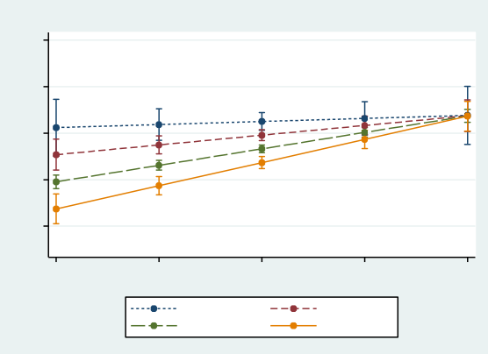
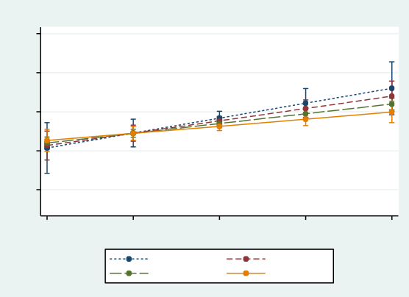
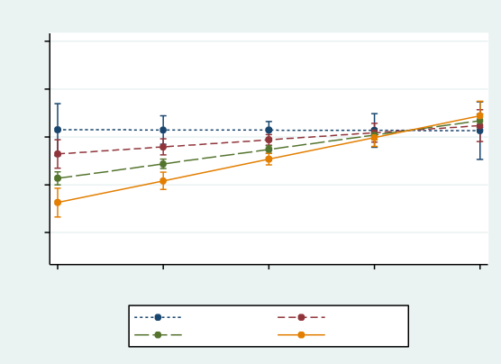
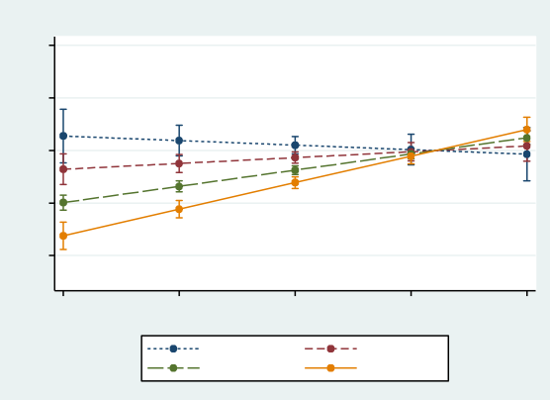
4
3
2
4
3
2
4
3
2
4
3
2
Predicted PAV score 2 3 4
Predicted PAV score 2 3 4
5
1
5
1
5
Predicted PAV score 2 3 4
Predicted PAV score 2 3 4
5
1
5
1
5
Belgium
Czech Republic

1
Scale of technological optimism (higher values = more optimistic)
5
1
Scale of technological optimism (higher values = more optimistic)
5

sociability=2 sociability=4
sociability=3 sociability=5
sociability=2 sociability=4
sociability=3 sociability=5
France
Germany

1
Scale of technological optimism (higher values = more optimistic)
5
1
Scale of technological optimism (higher values = more optimistic)
5

sociability=2 sociability=4
sociability=3 sociability=5
sociability=2 sociability=4
sociability=3 sociability=5
Italy
Netherlands

1
Scale of technological optimism (higher values = more optimistic)
5
1
Scale of technological optimism (higher values = more optimistic)
5

sociability=2 sociability=4
sociability=3 sociability=5
sociability=2 sociability=4
sociability=3 sociability=5

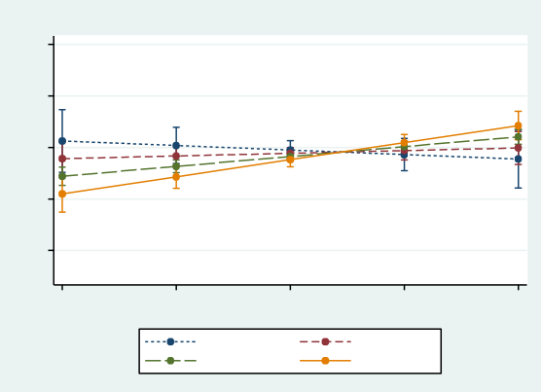
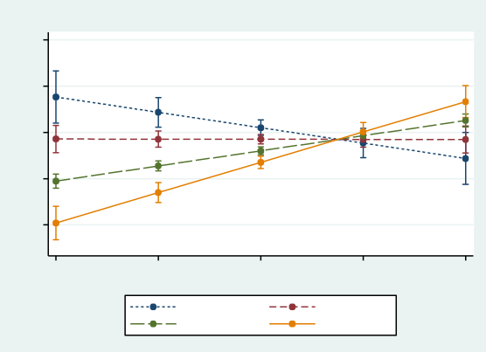
Fig. 4. Fitted values (predicted PAV scores) from the models in Table 6 (with values of other explanatory variables set at: gender = male, age = 48, typical annual driving distance = between 10,000 and 19,999 km; a little driving time on motorways; a fair amount of driving time in cities/large towns; a fair amount of driving time in small towns/villages; a little driving time in the countryside); 95% confidence intervals indicated by whiskers at each integer value of the sociability score.
4
3
2
4
3
2
Predicted PAV score 1 2 3 4
Predicted PAV score 1 2 3 4
experience was anchored in experience of interactions with human-driven vehicles, defaulting to the assumption that inter- acting with AVs will be similar.

- Discussion

  - Comparison with previous survey research

The broad finding that more respondents are uncomfortable than comfortable with the prospect of AVs is consistent with previous research (e.g. European Commission, 2015, 2017). Many of the more detailed results, e.g. men expressing more pos- itive views than women, are also consistent with the literature (Hohenberger, Spörrle, & Welpe, 2016; Hulse, Xie, & Galea, 2018). Similarly, that those who enjoy driving are less positive about AVs was remarked upon as early as in KPMG (2013):

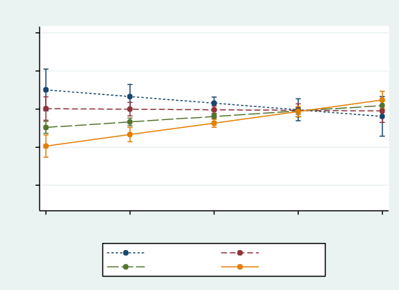
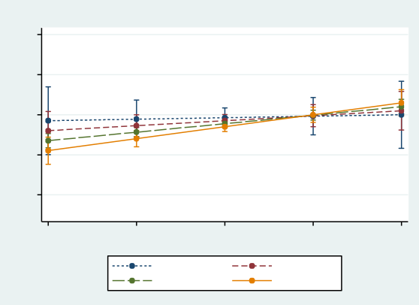
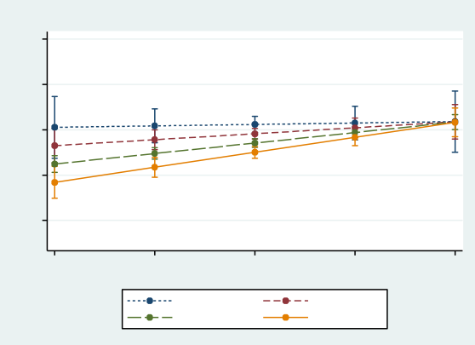
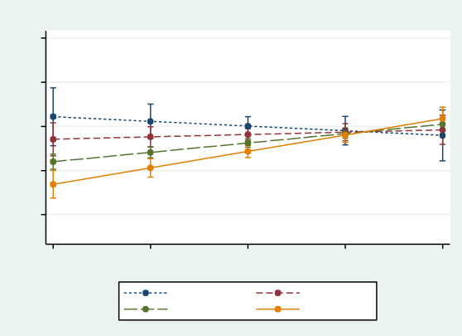
4
3
2
4
3
2
4
3
2
4
3
2
Predicted PAV score 1 2 3 4
Predicted PAV score 2 3 4
5
5
1
5
Predicted PAV score 1 2 3 4
Predicted PAV score 2 3 4
5
1
5
Poland
Serbia

1
Scale of technological optimism (higher values = more optimistic)
5
1
Scale of technological optimism (higher values = more optimistic)
5

sociability=2 sociability=4
sociability=3 sociability=5
sociability=2 sociability=4
sociability=3 sociability=5
Spain
Sweden

1
Scale of technological optimism (higher values = more optimistic)
5
1
Scale of technological optimism (higher values = more optimistic)
5

sociability=2 sociability=4
sociability=3 sociability=5
sociability=2 sociability=4
sociability=3 sociability=5
UK

1
Scale of technological optimism (higher values = more optimistic)
5

sociability=2 sociability=4
sociability=3 sociability=5

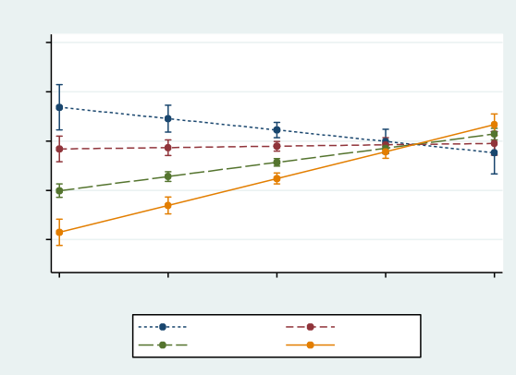
Fig. 4 (continued)
4
3
2
Predicted PAV score 1 2 3 4

intuitively, we would expect those who enjoy driving to baulk at the prospect of relinquishing control of the vehicle (Fraedrich et al., 2016).
In Section 7.4 we reported the finding that less sociable respondents described themselves as less likely to help an AV than more sociable respondents, and also more likely to treat AVs differently from traditional vehicles, with the implication that they might take advantage of AVs. These findings are consistent with suggestions that some people may drive more aggressively towards AVs (e.g. Cohen, Jones, & Cavoli, 2017), and warrants further research.

  - Novel technological objects

The theoretical literature encourages the expectation that members of the public will make sense of AVs by relating them to their experience of the road today, and to their views on new technologies generally. Our survey results suggest that both of these are playing a part in how the public makes sense of AV technology. It may be that expressions of unease simply

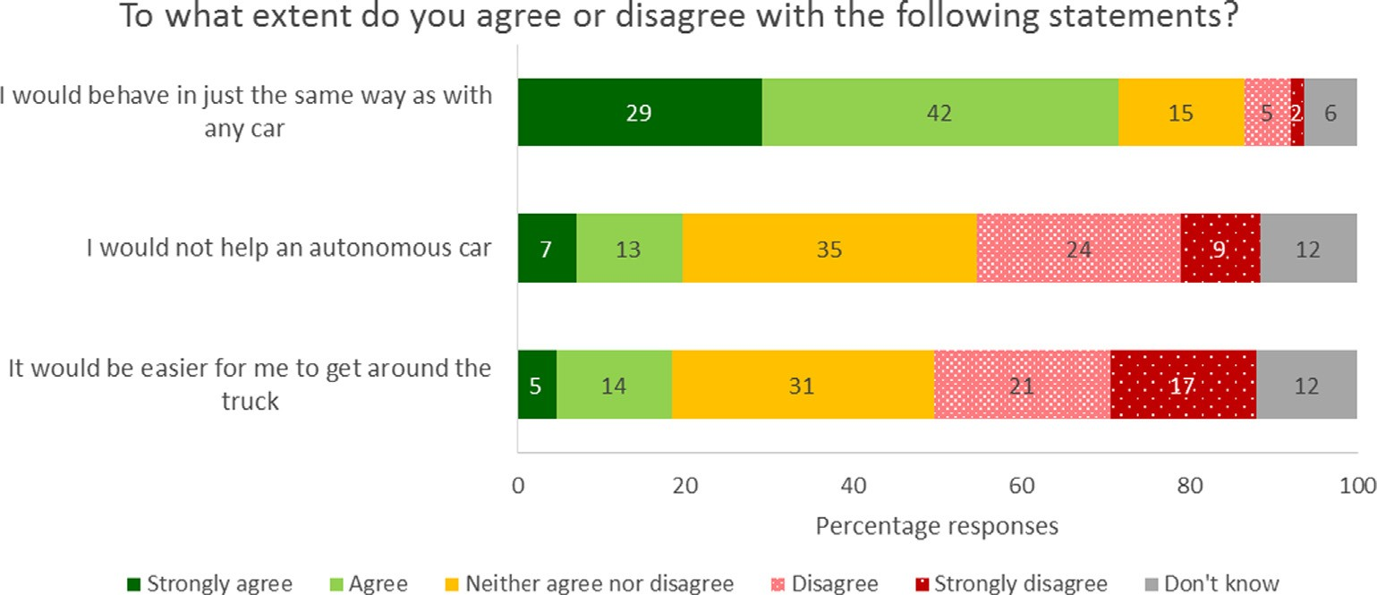

Fig. 5. Selected responses to vignette questions about negotiating passage around an obstacle in the road (aggregated from 11 European countries).

Fig. 6. Responses to vignette questions about negotiating passage around an obstacle in the road, by sociability quartile (aggregated from 11 European countries).
Driving sociability quartile
Highest
Mid-high
Low-mid
Lowest
1
2
I would not help an autonomous car

It would be easier for me to get around the truck
3
I would behave in just the same way as with any car
4
5
To what extent do you agree with the following statements?
Mean agreement with statement (1=strongly disagree, 5=strongly agree

reflect the fact that AVs are not part of the road of today and so are unfamiliar: but having asked respondents to think about the prospect, and to imagine themselves interacting with AVs on the road in a typical driving scenario, the level of discomfort they express was slightly reduced.
These findings might lend support to the idea that public unease will dissipate as people become more familiar with the technology, although this interpretation is speculative. Some existing survey research takes for granted the arrival of AVs, and seeks to understand resistance to the technology in order to ‘overcome’ it (e.g. König & Neumayr, 2017, p. 45) or pro- poses public education with a view to facilitating AV introduction (e.g. Sanbonmatsu, Strayer, Yu, Biondi, & Cooper, 2018). But it is worth stressing that the promise of AV technology is precisely that AVs will drive better than, and so differ- ently from, human drivers. If members of the public become comfortable with novel technological objects, such as AVs, by fitting them into their pre-existing understanding of the road, then it might be easier if they do fit in to the public’s idea of the road. On this understanding of how the public make sense of new technology, promising a ‘revolution’ (e.g. The Economist, 2016) may provoke resistance. Systems theorists emphasise the need for collaborating with the public (Epprecht, von Wirth, Stünzi, & Blumer, 2014) as an alternative to overcoming resistance.
The findings from the driving vignettes also encourage further investigation. Respondents more likely to act co-operatively towards AVs on the road (because higher in driving sociability) were on average less positive about their introduction, while those more positive towards AVs as a prospect include respondents more likely to take advantage of

AVs, presumably on the expectation that they will be risk-averse. These issues suggest that it will be important to track how public attitudes towards sharing the road with AVs evolve, as expectations are replaced by actual experiences.

  - Data quality limitations

We noted in Section 6.3 that there are unavoidable limitations regarding the quality of data yielded by online panel sur- veys, but we also recorded the steps we took to mitigate these issues. We discuss below a few residual limitations.
We reported in Section 7.2 that comfort with driving alongside AVs was very closely correlated with comfort with riding in AVs. It is possible that the answer to the first question influences the answer to the second, either because introducing the idea of driving alongside first primes a different framing compared to asking about riding in an AV first, or because respon- dents wish to present a consistent overall response to the issue. However, it is also possible that respondents simply do not differentiate strongly between the two different scenarios – further research is needed to investigate this.
We noted the challenge of introducing the topic of AVs to survey respondents and the risk of priming respondent atti- tudes towards AVs with the framing adopted. Whilst we consider the framing used in this survey to be a reasonably neutral presentation, the content still suggests that AVs are a natural progression of increasing levels of automation. Even the term to designate the AV in the survey may have priming effects. We used more than one term for the AV in our survey, and it is possible that respondents may not consider these to be the same thing, which might impact the validity of our findings. Additional studies are required to research whether briefings for AV attitude surveys, and the terminology adopted, influence respondents’ answers significantly.
Since we introduced a particular focus on driving sociability, and expectations of what it would be like to drive alongside AVs, we conducted an experiment to test whether our questions about driving sociability might prime responses to the AV questions. The results indicate not. Following the same logic it is possible that our questions about attitudes to technology in general might prime responses about AV technology specifically, but we did not have the capacity to test for this in addition: further research would be necessary to rule this out.
Based on the between-country variations reported in the literature, we were unwilling to aggregate our detailed regres- sion results and provided regressions for each of the 11 different countries surveyed. The variation in salience of the regres- sion coefficients between different countries, particularly noticeable with driving sociability, warrants further investigation. This would have been beyond the scope of this paper and without additional data we could only have speculated as to the underlying factors.

  - Future survey research.

We identified some of the difficulties in researching attitudes towards AVs in so far as they are novel technological objects. Some of these, such as the problem of briefing without priming respondents, can only be mitigated by due care rather than wholly avoided; others, such as the trade-off between expensive probability samples and affordable panel or convenience samples are common to all survey research.
Tracking trends in public sentiment as the technology emerges on the roads will be necessary, and requires a firm research design foundation. Elsewhere we describe the development of our PAV scale to enable such a tracking exercise specifically for drivers, combining both perceptions of using AVs and sharing the road with them (Tennant et al., In preparation). Alternative scales should also be considered, both for drivers and for other user and non-user groups (for exam- ple, pedestrians, cyclists, transport sector workers). Some have been developed building on the measures of usefulness and satisfaction proposed by Van Der Laan et al. (1997), and on the broader UTAUT scale (Venkatesh et al., 2003) that incorpo- rates social influence and effort expectancy. In particular these have been used already in mobility scheme acceptance stud- ies (Fujitsu, 2017; Madigan et al., 2017; Nordhoff, van Arem, & Happee, 2016). Necessarily these emphasise the users’ experience rather than incorporating that of non-users exposed to the technology. Our survey suggests that, without such exposure, respondents do not discriminate between the idea of using and the idea of sharing the road with AVs. This may change once the public encounter AVs on the road and the factors driving users’ attitudes and non-users’ attitudes may diverge. Further, existing measures were originally conceived to assess acceptance of incremental driver assistance systems, whereas AVs promise eventual elimination of the driver: the driver’s response to this may go beyond considerations of use- fulness and satisfaction. A broader measure of public sentiment is likely to be needed in due course.
Our results point to a role for general attitudes to technology as well as general attitudes towards the task of driving, but not yet for expectations of what it will be like to share the road with AVs. Attitudes to AVs, as novel technological objects, are hard to pin down. There is uncertainty over the economic models to be adopted, which makes the target dependent variable unclear. Levels of knowledge of, and experiential exposure to AVs will change and this is likely to change which independent variables are salient in future models. Nevertheless we believe that it is possible to construct a firmer foundation for measurement.
Our review of the survey literature prompts us to invite researchers:

To pay due attention to possible framing effects arising from the naming of the attitude object, descriptions of the tech- nology and the sequencing of questions.
•
To record steps taken to ensure that the attitude object is clearly defined for respondents, since such steps may well cre- ate framing.
•

To record quality control steps taken, in particular for online panel surveys which are increasingly used as cost-effective alternatives to traditional probability samples.
•
To give full prominence to the limitations of scope of each study.
•
Where general measures of public sentiment towards AVs are reported, these should be benchmarked against the avail- able literature to contribute to more transparent development of knowledge of this field. In other words, where results show deviations from the general trends of other research, researchers should discuss whether these deviations reflect (a) genuine shifts in broad public sentiment, (b) temporary contextual factors, (c) sampling factors or (d) artefactual conse- quences of survey instrument design.
•

- Conclusion

Policy makers see public concern as a significant obstacle to the successful introduction of AVs. Academic survey research has tended to focus on willingness to use or purchase, and the methods adopted have sometimes understated the wide- spread public anxieties about the technology, while the wider survey literature presents a fairly consistent picture of more respondents expressing negative than positive sentiments. Respondents to our own survey of drivers provide a further set of evidence supporting this general conclusion. Our respondents do not yet demonstrate separate attitudes towards the pro- spect of riding in an AV and that of sharing the road with other AVs. Our evidence suggests that many drivers expect that they would interact with AVs on the road in the same way in which they interact with human-driven vehicles. This is par- ticularly true of those who take a more ‘sociable’ approach to driving as an activity that necessitates cooperation with fellow road-users, despite the fact that these ‘more sociable’ drivers tend to be less enthusiastic about the prospect of AVs in gen- eral. The negative relationship between driving sociability and enthusiasm for AVs is attenuated by enthusiasm for technol- ogy, and we also observe that those who enjoy driving as an activity tend to be less enthusiastic about AVs. Current plans and forecasts for the development of AVs suggest that for many people, early experiences of the technology will take the form of encounters with other AVs on the road, and we propose that to understand the evolution of public sentiments to AVs, researchers need to broaden their scope of study to incorporate, and differentiate between, different forms of exposure to AVs.

Acknowledgements

Funding for the data collection was provided by a commercial company, Goodyear Tyre and Rubber Company. The ques- tion set was developed in collaboration with the company, and as noted the selection of countries surveyed within the EU was determined by the company’s market interests. The terms of engagement required the company to respect the academic independence of the authors. Surveys are constrained by respondent attention span: keeping the survey to a manageable length requires a negotiation between stakeholders as to which questions are included and which left out. The authors are satisfied that the complete question set includes the material required for the research presented here, and that the response quality is not compromised by inclusion of a limited number of questions proposed by Goodyear. The company has had no role in the preparation of this paper and there was no obligation to seek their involvement or approval of research utilising the data subsequent to conclusion of the original project.
We gratefully acknowledge the help of the editor and the comments of two anonymous referees which have substantially improved the paper.

Appendix A. Supplementary material

Supplementary data to this article can be found online at https://doi.org/10.1016/j.trf.2019.04.017.

References

AAA (2017). Americans feel unsafe sharing the road with fully self-driving cars. Retrieved from http://newsroom.aaa.com/2017/03/americans-feel-unsafe- sharing-road-fully-self-driving-cars/ (July 13, 2017).
Adrian Flux (2015). Would you own a driverless car? Retrieved from https://www.adrianflux.co.uk/driverless-cars/would-you-own-a-driverless-car/ (September 18, 2016).
Allum, N., Sturgis, P., Tabourazi, D., & Brunton-Smith, I. (2008). Science knowledge and attitudes across cultures: a mtea-analysis. Public Understanding of Science, 17(1), 35–54.
Tennant, C., Stares, S., Howard, S., Franks, B., Hall, M., Bauer, M. (2015). The Ripple Effect of Drivers’ Behaviour on the Road: A study on drivers’ behaviour Retrieved from http://www.goodyear.eu/corporate_emea/images/3.12.2015%20-%20Executive%20Summary%20-%20FINAL_tcm2447-180821.pdf.
Tennant, C., Stares, S., Howard, S., Hall, M., Franks, B., Bauer, M. (2015). Research Project on Driver Behaviour: Report submitted by LSE Enterprise to Goodyear London: London School of Economics.
Tennant, C., Howard, S., Franks, B., Stares, S. (In preparation). Putting drivers back into the picture: understanding drivers’ resistance to being automated. In preparation.
Axa (2016). With the first driverless taxis soon available1, Brits think driverless will be more popular than Pokemon Go! Technology. Retrieved from http:// www.axa.co.uk/newsroom/media-releases/2016/brits-think-driverless-will-be-more-popular-than-pokemon-go/ (January 30, 2017).
Bansal, P., & Kockelman, K. M. (2017). Forecasting Americans’ long-term adoption of connected and autonomous vehicle technologies. Transportation Research Part A: Policy and Practice, 95, 49–63. https://doi.org/10.1016/j.tra.2016.10.013.
Bansal, P., Kockelman, K. M., & Singh, A. (2016). Assessing public opinions of and interest in new vehicle technologies: An Austin perspective. Transportation Research Part C: Emerging Technologies, 67, 1–14. https://doi.org/10.1016/j.trc.2016.01.019.

Bauer, M. (2015). Atoms, bytes and genes: Public resistance and techno-scientific responses. New York: Routledge.
Becker, F., & Axhausen, K. W. (2017). Literature review on surveys investigating the acceptance of automated vehicles. Transportation, 44(6), 1293–1306. https://doi.org/10.1007/s11116-017-9808-9.
Boersma, R., Poortvliet, P. M., & Gremmen, B. (2018). The elephant in the room: How a technology’s name affects its interpretation. Public Understanding of Science, 0963662518812295. https://doi.org/10.1177/0963662518812295.
Bonnefon, J.-F., Shariff, A. F., & Rahwan, I. (2016). The social dilemma of autonomous vehicles. Science, 352(6293), 1573–1576. Callegaro, M. (2014). Online panel research: A data quality perspective. Chichester: Wiley.
Cohen, T., Jones, P., & Cavoli, C. (2017). Social and behavioural questions associated with automated vehicles. Scoping study by UCL Transport Institute. Final Report. Retrieved from https://assets.publishing.service.gov.uk/government/uploads/system/uploads/attachment_data/file/585545/social-and- behavioural-questions-associated-with-automated-vehicles-final-report.pdf (January 13, 2017).
Cohen, T., Jones, P., Cavoli, C., & Phillips, B. (2017). Social and behavioural questions associated with automated vehicles: A literature review. Retrieved from https://www.gov.uk/government/publications/social-and-behavioural-questions-associated-with-automated-vehicles (January 13, 2017).
Continental (2017). Driverless cars – The road to nowhere? Retrieved from https://www.continental-tyres.co.uk/car/media-services/newsroom/driverless- cars-road-to-nowhere (January 24, 2018).
Coop, & ICM (2016). Fifth of young drivers believe driverless cars will enable them to drink and drive. Retrieved from https://www.co- operative.coop/media/news-releases/fifth-of-young-drivers-believe-driverless-cars-will-enable-them-to-drink-and-drive (September 19, 2016).
Cyganski, R., Fraedrich, E., & Lenz, B. (2014). Travel-time valuation for automated driving: A use-case-driven study. Paper presented at the Transportation Research Board 94th annual meeting, Washington D.C.
Daziano, R. A., Sarrias, M., & Leard, B. (2017). Are consumers willing to pay to let cars drive for them? Analyzing response to autonomous vehicles.
Transportation Research Part C: Emerging Technologies, 78, 150–164. https://doi.org/10.1016/j.trc.2017.03.003.
De Witt, A., Osseweijer, P., & Pierce, R. (2015). Understanding public perceptions of biotechnology through the ‘‘Integrative Worldview Framework”. Public Understanding of Science, 26(1), 70–88. https://doi.org/10.1177/0963662515592364.
Deb, S., Strawderman, L., Carruth, D. W., DuBien, J., Smith, B., & Garrison, T. M. (2017). Development and validation of a questionnaire to assess pedestrian receptivity toward fully autonomous vehicles. Transportation Research Part C: Emerging Technologies, 84, 178–195. https://doi.org/10.1016/j. trc.2017.08.029.
Deloitte, Giffi, C. A., Vitale, J. J., Robinson, R., & Pingitore, G. (2017). The race to autonomous driving: Winning American consumers’ trust. Retrieved from https://www2.deloitte.com/content/dam/insights/us/articles/3565_Race-to-autonomous-driving/DR20_The%20race%20to%20autonomous%20driving_ reprint.pdf (May 4, 2018).
Deloitte, Giffi, C. A., Vitale, J. J., Schiller, T., & Robinson, R. (2018). A reality check on advanced vehicle technologies: Evaluating the big bets being made on autonomous and electric vehicles. Retrieved from https://www2.deloitte.com/insights/us/en/industry/automotive/advanced-vehicle-technologies- autonomous-electric-vehicles.html (May 4, 2018).
Direct Line Group (2016). The car of the future: Where we’re going we probably do need roads. Retrieved from http://www.directlinegroup.com/media/ news/brand/2016/30122016.aspx (January 30, 2017).
Duveen, G., & Lloyd, B. (1990). Social representations and the development of knowledge. Cambridge, UK: Cambridge University Press. Ellson, A. (2018). Driverless car? Not for me thanks, say most motorists. The Times.
Epprecht, N., von Wirth, T., Stünzi, C., & Blumer, Y. B. (2014). Anticipating transitions beyond the current mobility regimes: How acceptability matters.
Futures, 60, 30–40.
Ernst, C.-P. H., & Reinelt, P. (2017). Autonomous car acceptance: Safety vs personal driving enjoyment. Paper presented at the Twenty-third Americas Conference on Information Systems, Boston.
European Commission (2015). Special Eurobarometer 427: Autonomous systems. Retrieved from http://ec.europa.eu/commfrontoffice/publicopinion/ archives/ebs/ebs_427_en.pdf (February 2, 2016).
European Commission (2017). Special Eurobarometer 460: Attitudes towards the impact of digitisation and automation on daily life. Retrieved from http:// ec.europa.eu/commfrontoffice/publicopinion/index.cfm/Survey/getSurveyDetail/instruments/SPECIAL/surveyKy/2160 (July 7, 2017).
Fleury, S., Tom, A., Jamet, E., & Colas-Maheux, E. (2017). What drives corporate carsharing acceptance? A French case study. Transportation Research Part F: Traffic Psychology and Behaviour, 45, 218–227. https://doi.org/10.1016/j.trf.2016.12.004.
Ford, & PRNewswire (2016). Sit back and enjoy the view! Survey shows self-driving cars could make you happier – And maybe give up the school run (January 30, 2017).
Ford (2016). Ford targets fully autonomous vehicle for ride sharing in 2021. Retrieved from https://media.ford.com/content/fordmedia/fna/us/en/news/ 2016/08/16/ford-targets-fully-autonomous-vehicle-for-ride-sharing-in-2021.html (March 1, 2017).
Fraedrich, E., Cyganski, R., Wolf, I., Lenz, B. (2016). User Perspectives on Autonomous Driving. A Use-Case-Driven Study in Germany Retrieved from https:// www.geographie.hu-berlin.de/de/institut/publikationsreihen/arbeitsberichte/download/Arbeitsberichte_Heft_187.pdf. Jaunary 26, 2018.
Fujitsu (2017). Technology in a transforming Britain. Retrieved from http://www.fujitsu.com/uk/news/pr/2017/fs-20171128.html (February 5, 2018). Gaskell, G., Eyck, T. T., Jackson, J., & Veltri, G. (2005). Imagining nanotechnology: Cultural support for technological innovation in Europe and the United
States. Public Understanding of Science, 14(1), 81–90. https://doi.org/10.1177/0963662505048949.
Gaskell, G., Stares, S., Allansdottir, A., Allum, N., Castro, P., & Jackson, J. (2010). Europeans and biotechnology in 2010: Winds of change? Publications Office of the European Union.
Gkartzonikas, C., & Gkritza, K. (2017). A literature review on surveys for autonomous vehicles. West Lafayette: Lyles School of Civil Engineering and Agricultural & Biological Engineering, Purdue University.
Goodyear EMEA, & ThinkYoung (2015). ThinkGoodMobility: Millenials views on the future of mobility in Europe. Retrieved from http:// www.thinkgoodmobility.goodyear.eu/the-survey (September 20, 2016).
Greene, J. D. (2016). Our driverless dilemma: when should you car be willing to kill you? Science, 352(6293), 1514–1515.
Grunert, K. G., Bredahl, L., & Scholderer, J. (2003). Four questions on European consumers’ attitudes toward the use of genetic modification in food production. Innovative Food Science & Emerging Technologies, 4(4), 435–445. https://doi.org/10.1016/S1466-8564(03)00035-3.
Haboucha, C. J., Ishaq, R., & Shiftan, Y. (2017). User preferences regarding autonomous vehicles. Transportation Research Part C: Emerging Technologies, 78,
37–49. https://doi.org/10.1016/j.trc.2017.01.010.
Hohenberger, C., Spörrle, M., & Welpe, I. M. (2016). How and why do men and women differ in their willingness to use automated cars? The influence of emotions across different age groups. Transportation Research Part A: Policy and Practice, 94, 374–385. https://doi.org/10.1016/j.tra.2016.09.022.
Höijer, B. (2010). Emotional anchoring and objectification in the media reporting on climate change. Public Understanding of Science, 19(6), 717–731. https:// doi.org/10.1177/0963662509348863.
Hulse, L. M., Xie, H., & Galea, E. R. (2018). Perceptions of autonomous vehicles: Relationships with road users, risk, gender and age. Safety Science, 102, 1–13. https://doi.org/10.1016/j.ssci.2017.10.001.
Hyde, S., Dalton, P., & Stevens, A. (2017). Attitudes to autonomous vehicles. Retrieved from https://trl.co.uk/reports/attitudes-autonomous-vehicles (January 18, 2018).
IAM Roadsmart (2016). Motorists want the right to drive. Retrieved from https://www.iamroadsmart.com/media-and-policy/newsroom/news-details/ 2016/04/28/motorists-want-the-right-to-drive (16 September 2016)
Institute of the Motor Industry (2017). Over half of Brits fear their car could be accessed and controlled by a hacker. Retrieved from https://www.theimi.org. uk/news/over-half-brits-fear-their-car-could-be-accessed-and-controlled-hacker (January 24, 2018).
Institution of Mechanical Engineers (2017). Public perceptions: Driverless cars. Retrieved from https://www.imeche.org/docs/default-source/1-oscar/ reports-policy-statements-and-documents/imeche-driverless-car-cs.pdf?sfvrsn=2.

Kennedys (2017). Driverless vehicles: Innovation to revolutionise the way we transport modern societies. Retrieved from http://www.kennedyslaw.com/ news/only-44-percent-of-uk-adults-back-driverless-cars-on-uk-roads-kennedys-survey-reveals/ (January 16, 2018).
Kockelman, K., Boyles, S., Stone, P., Fagnanat, D., Patel, R., Levin, M., .. . Li, J. (2017). An assessment of autonomous vehicles: Traffic impacts and infrastructure needs—Final report. Retrieved from https://library.ctr.utexas.edu/ctr-publications/0-6847-1.pdf.
König, M., & Neumayr, L. (2017). Users’ resistance towards radical innovations: The case of the self-driving car. Transportation Research Part F: Traffic Psychology and Behaviour, 44, 42–52. https://doi.org/10.1016/j.trf.2016.10.013.
KPMG. (2013). Self-Driving Cars: Are We Ready? Retrieved from https://www.kpmg.com/US/en/IssuesAndInsights/ArticlesPublications/Documents/self- driving-cars-are-we-ready.pdf 23 March 2016.
Krosnick, J., & Presser, S. (2010). Question and questionnaire design. In J. Wright & P. Marsden (Eds.), Handbook of Survey Research (2nd ed.. San Diego, CA: Elsevier.
Krueger, R., Rashidi, T. H., & Rose, J. M. (2016). Preferences for shared autonomous vehicles. Transportation Research Part C: Emerging Technologies, 69, 343–355. https://doi.org/10.1016/j.trc.2016.06.015.
Kyriakidis, M., Happee, R., & de Winter, J. C. F. (2015). Public opinion on automated driving: Results of an international questionnaire among 5000 respondents. Transportation Research Part F: Traffic Psychology and Behaviour, 32, 127–140. https://doi.org/10.1016/j.trf.2015.04.014.
Langdon, P., & Ruggeri, K. (2017). UK autodrive population attitudes survey: Technical report. Retrieved from http://www.ukautodrive.com/downloads/ (November 29, 2017).
Lee, C.-J., Scheufele, D. A., & Lewenstein, B. V. (2005). Public attitudes toward emerging technologies: Examining the interactive effects of cognitions and affect on public attitudes to nanotechnology. Science Communication, 27(2), 240–267.
Lustgarten, P., & Le Vine, S. (2018). Public priorities and consumer preferences for selected attributes of automated vehicles. Journal of Modern
Transportation, 26(1), 72–79. https://doi.org/10.1007/s40534-017-0147-5.
Madigan, R., Louw, T., Wilbrink, M., Schieben, A., & Merat, N. (2017). What influences the decision to use automated public transport? Using UTAUT to understand public acceptance of automated road transport systems. Transportation Research Part F: Traffic Psychology and Behaviour, 50, 55–64. https:// doi.org/10.1016/j.trf.2017.07.007.
Mazda, & Ipsos Loyalty (2017). Mazda driver project: Research into consumers’ views on the future of driving. Retrieved from https://www.mazda- press.com/uk/news/2017/seventy-one-per-cent-of-british-drivers-still-want-to-be-able-to-drive-even-if-self-driving-cars-become-commonplace/.
Milne, R., & Hook, L. (2016). Volvo joins Uber in race for self-driving taxi service; Pair close to testing autonomous fleet Project gains edge on Google and Ford. Financial Times https://www.ft.com/content/736b1f1c-6534-11e6-8310-ecf0bddad227.
Moscovici, S. (2007). Psychoanalysis: Its image and its public. Cambridge: Polity.
Nissan Europe (2016). The Nissan social index: Consumer attitudes to autonomous drive. Retrieved from https://newsroom.nissan-europe.com/uk/en- gb/media/pressreleases/426167777/british-drivers-think-self-driving-cars-will-deliver-most-benefit-to-the-disabled-and-the-elderly.
Nordhoff, S., van Arem, B., & Happee, R. (2016). A conceptual model to explain, predict, and improve user acceptance of driverless. Paper presented at the 95th annual meeting of the Transportation Research Board, Washington.
Observer/Opinium, & Adams, T. (2015). Self-driving cars: from 2020 you will become a permanent backseat driver. Retrieved from http://www. theguardian.com/technology/2015/sep/13/self-driving-cars-bmw-google-2020-driving (6 October 2015).
Owens, J. M., Antin, J. F., Doerzaph, Z., & Willis, S. (2015). Cross-generational acceptance of and interest in advanced vehicle technologies: A nationwide survey. Transportation Research Part F: Traffic Psychology and Behaviour, 35, 139–151. https://doi.org/10.1016/j.trf.2015.10.020.
Payre, W., Cestac, J., & Delhomme, P. (2014). Intention to use a fully automated car: Attitudes and a priori acceptability. Transportation Research Part F: Traffic Psychology and Behaviour, 27, Part B, 252–263. https://doi.org/10.1016/j.trf.2014.04.009.
RAC Press Centre (2017). Motorists sceptical driverless cars will be commonplace in 20 years’ time. Retrieved from https://www.rac.co.uk/press- centre#/pressreleases/motorists-sceptical-driverless-cars-will-be-commonplace-in-20-years-time-2053844 (January 24, 2018).
Randall, T. (2018). Waymo to start first driverless car service next month. Retrieved from https://www.bloomberg.com/news/articles/2018-11-13/waymo- to-start-first-driverless-car-service-next-month (December 19, 2018).
Ro, Y., & Ha, Y. (2017). A factor analysis of consumer expectations for autonomous cars. Journal of Computer Information Systems, 1–9. https://doi.org/ 10.1080/08874417.2017.1295791.
Rödel, C., Stadler, S., Meschtscherjakov, A., & Tscheligi, M. (2014). Towards autonomous cars: The effect of autonomy levels on acceptance and user experience. Paper presented at the proceedings of the 6th international conference on automotive user interfaces and interactive vehicular applications.
Sanbonmatsu, D. M., Strayer, D. L., Yu, Z., Biondi, F., & Cooper, J. M. (2018). Cognitive underpinnings of beliefs and confidence in beliefs about fully automated
vehicles. Transportation Research Part F: Traffic Psychology and Behaviour, 55, 114–122. https://doi.org/10.1016/j.trf.2018.02.029.
Schoettle, B., & Sivak, M. (2014a). Public opinion about self-driving vehicles in China, India, Japan, The US, the UK and Australia. Retrieved from https:// deepblue.lib.umich.edu/bitstream/handle/2027.42/109433/103139.pdf?sequence=1 (April 15, 2016).
Schoettle, B., & Sivak, M. (2014b). A survey of public opinion about autonomous and self-driving vehicles in the U.S., the U.K., and Australia. Retrieved from https://deepblue.lib.umich.edu/handle/2027.42/108384 (March 22, 2016).
Schoettle, B., & Sivak, M. (2015). Motorists’ preferences for different levels of vehicle automation. Retrieved from https://deepblue.lib.umich.edu/bitstream/ handle/2027.42/114386/103217.pdf?sequence=1&isAllowed=y.
Servicingstop (2017). Will autonomous cars pave the way for younger drivers and newer tests? Retrieved from http://servicingstopblog.co.uk/general- knowledge/will-autonomous-cars-pave-the-way-for-younger-drivers-and-newer-tests/ (January 24, 2018).
Sharples, S., Moore, T., Moran, H., Burnett, G., Meng, X., Galea, M., & McAuley, D. (2016). Written evidence to the House of Lords Science and Technology Committee AUV0049. Retrieved from http://data.parliament.uk/writtenevidence/committeeevidence.svc/evidencedocument/science-and-technology- committee-lords/autonomous-vehicles/written/41871.html (March 17, 2017).
Shladover, S. E. (2017). Connected and automated vehicle systems: Introduction and overview. Journal of Intelligent Transportation Systems, 1–11. https://doi. org/10.1080/15472450.2017.1336053.
Simis, M. J., Madden, H., Cacciatore, M. A., & Yeo, S. K. (2016). The lure of rationality: Why does the deficit model persist in science communication? Public Understanding of Science, 25(4), 400–414. https://doi.org/10.1177/0963662516629749.
Smith, A., & Anderson, M. (2017). Automation in everyday life. Retrieved from http://assets.pewresearch.org/wp-content/uploads/sites/14/2017/10/ 03151500/PI_2017.10.04_Automation_FINAL.pdf (April 16, 2018).
The Economist (2016). Uberworld: The world’s most valuable startup is leading the race to transform the future of transport. The Economist. The Society of Motor Manufacturers and Traders (2017). Connected and autonomous vehicles: Revolutionising mobility in society.
The Sun (2016). Self-drive slow start. The Sun, p. 19.
Tourangeau, R. (2013). The science of Web surveys. New York: Oxford University Press.
Tourangeau, R., Rips, L. J., & Rasinski, K. (2000). The psychology of survey response. Cambridge: Cambridge University Press.
uSwitch, & Cassells, K. (2016). Half of Brits fear driverless cars. Retrieved from https://www.uswitch.com/blog/2016/01/07/half-of-brits-fear-driverless- cars/ (September 18, 2016).
uSwitch (2015). Collisions and crashes put the brakes on Brits’ appetite for driverless cars. Retrieved from https://www.uswitch.com/media-centre/2016/ 01/collisions-and-crashes-put-the-brakes-on-brits-appetite-for-driverless-cars/ (16 September 2016).
uSwitch (2016). Driverless cars to wipe out road etiquette, say motorists. Retrieved from https://www.uswitch.com/media-centre/2016/09/driverless-cars- to-wipe-out-road-etiquette-say-motorists/ (16 September 2016).
Van Der Laan, J. D., Heino, A., & De Waard, D. (1997). A simple procedure for the assessment of acceptance of advanced transport telematics. Transportation Research Part C: Emerging Technologies, 5(1), 1–10. https://doi.org/10.1016/S0968-090X(96)00025-3.

Varooma (2016). What would you do in your driverless car [Survey Data]. Retrieved from https://www.varooma.com/common/images/driverless-car- survey-data.pdf (30 January 2017)
Venkatesh, V., Morris, M. G., Davis, G. B., & Davis, F. D. (2003). User acceptance of information technology: Toward a unified view. MIS Quarterly, 27(3), 425–478. https://doi.org/10.2307/30036540.
Waymo (2017). Press. Retrieved from https://waymo.com/press/ (March 16, 2017).
WhatCar (2016). One in four drivers happy to sleep in cars that drive themselves. Retrieved from http://www.whatcar.com/news/one-in-four-drivers- happy-to-sleep-in-cars-that-drive-themselves/ (September 19, 2016).
Williams, R. (2017, November 11). Are we ready for driverless vehicles? i-Independent.
YouGov, & Moore, P. (2016). Most still skeptical of the safety of driverless cars. Retrieved from https://today.yougov.com/news/2016/03/04/driverless-cars/ (16 September 2016).
YouGov, & Smith, M. (2016). Majority of public would be scared to take a ride in a driverless car (16 September 2016).
Zmud, J., Sener, I. N., & Wagner, J. (2016). Consumer acceptance and travel behavior impacts of automated vehicles. Retrieved from https://tti.tamu.edu/tti- publication/consumer-acceptance-and-travel-behavior-impacts-of-automated-vehicles-final-report/ (May 8, 2018).

