Figure 1: China’s loans to Africa, Africa’s total borrowing and China’s total lending, 2009–2017 (US$ million)
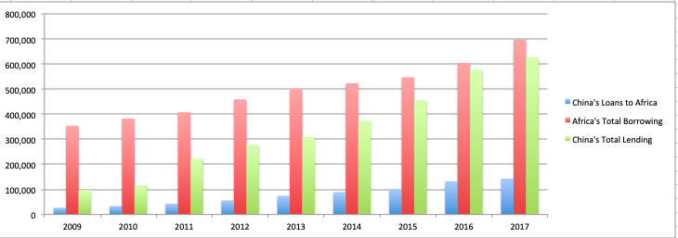
Note: Owing to the limited access to data, this graph is made using data from different sources, and thus offers only a schematic illustration for the reader’s reference.
Source: Authors. Data on China’s loans to Africa are from SAIS-CARI, Chinese loans to African governments, version 1.1, Sept. 2018; data on Africa’s total borrowing are from the World Bank online database of international debt statistics; data on China’s total lending are from the ‘international investment position’ released by the Chinese government in 2018.
<if possible, please change unit in heading to US$ billion and remove comma and final three noughts from vertical axis labels>
<legend: please remove unnecessary capitals on ‘loans’, ‘total borrowing’, ‘total lending’>

Figure 2: Chinese overseas project contracting and FDI in Africa, 2000–2017 (US$ billion)
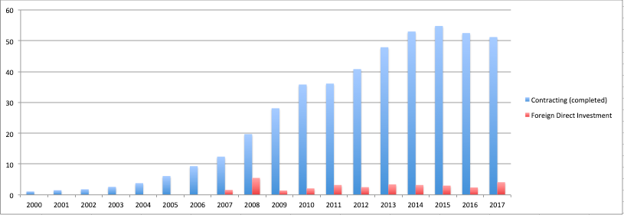
Note: Data on FDI in Africa before 2007 are not available.
Source: Authors, using data from the online database of the National Bureau of Statistics of China.
<legend: please remove unnecessary capitals on ‘direct investment’>

