THE CAMPHOR WAR OF 1868:
ANGLO-CHINESE RELATIONS AND
IMPERIAL REALIGNMENTS WITHIN EAST ASIA

The most totemic nineteenth century military conflict between Britain and China was the First Opium War (1839-1842). The least memorable was perhaps the Camphor War of 1868, which broke out twenty-nine years later on the other side of the Taiwan Strait. The Camphor War, like the Opium War, was triggered by disputes over a natural resource extract. Yet unlike the poppies used in opium, which were grown in British India, camphor trees were cultivated extensively in Qing-Taiwan. For the British, the Opium War sought to force enormous quantities of Indian opium onto Chinese consumers, whereas the Camphor War was intended to open up Qing-Taiwan in order to exploit its rich camphor resources and monopolize the camphor trade. In both wars, there were vast disparities in technological force between the protagonists, as we might imagine; and the Qing lost badly. Yet the Camphor War, as we shall see, was more than just a military skirmish between the British and the Qing. It involved provincial statesmen in Fujian, the local administration in Taiwan (both civil and military), the native Taiwanese community, a cohort of British traders and diplomats, as well as Americans from the other side of the Pacific Ocean. The war per se deserves a fresh treatment as such, and should be given more visibility in the study of Anglo-Chinese, or Sino-British, diplomacy and international history.

After the First Opium War, the Qing Empire (1644-1912) was a deteriorating citadel which lacked the capacity to reorient itself – diplomatically, militarily, and economically— in the global arena between 1843 and 1860. It was not until the Self Strengthening Movement, first initiated in 1861, that the Qing launched institutional reforms to modernize the country. Most historians, following the renowned Mary C. Wright, have long viewed the Qing leadership during this period of reform as virtually uninterested in anything but the acquisition of Western military technology and armaments (qiwu cengci de xiandaihua). This observation is not completely erroneous, as the Self-Strengthening Movement was, in many ways, focused on military modernization. Nevertheless, this single-sided emphasis is insufficient to interpret the complexities of late Qing politics. Scholars such as James L. Hevia, Kirk W. Larsen, and Par Kristoffer Cassell have pointedly reminded us that the Qing court at the time was not necessarily insular, conservative, or moribund after the two Opium Wars. They suggest that the Qing Empire was an active participant that engaged in multi-national affairs from a variety of political, legal, and economic perspectives.

Building on what Hevia, Larsen, and Cassell have theorized, I attempt to argue that the Camphor War is one of the examples that demonstrates the Qing government had not lost sight of re-positioning itself in the global arena, politically and economically, in the late nineteenth century. Yet the way it repositioned itself was not to actively engage in the global camphor market by opening its door freely. Instead, it strove to maintain a kind of guarded management over camphor production and distribution by maintaining a monopolistic structure in the face of Western interventions. By sketching out the whole sequence of the Camphor War, which is badly understudied so far, I suggest that the war should not be seen as an insignificant military conflict between China and Britain, nor was it simply another armed conflict featuring a so-called “clash of empires.” It was rather an encounter that indicated the eagerness of the Qing to maintain its autonomy over the camphor market as well as its inability to balance power against power towards the end of the nineteenth century. This article also challenges to a substantial extent the clash of empires narrative, and instead features the Qing as an autonomous force, even though it was out of balance with the wider world and failed to implement its policy of “using one barbarian to control another barbarian (yiyi zhiyi).” Yet before we move on to the details of this long-forgotten war, it is essential to connect camphor and material culture in order to better situate camphor, as the key commodity in question, within a transregional competition network throughout the long nineteenth century. Only by explicating the materiality of camphor can the meaning and interpretations of the war be given more historiographical, methodological, and conceptual depth.

II

The study of material culture has recently been enjoying something of a renaissance. Collection of essays and special editions of academic journals on this subject have poured from the presses. In 2014, a refereed journal entitled the Journal of Material Culture was officially launched in order to “explore the linkage between the construction of social identities and the production of things.” By the study of material culture, historians generally adopt the definition by Ann Smart Martin that “it is to understand and to explore the way people live their lives though, by, around, in spite of, in denial of, and because of the material world.” According to Anne Gerritsen and Giorgio Riello, the concept of material culture can be divided into two segments, namely the objects themselves and “the meaning they hold for people.” In other words, material culture can be seen as an approach historians have increasingly applied to help us perceive and apprehend how social reality was structured and framed through objects and materiality. This approach also engages with the psychology of taste, individual motivation, metaphorical analogies, and social unity. It does so by recapturing the physical conditions and structural patterns of everyday life among various communities or within the capitalistic market. In the narration of Ian Hodder, the interaction of humans and objects are capable of revealing the shared value and ideas of a particular society, as well as the sharping and creation of social meanings. In short, objects are not merely revelations of culture but, as John Kieschnick noted, “the means by which culture is created.”

If we agree with Hodder and Kieschnick that culture can be created via the definition and redefinition of objects, I should add that the meaning embedded in and created by objects themselves change over time and space. Objects are never static. As Arjun Appadurai pointed out in his influential The Social Life of Things, the meaning of an object is “inscribed in their forms, their uses, [and] their trajectories.” By tracing these trajectories, we can then interpret “the human transactions and calculations that enliven things.” From a theoretical point of view, “human actors encode things with significance,” while from a methodological point of view, “it is the things-in-motion that illuminate their human and social context.” In light of Appadurai, scholars have further refined the “human-object interactions” over the past three decades by emphasizing “people’s attachment to objects,” rather than simply narrating the “culturally informed economic biography” of an object, which only focuses on a commodity’s changing status in the economic sphere. For instance, Janet Hoskinshas manifestly stated that “things can be said to have biographies (not only biography) as they go through a series of transformations from gift to commodity to inalienable possession, and persons can also be said to invest aspects of their own biographies in things.” In a similar vein, in this article I will follow the biographical trajectory of camphor, which was originated in Taiwan, harvested by native Taiwanese, purchased by Han Chinese, administrated by the Manchu, and then later attracted to the British, in order to explore the intertwined social and cultural lives of the commodity and its users. By locating individuals’ interactions with camphor in a specific historical context, we will delineate the meanings embedded in and mediated through camphor (i.e. what did camphor mean to different group of people?); dissect these actors’ agenda and their motivations that drove their actions; and comprehend the symbolic and cultural meanings carried by camphor, as well as the networks it generated and the individuals connected.

Tracing the life history of an object is like peeling an onion, and it is always practical to start with asking: What is it? In the case of camphor, perhaps the questions are: what type of crop is it? What form is it when harvested? And what different kinds of uses does it have? In the next section , we will examine in fuller details the above questions related to camphor as a regional crop and then a global commodity.

III

Taiwan is known for its computer hardware and bicycles today, and is not remembered as a major producer of global camphor in the eighteenth and nineteenth centuries. But for a very long time, Taiwan was widely recognized in East Asia and the world for its camphor production (see figure 3) and it was considered one of Taiwan’s three treasures – along with tea and sugar. Camphor-producing trees covered the whole stretch of the high mountains extending north and south through the centre of the island of Taiwan. In Plant Resources of South-East Asia: Essential-Oil Plants, F. Indah Windadri and S.S. Budi Rahayu described the specific gigantic camphor tree (cinnamomum camphora) as “evergreen and aromatic,” standing between 15 to 30 meters tall. Essentially, camphor and camphor oil was distilled from the camphor trees that were 50 or more years old. In Qing Taiwan, before chopping down a tree, the soil was removed from its base to expose its root. At a later time, roots, stump, trunk, and branches were all cut into a convenient size and transported for distillation. The distilled camphor would then become an organic compound commonly used in creams, ointments, and lotions, or turned into camphor oil. Due to its antibacterial and anti-inflammatory properties, camphor has a wide variety of topical uses, ranging from relieving pain and itching to lessening chest congestion, and from alleviating inflammatory conditions to improving respiratory function. In addition to its medicinal effectiveness, camphor had military applications. According to the following entry from a publication released by the Royal Society of London in 1745, “when the gunpowder is very dry, and ground very fine,” you would need to mix “a little camphor with the gunpowder in order to fire the gun.” And as recorded in the Bulletin of the United States (Bureau of Labour Statistics), “In Emperor Yung Tsen (Yongzheng) time, camphor trees were felled for use in shipbuilding, and much camphor wood was used in military work…A license was required of those who owned iron implements for manugacturing camphor, or for its use in military mechanics…Between 1821 and 1850, the use of camphor for military purpose greatly increased. The military supply stations not only purchased the manufactured camphor but also to erect camphor stoves an stills in the mountains of Taiwan.”

Camphor was being used far earlier than the eighteenth century. Historical records indicate that trade in Borneo camphor occurred as early as the eighth century or even earlier, and in 1820, John Crawfurd stated that camphor “has long been known to man, and finds mention in the various writings from the 8th century on.” R. A. Donkin also briefly identified the uses of camphor in ancient and medieval times across various places in Asia, including China, Japan, India, Western Asia, and Southeast Asia. The nineteenth century, however, was a remarkable era for the social history of camphor as it began to permeate almost every realm of human affairs, from politics, trade, and warfare to religion, medicine, and culinary culture.

Due to the outbreak of Asiatic cholera in Western Europe in the 1830s, camphor swiftly became a product of conspicuous consumption. This paralleled the first cholera epidemic of 1831 that swept through Germany, France, and Britain from India, Inner Asia, and Russia. Samuel Hahnemann (1755-1843), a German physician who is best known for creating the system of alternative medicine called homeopathy, discovered that camphor had preventive and curative properties to treat cholera. He formulated a way to administer pure camphor in alcohol or water to prevent the disease. This discovery, in itself, ignited a significant rise in global camphor imports into Europe. Camphor, after that, was no longer a marginal commodity to the international market. As a British mercantile agent and accountant William Waterston reported, “the quantity of camphor exported from Canton varies much from year to year (from 1829-1831). In the United Kingdom about 650 cwts. are annually entered for home consumption.” In 1832, however, the volume of the private trade out of Canton reached 5,299 piculs valued at $148,372 Mexican dollars.

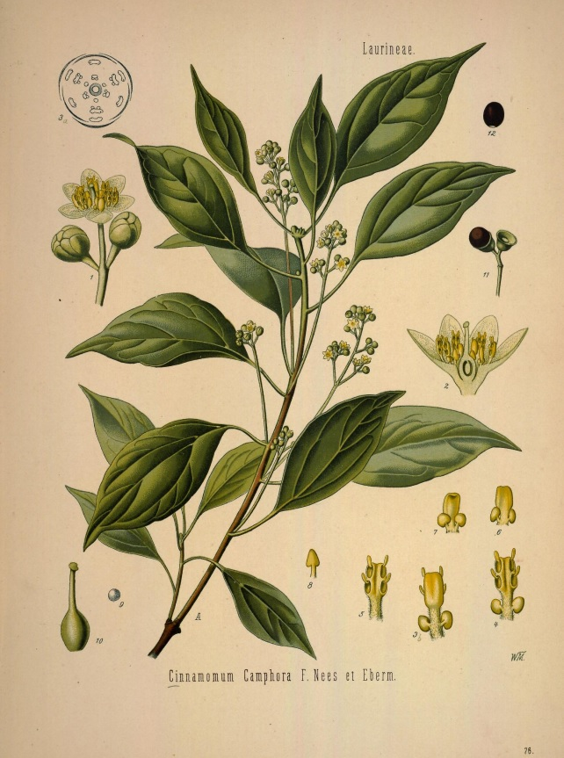
FIGURE 1: Illustration of camphor. Franz Eugen Köhler, Köhler’s Medizinal-Pflanzen in naturgetreuen Abbildungen mit kurz erläuterndem (Gera: Verlag von Fr. Eugen Köhler, 1887), Band I, 78.

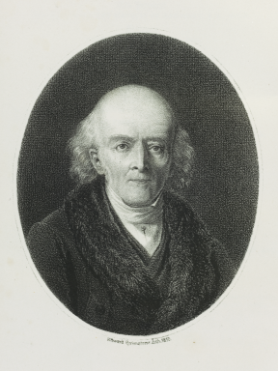
FIGURE 2: Samuel Hahnemann
Source: Science Museum Science Museum’s History of Medicine Website (Wellcome Trust)

III

Before camphor became a major global commodity, as briefly mentioned above, people generally used it as a repellent for moths and insects and as a tonic to ease aches and pains. Although it was not as lucrative as it became later in the nineteenth century, Chinese merchants, mainly from Fujian and Guangdong, had already recognized the profitability of peddling camphor crystals to consumers in China, Southeast Asia, and the Middle East. Until the early eighteenth century, these camphor merchants were not restricted by state control, and were therefore able to expand their businesses freely without governmental restrictions. By the 1710s, the camphor trade had spread across the entire coastline of China and a substantial portion of Southeast Asia. At the time, these merchants could earn ten times more profit selling camphor than selling rice and grain. This growing business gradually came to the attention of the central government, which then sought to marginalize them within the market that they had themselves created.

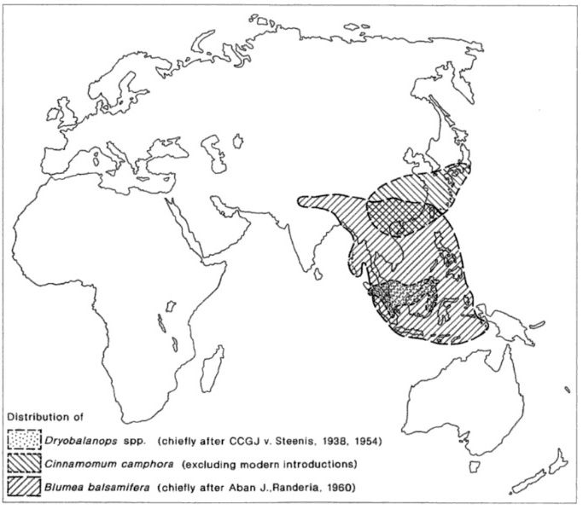
FIGURE 3: Distribution of Dryobalanops, Cinnamomum camphora (camphor), and Blumea balsamifera.
R. A. Donkin’s Dragon’s Brain Perfume: An Historical Geography of Camphor, 52.

In 1720, the Qing court declared a monopoly over camphor and other forest products in Taiwan. The central government justified this action by asserting the need to maintain the magnitude of the camphor forest, but this was not its ultimate objective. Initially, its goal was to maintain naval development. At that time, the institutions and practices that comprised the camphor monopoly functioned primarily to supply camphor lumber from inner Taiwan to shipyards in Fuzhou, Hengchun, and Tamsui, because camphor wood was an important product for maintaining the navy. Both the imperial court and provincial officials considered the construction and repair of warships on Taiwan “foremost and important” for the maintenance of a well-functioning military along the coast and across the Taiwan Strait. Additionally, the Qing court believed that the continued exploitation of the camphor forest was a stimulus for the chronic conflict between Chinese traders and native Taiwanese settling in the mountainous area. In fact, by the first few decades of the eighteenth century, the population of the southeastern coast had recovered from the devastation of the sea blockade policy initiated by the Kangxi emperor in the 1660s and 1670s. Chinese farmers and traders from those coastal prefectures began pouring into Taiwan to take advantage of strong mainland demand and high prices for rice, sugar, and camphor produced in Taiwan. As the expanding Chinese population rushed into the native settlements, tension began to mount unpleasantly throughout the eighteenth and nineteenth century. According to the Qinggong gongzhong dang zouzhe: Taiwan shiliao (Imperial documents of Taiwan collected in the Qing palace), the aborigines often complained of the injustice in taking away from them their very best land, their cattle, wagons, and camphor by the Han Chinese. They had no choice but to attack the “Chinese invaders” by beheading them (chucao). In revenge some Chinese traders decided to torture, rape, plunder, and kill the aborigines.

The government thus found it urgent to promulgate a series of laws to mitigate the tension. In order to regulate the centralization of camphor production, the Qing court imposed severe penalties on those who violated the laws on acquiring camphor in Taiwan. State laws were brutal and penalties remorseless, with what were called “savage areas” closed and those breaking the law to be “sentenced to death (fengjin fandi, fanzhe si).” At the end of the year when the monopoly law was first imposed, the central government decapitated two hundred Hakka merchants and workers for illegally trading in camphor. The victims were not even given a chance to express their remorse. Nevertheless, despite such harsh laws, the oil and crystal distilled from camphor trees made for a booming business in China and Southeast Asia during the eighteenth century. Even in the face of extreme punishments, private harvesters continued risking their lives to extract camphor from the forests. And local offices kept reporting their concern over illegal camphor harvesting and smuggling to Beijing. In response, a clique of local officials in Southeast China argued that changing the existing law would be the only way to eliminate “illegitimate harvesting.” Two years later, they petitioned for a more lenient policy on camphor production and circulation. Considering the difficulty of combatting illegal camphor trade and smuggling, the Kangxi emperor approved their petition and made the monopoly law more lenient in 1722. From then on, Chinese merchants and workers were permitted to extract camphor in Taiwan under a system of supervision and by paying certain royalties.

The camphor forest also attracted significant interest among the British, who had long kept an eye on the camphor market in Taiwan. Beginning in the early nineteenth century, they had been enticed by the island’s commercial and military potential. After the discovery of the homoeopathic use of camphor to treat cholera, the British became even more obsessed with natural camphor in Taiwan. Assisted by Chinese traders, some British merchants carried on an illicit trade, exchanging opium for camphor, in Quanzhou, Hong Kong, and Southeast Asia. Others smuggled camphor directly from Taiwan to Western Europe. The camphor market also excited big conglomerates such as the Jardine Matheson Company (JMC). In 1839, Dr. William Jardine, the co-founder of JMC, famously pressed the British Foreign Secretary, Lord Palmerston, to respond forcefully to the Qing after Lin Zexu destroyed 20,000 cases of British-owned opium. What has been overlooked is the fact that in that same year the Scottish merchant also proposed to the Foreign Secretary that the acquisition of Taiwan be considered for its abundance of camphor.

In 1842, the year when the First Opium War ended, British observers on the Taiwan coast seconded Jardine’s proposal. Yet, Britain was too preoccupied with the opium conflict to seriously consider such a prospect. Even the murder of 197 shipwrecked passengers from two British vessels, the Nerbudda and the Ann, off the coast of Tainan did not fuel a clear and direct policy to annex Taiwan (in an affair known as the Nerbudda incident). In the 1840s, the coastal cities across the Taiwan Strait, particularly Canton, in the Pearl River Delta, and Zhoushan, a small island at the mouth of the Yangtze River, continued to be Britain’s primary focus. But the British never lost interest in Taiwan’s camphor market. Even though the Nerbudda incident did not lead to an immediate military conflict between the two powers, it heightened interest among the mercantile communities in extending Britain’s growing China trade to Taiwan and, by extension, to the camphor market in the years that followed. In 1856, the British launched a Second Opium War on China lasting two more years. Again, the Qing was defeated, and the Treaty of Tianjin, another unequal treaty, was imposed. This opened eleven additional treaty ports for foreign trade, including Taiwanfoo and Tamsui in Taiwan. British merchants were then allowed to “freely” participate in Taiwan’s camphor market. Yet, we should keep in mind that, even as the Treaty of Tianjin opened these “treaty ports” on Taiwan, the Qing government continued to exercise unwavering control and supervision over its camphor trade.

Some may now wonder why an immediate military contest over camphor did not ensue after the Second Opium War. The reason is that Britain readjusted its foreign policy at the start of the 1860s. With the signing of the Treaty of Beijing in 1860, Britain embarked on a new cooperative approach in its diplomatic relations with China. The British authorities became convinced that conciliatory diplomatic gestures toward the Qing, rather than forceful demands, would be of greatest benefit. The British envisioned that the treaty system, namely the Treaty of Nanjing and the Treaty of Tianjin, would bring stability and reason to what had been a combative relationship. As Leonard Gordon has explained, this new conciliatory approach implied two things: (1) acquiring territory and resorting to force were prohibited, and (2) cooperation between the Qing court and western powers needed to be enhanced. Yet the new approach did not please every member of the British Parliament. George Hanover (The Duke of Cambridge) and Lord Seymour (the Duke of Somerset), for instance, in concert with military personnel, considered this policy “an approach of restraint.” They continued to advocate forceful opposition to what they regarded as any Chinese duplicity and intransigence that hindered the development of free trade, and above all, British interests. It took some time for the British to decide whether to maintain their old aggressive methods or proceed along a new cooperative path. Ultimately, in 1868, the cooperative policy was formally proclaimed in London. While everyone was therefore anticipating the development of more collaborative and harmonious relations between Britain and China, the Camphor War, ironically, broke out in August that same year.

IV

While the Britain debated whether it should adopt a less aggressive foreign policy toward the Qing in the first half of the 1860s, British traders and the local Chinese in Taiwan had difficulty achieving mutual respect. The British had assumed that once treaty ports were opened in Taiwan, they would make greater profits from camphor trade. Yet, the Treaty of Tianjin, did not authorize them to conduct camphor trade individually. They were only granted the authority to trade in the closest seaport to a camphor forest. American traders, for instance, were only allowed to trade in one seaport, which was too far away from camphor production operations. Even though the British were granted the privilege of “free trade,” they soon realized that they were mostly hindered by the Qing camphor monopoly mechanism, whereby all camphor produced on the island had to be purchased through the government. Chen Fangbo, the Taiwan local daotai, was the key administrator of this monopoly. By virtue of his official status, he had access to forests that were off limits to Chinese settlers. Chen established a camphor office (naoguan) in 1863. Foreign merchants were only allowed to purchase camphor through the camphor office, which sold it at very high prices — whereas Chinese merchants who bribed the governing officers, occasionally with opium, often got a much better deal from the naoguan. The Vice-Consul George Braune summarized the situation as follows, “[British] merchants desiring to purchase camphor could choose from one of the several sources: (1) directly from the camphor office; (2) from other Chinese merchants and brokers on the coast at risk of seizure by the intendant’s deputies or the Maritime Customs officials; or (3) from wealthy settlers in the interior with enough influence and power to defy the local authorities.” Consequently, by 1866 the camphor trade from Taiwan was mainly in Chinese hands.

Refusing to bribe officers to purchase camphor from the office at exorbitant prices, most foreign merchants purchased camphor from private harvesters, Chinese traders who obtained camphor from the office, or even smugglers, as Braune notes. An independent trader and agent for Jardine, Matheson & Co. named John Dodd had this to say: “…as I consider monopolies illegal, I am going to ignore him [Chen Fangbo] and the monopoly too, especially as I can purchase camphor direct[ly] from the producers at $14.50 per percul [picul]. I have arranged for a small parcel at that figure, and shall run the blockade with it.”

Although British merchants in Taiwan found alternative means of purchasing camphor from private owners, they were dissatisfied with the monopoly system. They found it discriminatory and problematic. Their discontent escalated as they became more interested in the camphor market. However, the Qing was unlikely to adjust its managerial policy over camphor production. Realizing that they were not the only foreigners pursuing camphor resources in Taiwan made British traders even more worried. American merchants were waiting impatiently at the doorstep, ready to take a piece of the action. Since the early 1850s, the Americans had already purchased large quantities of camphor directly from Jin Hehe, a notable merchant of Amoy and Taiwan. Between 1855 and 1864, Jin had assumed a dominant role in the Taiwan camphor market. For example, the American enterprise Augustine Heard & Co. concluded a three year contract with Jin in 1855 for the sale of all camphor coming out of Taiwan (approximately 18,000 piculs). Thus, the camphor rivalry involved the Americans as well as the Qing and the British. Additionally, the rivalry was not only over camphor trade in a newly opened China. It was also a matter of whether the British would dampen its hitherto forceful foreign policy towards the Qing and whether the Americans could open their first lucrative market in China. Meanwhile, it was an opportune moment for the Qing court to reposition itself in order to acquire a more elevated stature vis-à-vis other imperialistic powers, and perhaps relegate the Opium War era to the past. As James Hevia has noted, the “Chinese [at the time] were both resentful and suspicious of the intention of their uninvited guests.” All of the parties were deliberately calculating how to take the next step, and the scene was much more complicated than many have assumed.

To explore the complexity of this environment in greater detail, I will present an account of the experiences of William Alexander Pickering (1840-1907), the British officer who first worked in the Chinese Customs Office and later in several British business firms in Taiwan. Pickering was bestowed with a Chinese name, Pi Qilin, by a military general in South China. He is a remarkable figure in the history of East Asia in general and Taiwan in particular. He became fluent in many Chinese dialects, including Mandarin, Cantonese, Hakka, Hokkien, Foochew, and Teochew, and cultivated acquaintances among both Taiwanese and aborigines. He is also the author of Pioneering in Formosa: Recollections of Adventures among Mandarins, Wreckers, & Head-hunting Savages, a personal reminiscence that sheds invaluable light on conditions in Taiwan before and after the arrival of the western gunboats. Above all of his other accomplishments, he was a pivotal figure in stirring up the Camphor War. As the governor-general of Fujian once put it in a petition to the emperor, “for the many outrages he [Pickering] had committed during the camphor troubles, he had a dangerous influence over the people, through his knowledge of our languages and customs. He aroused them to revolt and rebellion against the Qing.” Pickering’s position during the war therefore concretely illustrates the intricacies of this significant, though long-forgotten, chapter in nineteenth century Anglo-Chinese relations. He is also the key character who interfered in Qing politics. His interactions with Qing officials, moreover, reveal the repositioning the Qing government was trying to undertake throughout the camphor conflict.

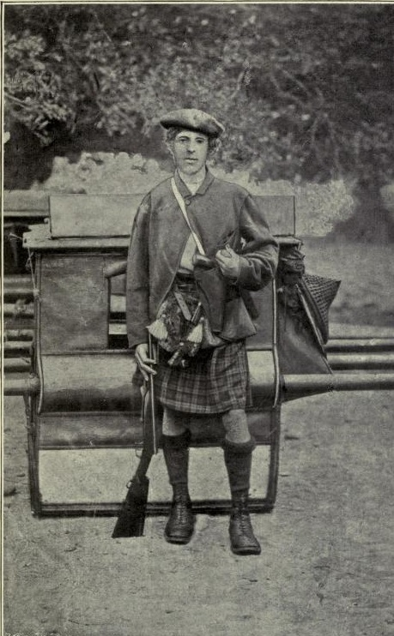
FIGURE 4: William Pickering in 1869. He is pictured in a kilt, although he was born in Eastwood.
William A. Pickering, Pioneering in Formosa, 232b.

V

The first record we have of William Pickering is of a teenager who was bonded to the sea. While growing up in Eastwood, Nottinghamshire, Pickering studied at a private school. After graduating at the age of sixteen, he did not pursue further studies but began working as a crew member for a shipping company and later at the East India Company (EIC). It is not clear exactly what drove Pickering to the sea, given Eastwood’s inland location and limited associations with maritime affairs. Most likely, Pickering’s yearning for the sea stemmed from Britain’s status as ruler of the waves throughout Pickering’s lifetime and the profitability of seaborne trade at the time. Of all of the shipping companies across the globe, the EIC was the most powerful one. But the company had a recurring financial problem after the “Government of India Act” was finalized in 1858. Pickering recognised the structural problem and left the company in 1862. Yet, leaving his job at the EIC did not seem to upset him. Instead, he eagerly joined the Chinese Maritime Customs Office run by Robert Hart (1835-1911). Pickering then spent two years in China (mostly along the southeast coast), mastering a few Southern Chinese dialects. Impressed by Pickering’s language proficiency, William Maxwell (1835-1865), the customs commissioner of Takou (now Kaohsiung in Taiwan), quickly appointed him as tidewaiter to check imported goods landing in Southern Taiwan.

This appointment in Taiwan significantly changed Pickering’s life and career, exposing him to the lucrative and expanding camphor market. As he recorded in Pioneering Formosa, “in former years, a good deal of the drug [camphor] was clandestinely produced and smuggled across to the mainland, where it was bought up by European speculators and transmitted to Calcutta, where the Hindustani made considerable use of it.” Pickering spent his first year in Taiwan studying the production of camphor. The following passage from his records gives us a sense of Pickering’s thoroughness in surveying the best place to obtain camphor, the best selection process, the best way to secure the extracted sap, and the best way to distil camphor crystal:

The trees [the huge great trees], as they were required, were selected for the abundance of their sap, for many were too dry to repay the labour of the undertaking. The best part of the felled tree was secured for timber, and the refuse was cut up into chips. These chips were boiled in iron pots, one inverted on another, and the sublimated vapour was the desired result……The camphor was then stowed in large vats, with escape holes in the bottom, through which an oil slowly exuded, known as camphor oil, which was a much-valued remedy amongst Chinese doctors for rheumatic diseases. From the vats the camphor was placed in bags containing about a pecul each, or in large tubs holding three peculs (400lbs.) each, and it was then ready for shipment.

Pickering considered camphor to be a profitable investment and became increasingly obsessed with the business. Yet, because British merchants were not allowed to extract camphor independently and had to go through the camphor office, Pickering and other Britons felt that they were unfairly constrained by the monopoly mechanism. Therefore, he decided to purchase camphor from a Chinese trader – whom we will discuss more extensively in the next section – in the Wuqi Harbour region (Gawehay or Goche), a small port lying about sixty miles north of Taiwanfoo and the closest harbour to a site where fine camphor crystals could be extracted. Pickering even left the Customs office to work for the Messrs. McPhail & Company (MMC), one of the largest British merchant firms in Southern Taiwan, in order to submerse himself in the camphor trade.

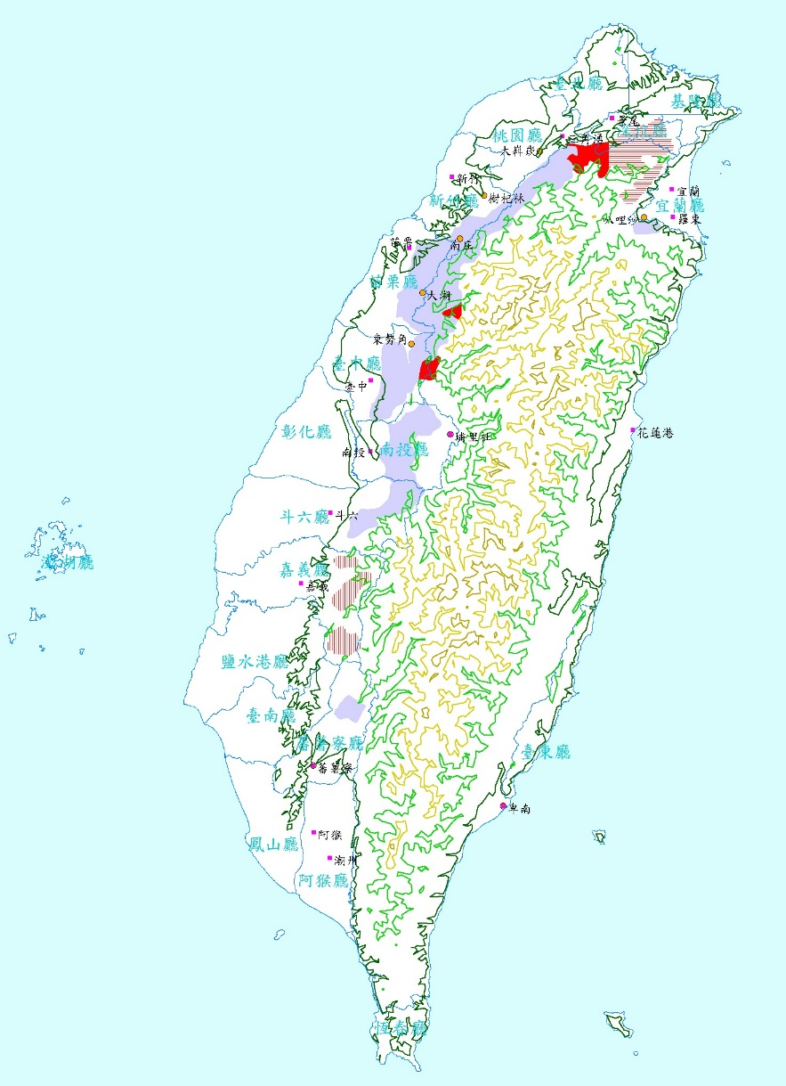
FIGURE 5: Camphor distribution in Taiwan. The shadowed region showing
approximate areas where camphor trees could be found.

VI

As a representative of the MMC, Pickering made a handsome return on his investment. He even managed to establish camphor warehouses in Wuqi, managed by a foreman from a local clan. For Pickering and other foreign traders, subcontracting with Taiwanese foremen was essential to keep the business running, because local clans helped supervise most of the camphor forest in Taiwan. Anyone who might be reluctant to purchase camphor from the camphor office could turn to local clan leaders - key people who got better deals on camphor obtained through the camphor office. When Pickering took up the camphor trade on behalf of the MMC, a wealthy landowner and the head of an important clan, named “Choa,” offered to supply him with camphor. This is why he had a foreman from one of those clans manage his warehouse.

Because Chen Fangbo, the Taiwan daotai, did not allow foreigners to expand their camphor business “illegally” in collaboration with local foremen, the MMC soon came under suspicion. Yet Chen did not confiscate the MMC’s camphor immediately. Instead he adopted a “clandestine opposition policy,” bribing another Chinese foreman to attack the foreman Pickering had hired. In May 1865, a Chinese foreman directed by Chen Fangbo plundered a $6,000 shipment of camphor owned by the MMC that was sitting in Wuqi. At that time, Pickering had no idea that Chen Fangbo had instigated this behind the scenes, but felt the plunder could not be tolerated and undertook an investigation into the matter himself.

Pickering would have suspected something was wrong when the local office in Taiwanfu interrupted his journey. According to the Treaty of Tianjin, foreign traders were required to have their passports stamped by local officers when they entered or exited a city, a restricted area, or a designated zone. When Pickering decided to go to Wuqi, he was in Taiwanfu. He therefore needed approval from the local office to have his passport stamped. But the Taiwanfu officials refused to stamp his passport at first. The office only gave him permission to proceed to Wuqi after Pickering strongly protested against what he regarded as an unreasonable decision. Pickering later described the officers in Taiwanfu as “wily,” because they had informed him that the Qing would send over to Amoy for a gunboat to reason with the plunderers who had looted his camphor.

While Pickering was heading to Wuqi, Chen Fangbo was planning his next move. In order to find grounds for some trumped-up charges against the agent whom Pickering had hired (the Chao), Chen directed his officers to inspect the Chao clan and its leader. This investigation was accomplished very quickly. Chen found that the late father of the Chao clan leader had been involved in some long forgotten rebellion. This gave the Taiwan camphor office the requisite authority to harass the Chaos. As a result, two hundred soldiers were dispatched to Wuqi on the pretext of arresting the leader of the clan for his father’s involvement in an earlier rebellion.

It took a while for Chen’s army to arrive at Wuqi harbour. When Pickering landed at Wuqi by way of the sea, he did not see Chen’s troops but found his warehouse besieged by another local clan named Tan. He soon realized that the Tan leader had plundered his camphor – but he was unsure if the camphor office was involved in the incident at that point. His warehouse was surrounded by the Tan people, although they were not fully armed. Pickering and his team, however, were equipped with seven-shooter rifles and two boat guns. To no surprise, Pickering succeeded in routing the poorly-armed enemy and saving his foreman from the Chao clan, apparently in less than an hour. But the story does not end here.

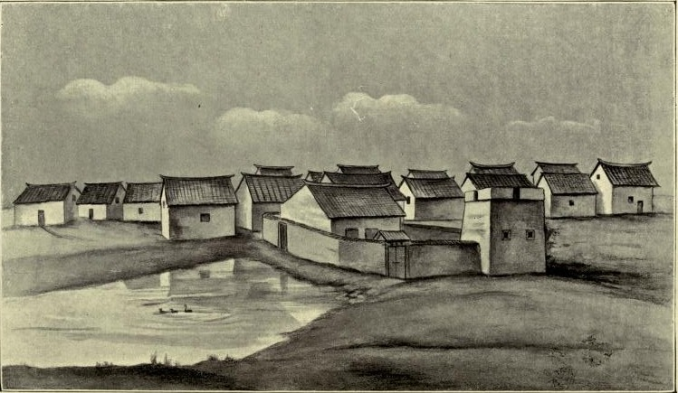
FIGURE 6: Pickering’s Camphor Warehouse in Wuqi (from a drawing by Pickering).
William A. Pickering, Pioneering in Formosa, 205a.

Normality was restored after Pickering regained control of his camphor warehouses, but after a few days Chen’s militia appeared.. The Tan clan immediately joined the Chen forces, whist the Chao clan, in contrast, promptly removed “their women and children and furniture in carts and ran away.” Pickering and his workmates were left alone to defend the warehouse, barricading the principal entrance with large tubs of camphor and a boat gun loaded to the muzzle with nails and iron. As Pickering himself recorded, he even “lighted joss-sticks ready to fire it in the event of the enemy trying to get in.”

As Pickering anticipated incremental clashes between Chen and himself, a Qing official appeared on the scene, bearing a letter inviting Pickering to visit the Qing general to talk matters over. Despite protests from his workmates, Pickering accepted the invitation. At the negotiation table, the Qing representative was Liang Yuangui, the newly appointed officer of Taiwan (Taiwan zhifu). Liang implored Pickering to stop conducting camphor trade, leave the Wuqi harbour, and return to Taiwanfoo at once. Pickering flatly refused to do this. He assured Liang that he was prepared to resist all attacks, but he agreed to a compromise by forestalling any further purchases or shipments of camphor until he had communicated with his company. Meanwhile he also advised Liang to write to Chen, stating all of the circumstances frankly before him. By promising to cease buying camphor, Pickering brought the negotiation to a close, but after he left the warehouse – where the negotiation had taken place, the Tan clan blocked his way back. Pickering and his workmates took it as a sign of attack, so they fired down the street above the heads of the Tan clan members, at first, which made them scatter.Pickering drove them away into the houses near the warehouses, while some of the Tan soldiers held children in front of them, using them as shields, behind which they kept firing at Pickering and his workmates. But their weapons – without the help from the Qing troops – were not powerful enough to threaten Pickering’s defensive line. This was the first military contest that the Tan clan, representing the native Taiwanese, had initiated against the British over camphor and was arguably a prologue to the imminent Camphor War.

VII

Soon after the negotiations with Liang, Pickering drew up on report of the whole affair and sent it to the MMC and the British consul. Days passed, while Pickering waited for instructions from the consul, and he became down-hearted. He had nothing to eat but rice and water, with roasted peas for coffee. He could not return to Taiwanfoo because the weather at sea was too rough; nor did he dare travel by land due to the risk of falling into the hands of the Tan clan or the Qing troops. After waiting for almost two weeks, a courier from the British consul delivered a letter to him, advising him to escape anyway he could. As Pickering later wrote, “the weather prevented any communication with the mainland of China, and the consul had received secret information, on good authority, that Chen Fangbo had determined either to have me poisoned or to accuse me of murder.” The consul’s letter was accurate. By then, Chen and his superiors, namely Ying Gui (the Governor-general of Fujian and Zhejiang) and Bian Bao (the Inspector of Fujian) had lost patience. Their ultimate goal was to seize this opportunity to remove Pickering and the MMC from the camphor trade. Pickering immediately sent a man to order his boatmen to prepare to receive them on board, as the weather had improved somewhat. Yet to Pickering’s dismay, the messenger returned with news that his boat had been taken out of the harbour at Chen’s order. Pickering felt desperate at hearing this, for he could trust none of the Chinese anymore. He wrote “there were evidently such [Chinese] traitors around.” And sometime later he wrote: “The Chinaman is an unfathomable creature! A mixture of every best and every worst quality in human nature!”

Luckily for Pickering, he and his workmates were able to find a boat owned by a local fisherman with which to escape, bribing the fisherman was a chest of opium. In his warehouse, Pickering had stored a certain amount of opium, along with camphor, as it was valuable to the Chinese. Pickering set off in the dark, arriving at the harbour about midnight. Suspecting that it would be dangerous to go to Taiwanfoo, he sailed north instead to Tamsui harbour. Tamsui was a treaty port at that time where the British had the right to consolidate their power under the Treaty of Tianjin. Between 1862 and 1868, more than five British battleships including the Snap, the Snake, the Staunch, the Grasshopper, and the Janus, were already deployed to Tamsui to resolve a variety of small-scale Anglo-Chinese disputes in Taiwan.

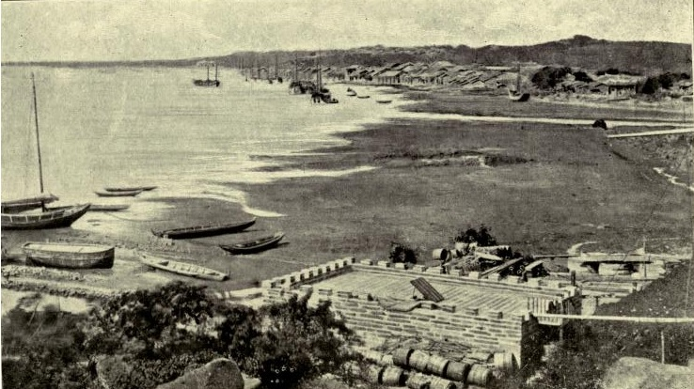
FIGURE 7: Tamsui in the 1860s (Picture from the British Consulate).
William A. Pickering, Pioneering in Formosa, 231a.

The Pickering incident was widely discussed in British circles. Despite the fact that the cooperative policy had been proclaimed formally in London, British diplomats in Beijing saw this incident as absurd and intimidating. As James Hevia and Robert Bickers noted, most westerners living in China, in fact, also viewed the use of force against the Qing as a necessary and positive good when problems arose. As such the British sought to resolve the dispute in a familiar manner by dispatching HMS Icarus, a gunboat commanded by Lord Charles T. Scott, to Taiwanfoo. But Scott was restricted from firing on the Chinese. The British expected that, for the sake of peace, the Chinese would be flexible on the issue if they saw an approaching gunboat. Accordingly, Scott called on Chen Fangbo in order to have him promise not to interfere any further in the camphor trade of British merchants. However, Chen insulted the consul and Scott in every way possible. He refused to listen to reason, showed utter contempt for the treaties, and insisted that no European should purchase camphor except through the official depot on his terms. Scott was disappointed that the Qing side had turned down the chance of negotiations without even considering his proposal. Thus, after handing Chen a protest and ultimatum, Scott returned to China for further instructions. Subsequently, Charles W. LeGendre, a perceptive camphor watcher representing the U.S. Consul at Amoy, informed Scott that the Americans were willing to open the camphor market together with the British. Surely, Scott realized that the Americans had long been targeting the camphor market in Taiwan, but he thought that the first and most important task was to abolish the camphor monopoly by any means. Scott accepted the request from the U.S. Consul, and Le Gendre then sailed the USS Aroostook, an American warship, to Tainan, where he called upon the Chinese camphor office. Le Gendre was no more successful than the British, however, and his troops were forced to leave Taiwanfoo momentarily.

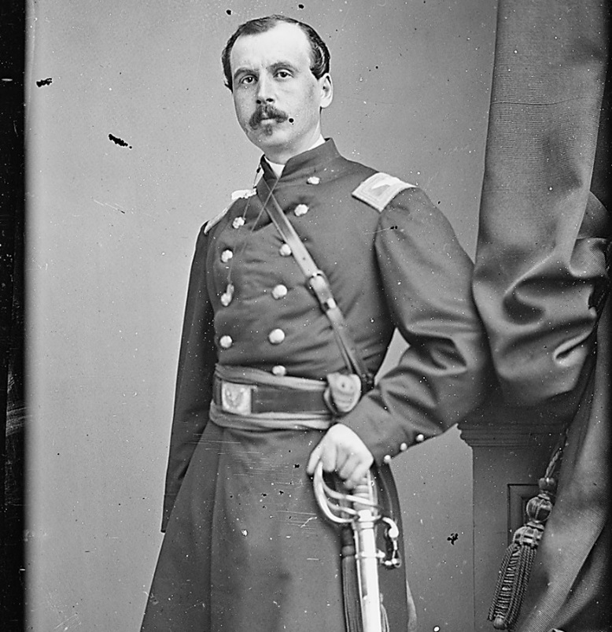
FIGURE 8: The American general, Charles W. LeGendre. Source: US National Archives

The Qing saw this temporary evacuation of the British and the American navies as a great victory. According to Chen’s records, he tried to take every advantage in both sets of negotiations. This showed that the Qing had managed to safeguard their interests and keep foreign encroachment at bay. Following this “success,” the camphor office incited the people all over Taiwan to rise up against the foreigners – to attack and kill them. The Qing officials believed that the time had come to re-elevate their status in the Sino-foreign rivalry. The friction was as such no longer just between the camphor office and foreign traders, it was between the local population and all westerners, including traders, missionaries, and travellers. This all built on pre-existing tensions. The British Consul George Jamieson, for instance, had this to say about an earlier disturbance between British missionaries and local Taiwanese in April 1863: “all began as a result of a report claiming that the missionaries were administering some sort of poisonous drugs in secret among the local residents to induce them to become converts. The local people, enraged by these rumours, easily resorted to violence.” Further violence against missionaries occurred later in the year. The missionary houses, both Roman Catholic and Protestant, were plundered and burned, and converts were persecuted and murdered. And of course, European firms and warehouses in Takao and Tamsui were wrecked by local villagers and gangsters. The comprador of Messrs. Elles & Co. – the other British hong merchant in Taiwan – was arrested in Taiwanfoo. His mansion was plundered and sacked, and costly furs, robes, and jewellery were ruthlessly taken by the Qing troops. Total mayhem ensued for foreign traders and missionaries in Taiwan.

Tensions rapidly developed, especially after the Tongzhi government (1856-1875, r. 1861-1875) took it as a crucial opportunity to showcase Qing power after the humiliation of the Opium Wars and demonstrate they could protect its camphor monopoly on Taiwan. As a result, the central court in Beijing gave its full support to the camphor office and rioters in Taiwan to repel “foreign invaders” – much as Empresses Cixi (1835-1908) championed the Boxer Uprising at the turn of the twentieth century. In October 1867, the camphor office issued a proclamation that read, “Chinese officials command the people living in the seaboard of Tamsui district—whenever they see people illicitly purchasing camphor and carrying it down to the seashore—the local populace shall be allowed to seize both men and goods and turn them over to officials to deal with. The captured goods shall be divided, one half being confiscated by the government and the other half given as reward to the capturers.” The British saw this attempt to curb “smuggling” as unlawful and, indeed, as a violation of the Treaty of Tianjin. As vice consul H. E Holt argued, Article 11 of the Treaty granted foreigners the right to trade with whomever they pleased. Furthermore, camphor was listed among the export tariffs and thus could not be considered a contraband commodity. In spite of Holt’s opposition, the situation did not improve as the vice-consul of Tamsui reported in March 1868, “Trade in camphor, also a most valuable and important article of commerce, is now so trammelled by the extortions of rapacious monopolists and the apathy of a venal Government that in spite of my utmost exertions I have been only able to affect a partial improvement in it.”

Meanwhile, the Americans did not give up on opening the Taiwan camphor market. In response to the chaotic situation in Taiwan, the U.S. forces were about to proceed to the island from the Yangtze River to protect American expatriates in Taiwan. Apparently alerted by this military manoeuvre, the Beijing government dispatched a high commissioner, Zeng Xiande, the daotai of Amoy, to Taiwan from Fuzhou – armed with full authority to lead any potential military action. After arriving in Taiwan, Zeng immediately met with the British consulate in Anping, John Gibson, to negotiate some ways to resolve the mayhem, yet failed to reach a mutual agreement. At the same time, considering the American move from the Yangtze, the British consul in Beijing pondered how to stop the Americans, out of fear that the latter might swallow up the crown’s existing interest. While discussing how to prevent the American encroachment on Taiwan, the British received news that the HMS Algerine was being fired on by a garrison of Qing troops. In October 1868, John Gibsondecided to take independent action, resorting to force. Without consulting the British Minister in London, Gibson called on Lieutenant Gurdon for assistance to prepare a military campaign against the Qing. Quickly responding to this request, Gurdon landed with a platoon of armed sailors and attacked Fort Zeelandia, considered Taiwanfoo’s strategic front gate. The Qing troops guarding the Fort quickly surrendered to Gurdon, bringing the war to an end. The Chinese commander Jiang Guozhen committed suicide — evading his responsibility for the outcome. On 21 November, the British proceeded to lay siege to the ramparts of Taiwanfoo, killing twenty-one Chinese soldiers. When the American approached Taiwanfoo, they found that British forces had subdued all local resistance. The Americans sailed to Hong Kong, and then returned to the Yangtze for further instructions.

VIII

In the Camphor War, the Qing troops once again overestimated their military capacity to resist the British. Fort Zeelandia was poorly guarded and armed at the time. Yet even after the fall of Zeelandia, the Qing did not intend to give up its legal camphor trade monopoly (zunli), although they were forced to discuss the matter with the British. Zeng Xiande, the daotai of Amoy and Ye Zongyuan, the acting daotai of Taiwan, represented the Qing, while Gibson, accompanied by Pickering, represented Great Britain. In the negotiations, each side blamed the other for violations of the Treaty of Tianjin. Gibson maintained that “the Chinese officials had no intention of complying with his demands which he believed to be reasonable,” while Zeng and Ye insisted that their actions towards foreigners were justified; Gibson believed that the camphor monopoly system undoubtably violated the Treaty of Tianjin, while Zeng and Ye asserted that the monopoly had long been established as a foundation to maintain peaceful collaboration. They also charged Gibson with violating the treaty by resorting to force without bringing the matter to the attention of the Beijing imperial court. It is not particularly surprising to see the two sides confronting each other across the negotiating table. What must be borne in mind, however, is that Zeng and Ye, even though representing the defeated side, maintained a strong stance in front of Gibson. In other words, they did not simply defer to the British but continued to exercise a forceful policy to safeguard China’s camphor monopoly. On this occasion, the emphasis would not be on how the Qing were subordinate to the British, but rather on the fact that the Qing upheld their interests even after the setbacks of the two Opium Wars and the signing of more than ten unequal treaties. The Qing court belied its status by attempting to monopolize and maintain its authority over camphor production and to guard against foreign intervention, if not encroachment, on this valuable market.

Yet, the British side, led by Gibson, were undoubtedly aggressive in the conduct of the negotiation. Despite the fact that the policy discussions in London were more favourable toward a cooperative, conciliatory approach, Gibson advocated putting pressure on the Chinese authorities when appropriate. This echoes what James Hevia pointed out in his English Lessons: “in an age of European global hegemony and competing empires, there would be no shortage of punishments meted out to recalcitrant others.” In his dealings with Zeng and Ye, Gibson even threatened to declare another war along China’s coast, when he at first was not able to eradicate the camphor monopoly system. Zeng and Ye were reluctant to conclude another unequal treaty, but they had little choice when confronted by a formidable gunboat. As a result, the camphor monopoly was finally abolished on 10 December 1868, and the British also imposed a large indemnity on China. In the final agreement, the indemnity was to be distributed as follows: £6,000 for the camphor company, £1,167 for the Protestant Mission, and £2,000 for the Catholic fathers.

Yet the camphor agreement did not please everyone in the British Parliament—especially after London announced a new diplomatic policy towards the Qing. The Secretary to the Admiralty, W.G. Romaine, for example, seemed uncertain as to whether the measures taken by Gibson were appropriate. The foreign secretary, Lord Clarendon [George William Frederick Villiers (1800-1870)], even contended that “Gibson and Gurdon (the naval commander) were wrong to commit any acts of hostility whatever.” Cautioning that Gibson’s removal would serve as a warning to his fellow colleagues in Britain and Asia, Clarendon urged “under no circumstances must he be allowed to remain in Taiwan.” Even though Gibson was supported by some other British diplomats such as his superior, Sir Rutherford Alcock (the British minister in Beijing), the foreign secretary was extremely sensitive to relations with the Qing. Alcock was forced to remove Gibson from his post; and Commander Gurdon was forced to quit the navy. The indemnity was also returned to the Qing court as a political gesture symbolizing the British determination to have no trouble with China in the years that followed.

Nonetheless, the end of the camphor monopoly resulting from the Camphor War did not empower foreign traders to conduct camphor trade without any restrictions. Conflicts between British consuls, merchants, and Qing officials in Taiwan continued until 1895. Although what happened after the Camphor War is beyond the scope of this paper, it is no less absorbing than the complexities of the Camphor War discussed here. In addition to the British and their relations with communities on Taiwan (Chinese, Taiwanese, and Aborigines), the Americans, the French, and to a lesser extent the Germans, were also attracted to the island’s camphor market, particularly after camphor was found to be essential to the manufacture of smokeless gunpowder in 1887. After the breakup of the camphor monopoly in 1868, Chinese merchants continued to dominate the market until 1886. It was only after the mid-1880s that western merchants began to surpass the Chinese. Ironically, it was the Japanese who were the ultimate beneficiaries of the camphor trade in the early twentieth century. The rivalry over camphor therefore did not end when the monopoly system was dismantled in 1868. In fact, the eventful and intriguing aftermath of the Camphor War is worthy of further study.

IX

As in the First Opium War, the Qing were defeated in the Camphor War owing to Britain’s clear technological edge over China at the time. Gibson’s cannons and warships held substantial advantages over the Qing. When Pickering reminisced about the war, he expressed the conventional opinion that the Chinese had no choice but to surrender when the British attacked Fort Zeelandia. And according to the Qing imperial archive, the war was only sketchily recorded as a defeat against the British. This all sounds straightforward, as if there is nothing left to explore. Yet, as I said at the beginning of this paper, the meaning the Camphor War conjures up is more than we might assume. And by tracing the social history of camphor as well as its materiality, we realize how camphor, as a global commodity, set the gears of the Qing, the British, and the American empires into motion.

First, while most of us might agree that technology is crucial to concluding wars, it alone cannot determine the result. In the Camphor War, for instance, timing was key. Imagine if the Qing had been able to tap into the diplomatic debate in London, they might have been better able to soldier on in the war and safeguard their camphor monopoly. If they were aware that the “London debate” favoured a relatively cooperative policy, the Qing might have collaborated with the Americans to ensure the monopoly could be maintained — a collaboration that would have fit nicely within their diplomatic principle: “use the barbarian to control another barbarian (yiyi zhi yi).” In fact, as Pär Cassel and many other diplomatic historians have suggested, the Qing did try to balance power against power by deploying the yiyi zhi yi policy; in other words, the Qing might have been able to prevent an armed solution. If the British Foreign Office had sent Gibson orders for a firm conciliatory policy a couple of weeks before the admiral sent his warships to Taiwan, Gibson might not have risked his career to take independent military action against the Qing. Of course it is pointless to pose endless “what ifs,” but we must accept that the Camphor War broke out at a time full of variables and possibilities. If the soldiers guarding Fort Zeelandia had not fired on HMS Algerine, the Camphor War between the Qing and the British might never have occurred.

Yet the timing of the Camphor War is perhaps a less important factor than the location of the battlefield — Taiwan. Traditionally, scholars have held that Sino-foreign contests stretch from the coast of the northeast to southeast China. Taiwan, which is customarily considered a frontier island, only featured the remarkable Sino-Dutch conflict, dating back to the seventeenth century, and the First Sino-Japanese War, which broke out in the last decade of the nineteenth century. However, as Sophia Yen reminded us in her Taiwan in China’s Foreign Relations, “[i]n every period of China’s diplomatic history (between 1836 and 1874), Taiwan was involved in various degree.” The Camphor War is thus an example demonstrating the fact that Taiwan was also a critical site of Sino-British contestation in the age of high imperialism. Perhaps, one of the differences between Taiwan and coastal China lies in the nature of the conflicts. Western powers sought to open coastal China for an enormous market to accommodate their expanding export enterprises, but to open Taiwan for its abundant natural resources. The Camphor War suggests that the Qing court considered Taiwan a strategic concern before the outbreak of the Mudan incident in 1871. Throughout the camphor conflict, we see that Taiwan was not only a geostrategic frontline, but a treasure island full of camphor and lumber, and other raw materials. The Camphor War as such not only signified another British victory over the Qing Empire in East Asia, it altered the landscape of Sino-foreign contests in East Asia and, in turn, elevated Taiwan’s status both economically and politically. If we agree with James Hevia that the “imperial adventure of power [had] integrated ever more remote areas of the world into its forms of practice,” Taiwan was arguably part of the process at the time which was accompanied by the thickening and extension of imperial networks of the British Empire along which “capitals, goods, and people moved between more and less developed areas of the world.” Afterwards the value of Taiwan in the Asian-Pacific region was closely related to the political configuration of the relations of both the Qing and those Western powers, either in time of peace or at a time of hostilities.

Another compelling aspect of the Camphor War is the mentality of the Qing officials on Taiwan. Historians consistently describe the Qing as engaged in a fierce debate after the First Opium War over whether to learn from or repel the West. Some Qing officials (led by Prince Gong) advocated learning from foreigners to master technology as part of a Self-Strengthening Movement; others (led by Woren) believed that “loyalty and rites are the armour and shield.” Qing officials seem to have had only these two ways of thinking. The Camphor War, however, indicates that a new self-consciousness was developing, a consciousness among local, if not frontier, officers concerning the Qing’s place from the point of view of the commercial and political values of a commodity. This consciousness emanated from Chen Fangbao, Liang Yuangui, Zeng Xiande, and Ye Zongyuan, officials who realized the importance of maintaining the camphor monopoly. Even though they might not have been aware of the degree to which camphor trade was developing rapidly on a global scale, they found the need to safeguard the existing, profitable camphor monopolistic structure against foreign pressure. Their attitudes helped reinforce the fact that the Qing did not appear to be living in the “fantasy world” Thomas Wade had identified. Rather, attentive scholar-officials and intellectuals were seeking practical ways to revitalize the “degenerating empire.” Actually, such attitudes towards the camphor trade, to a substantial extent, resembled that of British traders. In Taiwan, officials with pragmatic views brought peace and profit to the population through the establishment of a legal and regulated camphor office. Through the system of protection they created, Chinese traders benefited most from the camphor trade, while protecting against foreign competitors. But British traders perceived this system as an absolute and unlawful monopoly. To them, it was more like a system of discrimination than a regularized policy of protection. The British believed they could benefit from the camphor market only if the monopoly system were eradicated. And in order to bring the monopoly to a close, they felt they had to use forceful means. Clearly, both sides perceived the camphor market to be full of profit and significance. Both enacted measures to maximize their capabilities to dominate the market and subjugate each other. Their means might have been different, but their ultimate goals were largely similar.

Although Sino-British relations have long been exemplified as a clash of empires, the causes of these clashes are generally thought to be based on conflicts over sovereignty, diplomatic policies, and distinct worldviews. All of these factors are convincing and compelling, but the pulse of the Camphor War reminds us that the clash of empires is very much part of a process of global consumption and commercialization. This process not only pushed Euro-American capital flows into indigenous networks of trade, but triggered the destruction of particular institutions and practices that impeded the expansion of foreign merchant capital. Like the Opium War, the Camphor War highlights the political and economic dimensions, both in terms of institutional framework and ideology (i.e. the Canton system, the camphor system, and the idea of free trade), at the core of the nineteenth century clash of empires, or in other words, the process of conflict and engagement.

Yet, in the Camphor War, unlike the First Opium War, the Chinese did not aim to halt the spread of camphor across the country. And unlike the Second Opium War, it was not a reaction to being forced to open more treaty ports. The Camphor War forced the Qing for the first time to grapple with defending its natural resources and its monopoly over an established market. When the British demonstrated their desire to abolish the camphor monopoly, the Tongzhi government reacted proactively to safeguard its interests, thereby revealing that the Qing was concerned with dominating the camphor market by maintaining its arm of governance, and not just having a slice of it. The Qing attitude towards the Camphor War was remarkable as it suggests that not all nations that were active on the global scene in the nineteenth century would join the free trade bandwagon. In essence, the Camphor War was not about a territorial dispute or the opening of a port city, but about competition between the Qing Empire and foreign powers, namely the British and the American, over a global commodity in the post-Opium age.

London School of Economics and Political Science RONALD C. PO

Julia Lovell argued that “[f]or 170 years, the Opium War and its afterlives have cast a shadow over Sino-Western relations, both side tampering with the historical record for their own purposes.” See Julia Lovell, The Opium War: Drugs, Dreams and the Making of China (London: Picador, 2011), p. 359.
It should be noted that Taiwan only came under Qing rule when the Kangxi emperor annexed the island in 1683.
Tonio Andrade has made the point that “by the mid-1700s a military gap was opening, and by the Opium War the British had an overwhelming military edge.” See Tonio Andrade, The Gunpowder Age: China Military Innovation, and the Rise of the West in World History (Princeton and Oxford: Princeton University Press, 2016), p. 237.
Some historians have commented that the Opium War ended up breaking the back of the Qing or bringing it to its knees. In the words of Mao Haijian, the Qing “faced an unprecedented series of crises after the Opium War.” See his The Qing Empire and the Opium War: The Collapse of the Heavenly Dynasty (Cambridge: Cambridge University Press, 2016; this English version is edited by Joseph Lawson), p. 21. See also Zhang Chuangxin, Zhongguo zhengzhi zhidu shi 中國政治制度史 (Beijing: Qinghua daxue chubanshe, 2015), p. 313; Zhu Chengru (ed.), Qingchao tongshi 清朝通史 (Beijing: Zijincheng chubanshe, 2003), p. 39; Zhang Yan, Qingdai jingji jianshi 清代經濟簡史 (Zhengzhou : Zhong zhou gu ji chu ban she, 1998), p. 521; William Travis Hanes and Frank Sanello, The Opium Wars: The Addiction of One Empire and the Corruption of Another (Illinois: Sourcebooks, Inc., 2002), p. xii; Harold Miles Tanner, China: A History (Indiana: Hackett Publishing Company, Inc., 2010), p. 375; Zheng Yangwen, China on the Sea: How the Maritime World Shaped Modern China (Leiden: Brill, 2012), p. 317; Gerald S. Graham, The China Station: War and Diplomacy, 1830-1860 (Oxford: Clarendon Press, 1978), pp. 214-216; Sabine Dabringhaus, Geschichte Chinas im 20. Jahrhundert (Munich: Verlag C.H. Beck oHG, 2009), p. 28.
The best overview of the Self Strengthening Movement remains Mary C. Wright, The Last Stand of Chinese Conservatism: The T’ung-chih Restoration, 1862-1874 (Stanford: Stanford University Press, 1957), pp. 196-221; see also the classic Samuel C. Chu & Kwang-Ching Liu, Li Hung-chang and China’s Early Modernization (Armonk, New York : M. E. Sharpe, 1994); Paul Bailey, Strengthen the Country and Enrich the People: The Reform Writings of Ma Jianzhong [1845-1900] (London: Routledge, 2013), “Introduction,” pp. 1-37. Even until now, the Self-Strengthening movement is still widely discussed in China and Taiwan. See, for instance, Wang Renbo, Zhongguo de jindaixing 中國的近代性 (Guilin: Guangxi shifan daxue chubanshe, 2015); Xue’er, Diguo zhenggai: Gongqinwang Yixi yu ziqiang yundong 帝國政改 : 恭親王奕訢與自強運動 (Xinbei: Taiwan shangwu yinshuguan gufen youxiangongsi, 2015); Zhang Ming, Yangwu ziqiang洋務自強 (Chongqing: Chongqing chubanshe, 2016).
Richard S. Horowitz, “The Transformation of the Chinese Military, 1850-1911,” in David A. Graff, Robin Higham (eds.), A Military History of China (Lexington: The University of Press of Kentucky, 2012), pp. 154-155; Matthew W. Mosca, From Frontier Policy to Foreign Policy: The Question of India and the Transformation of Geopolitics in Qing China (Stanford: Stanford University Press, 2013), p. 269; Jin Yaoji, Jin Yaoji she hui wen xuan金耀基社會文選 (Taibei: Youshi wenhua shiye gongsi, 1987), p. 312; Sun Guangde, Wan Qing chuantong yu xihua de zhenglun 晚清傳統與西化的爭論 (Taibei: Taiwan shangwu yinshuguan, 1982), p. 125; Chen Zhihai, Gujin Zhongwai: Cong Zhonghua wenming kan shijie古今中外：從中華文明看世界 (Hong Kong: Qing sen wen hua, 2013), p. 379; Bao Shaolin, Wenming de chongjing: Jindai Zhongguo dui minzu yu guojia dianfan de zhuixun文明的憧憬 : 近代中國對民族與國家典範的追尋 (Hong Kong: The Chinese University Press, 1999), p. 31.
James Hevia, English Lessons: The Pedagogy of Imperialism in Nineteenth-Century China (Durham: Duke University Press, 2003); Kirk W. Larsen, Tradition, Treaties, and Trade: Qing Imperialism and Choson Korea, 1850-1910 (Cambridge, Mass.: Harvard University Press, 2008); and Par Kristoffer Cassell, Grounds of Judgment: Extraterritoriality and Imperial Power in Nineteenth-Century China and Japan (Oxford: Oxford University Press, 2012).
The Camphor War has not been studied extensively, with the exception of Sophia Yen in her Taiwan in China’s Foreign Relations, 1836-1874. Yen examined the role Taiwan played in China’s foreign relations from 1836 to 1874, and presented a nuanced account of camphor-related diplomacy. However, after her book was published in 1965, the War did not receive scholarly attention in Anglo-Chinese and global studies, generally being regarded as a brief and minor skirmish. , However, in 2004 when Antonio C. Tavares completed his PhD dissertation entitled “Crystals from the Savage Forest: Imperialism and Capitalism in the Taiwan Camphor Industry, 1800-1945,” the importance of camphor as a global commodity began to be re-evaluated. Even though Tavares’ unpublished thesis is exhaustively researched and deeply learned, the focal point of his study is not the Camphor War, nor the significant roles played by William Pickering, the protagonist of this article, the local administration in Taiwan, the native Taiwanese community, Chinese (non)state actors in Fujian and Beijing, or other Western diplomats and generals. .
Lydia H. Liu eloquently stresses that “civilizations do not clash, but empires do.” See Lydia Liu, The Clash of Empires: The Invention of China in Modern World Making (Cambridge, Mass.: Harvard University Press, 2004), p. 2.
Ann Smart Martin, “Material Things and Cultural Meanings: Notes on the Study of Early American material Culture,” William and Mary Quarterly, vol. 53 no. 1 (1996), p. 5.
Anne Gerritsen and Giorgio Riello, “Introduction: Writing Material Culture History,” in their edited volume Writing Material Culture History (London: Bloomsbury, 2015), p. 2.
See Ian Hodder, Meaning of Things: Material Culture and Symbolic Expression (London: Routledge, 2016). For a summary of Hodder’s conceptualisation, see Ann Smart Martin and J. Ritchie Garrison, “Shaping the Field: The Multidisciplinary Perspectives of Material Culture,” in their edited volume American Material Culture: The Shape of the Field (Knoxville: University of Tennessee Press, 1997), pp. 14-15.
John Kieschnick, The Impact of Buddhism on Chinese Material Culture (Princeton: Princeton University Press, 2003), p. 15.
Arjun Appadurai (ed.), The Social Life of Things: Commodities in Cultural Perspective (Cambridge: Cambridge University Press, 1986), p. 5.
Janet Hoskins, “Agency, Biography, and Objects,” in Chris Tilley et al. (eds.), Handbook of Material Culture (London: Sage, 2006), pp. 74-84.
Akemi Matsumoto, Taiwan huaijiu (Taipei: Chuangyili wenhua shiye youxian goingsi, 1990), 285; Daniel P. Reid, Images of Taiwan, Island Province of the Republic of China (Hong Kong: Hong Kong Publication Co., 1984), pp. 36; Peter C. Y. Chow, Taiwan in the Global Economy: From an Agrarian Economy to an Exporter of High Tech Products (Westport: Greenwood Publishing Group, Inc., 2002), p. 181; Robert Gardella, “From Treaty Ports to Provincial Status, 1860-1894,” in Murray A. Rubinstein (ed.), Taiwan: A New History, 170-171; Zhonghua Minguo quanguo gongye zonghui, Taiwan gongye fazhan 50 nian臺灣工業發展五十年 (Taibei: Jingji bu gongyeju, 2000), p. 261.
Jack Williams, Ch’ang-yi David Chang, Taiwan's Environmental Struggle: Toward a Green Silicon Island (London and New York: Routledge, 2008), p. 14. See also Charles A. Mitchell, Camphor in Japan and Formosa (Charleston: Nabu Press, 2011); Lin Manhong, Cha, tang, zhangnao ye yu Taiwan zhi shehui jingji bianqian, 1860-1895茶，糖，樟腦業與臺灣之社會經濟變遷, 1860-1895 (Taibei: Lianjing chuban shiye gongsi, 1997), p. 63.
L.P.A. Oyen and Nguyen Xuan Dung (eds.), Plant Resources of South-East Asia: Essential-oil Plants, no. 19 (Bogor: Prosea Foundation, 1999), p. 78.
For details, see K. Nirmal Babu, P.N. Ravindran, and M. Shylaja, “Camphor Tree,” in their edited volume Cinnamon and Cassia: The Genus Cinnamomum (New York: CRC Press, 2005), pp. 210-220.
Shih-Shan Henty Tsai, Maritime Taiwan: Historical Encounters with the East and the West, p. 112.
In fact, the use of camphor as camphor oil and/ or “camphor gun” had already been studied widely in the West since the eighteenth century. See, for instance, John Church, “An Inaugural Dissertation on Camphor” (Doctoral Thesis submitted to the University of Pennsylvania, 1797). See also Lyster H. Dewey, “The Camphor Tree” in his report submitted to the United States Department of Agriculture (Division of Botany) (1897), pp. 2-3.
Charles Hutton, Gerorge Shaw, and Richard Pearson (eds.), The Philosophical Transactions of the Royal Society of London, Vol. IX (from 1744-1749) (Blackfriars: C. And R. Baldwin, 1809), p. 138.
Bulletin of the United States: Bureau of Labour Statistics (Washington: Washington Government Printing Office, 1923), issue 340, p. 46.
Patricia Shanley, Tapping the Green Market: Certification and Management of Non-Timber Forest Product (London: Earthscan Publications Ltd., 2002), p. 281.
John Crawfurd, History of the Indian Archipelago: Containing an Account of the Manners, Arts, Languages, Religions, and Commerce of its Inhabitants (Cambridge: Cambridge University Press, first published in 1820 and reprint in 2013) vol. 3, pp. 417-418.
R. A. Donkin, Dragon's Brain Perfume: An Historical Geography of Camphor (Leiden: Brill, 1999), pp. 95-104 (uses of camphor in India), pp. 135-142 (in Western Asia), pp. 183-208 (in Southeast Asia), and pp. 225-232 (China and Japan).
Richard Haehl, Samuel Hahnemann: His Life and Work (London: Homoeopathic Publishing Company, 1922, reprint in 2003), pp. 175-176; Harris L. Coulter, Science and Ethics in American Medicine, 1800-1914 (Beloit: McGrath Publishing Company, 1973), p. 267.
William Waterston, A Cyclopædia of Commerce, Mercantile Law, Finance, and Commercial Geography (Edinburgh: Oliver & Boyd, Tweeddale Court; London: Simpkin, Marshall, & Co., 1843), p. 124. Waterson was based in London, and was an experienced mercantile agent who witnessed the development of England’s trading patterns in the nineteenth century. According to P.L. Simmonds, who prefaced this encyclopaedic work by Waterson, “this is in my estimation one of the most reliable, authentic, and complete of the portable works of reference at present before the public, whether regard be had to the descriptive articles of places and trade products, or to those on finance, law, shipping, and commerce.”
H.B. Morse, The Chronicles of the East India Company Trading to China, 1635-1834 (Oxford: Oxford University Press, 1926-29), vol. 1, pp. 62-63; Greenburg 1951, pp. 76-69.
Palmira Fontes da Costa, Medicine, Trade and Empire: Garcia de Orta’s Colloquies on the Simples and Drugs of India (1563) in Context (London and New York: Routledge, 2015), pp. 124-125.
Victor H Mair and Liam Kelley (eds.), Imperial China and Its Southern Neighbours (Singapore: Institute of Southeast Asian Studies, 2015), p. 222; Guoshi guan, Taiwan yuanzhumin shi: Taiya zu shipian臺灣原住民史: 泰雅族史篇 (Nantou: Guoshi guan Taiwan wenxian guan, 2002), p. 149. Lin Yuru, Qing dai Zhuqian diqu de zaidi shangren ji qi huodong wangluo清代竹塹地區的在地商人及其活動網絡 (Taibei: Lianjing chuban shiye gongsi, 2000), p. 59.
Qinding Daqing huidian zeli欽定大清會典則例 (Taipei: Taiwan shangwuyinshuguan, 1983), juan 135, p. 51 and Qinding Daqing huidian shili欽定大清會典事例 (Taipei: Xinwenfeng chuban gongsi, 1976), juan 936, p. 1; Huang Shujing, Taihai shicha lu台海使槎録 (first published in 1736), in Taiwan wenxian congkan台灣文獻叢刊 (Taipei: Taiwan yinhang, 1957-72, vol. 4), p. 27; Huang Yaodong, Ming-Qing Taiwan beijie xuanji明淸台灣碑碣選集 (Taizhong: Taiwansheng wenxian weiyuanhui, 1980), p. 303.
Hong Anquan, et al. (eds.), Qinggong gongzhong dang zouzhe Taiwan shiliao清宮宮中檔奏摺臺灣史料 (Taipei: Guoli gugong bowuyuan, 2001), vol. 2, pp. 3677-3679; see also Fujii Shizue, Taiwan yuanzhumin shi: Zhengce pian臺灣原住民史: 政策篇 (Nantou: Taiwan Sheng wen xian wei yuan hui, 2001), p. 31.
Chen Guodong, “Jungong jiangshou yu Qingling shiqi Taiwan de famu wenti, 1683-1865軍工匠首與清領時期台灣的伐木問題(1683-1865),” in his Taiwan de shanhai jingyan台灣的山海經驗 (Taipei: Yuan liu chubanshe, 2005), pp. 322-335.
Nicole Constable has made an excellent and succinct description of the Hakak people, “the term Hakka, which literally means guest people, or strangers, is the name of a Chinese ethnic group whose ancestors, like those of all Han Chinese, are believed to have originated in north central China. Estimated to number in the tens of millions today, Hakka now reside mainly in Southeast China, Taiwan, and regions of Southeast Asia, but the Hakka diaspora extends to virtually every continent in the world.” For fuller details, see her “What Does it Mean to be Hakka?” in her edited volume, Guest People: Hakka Identity in China and Abroad (Washington: University of Washington Press, 1996), pp. 3-35.
Lian Heng, Taiwan tongshi 臺灣通史 (Taibei: Zhonghua congshu bianshen weiyuanhui, 1985), juan 18, “zhangnao”; Walter A. Durham, Jr., “The Japanese Camphor Monopoly: Its History and Relation to the Future of Japan,” Pacific Affairs, vol. 5 (September, 1932), p. 797. A series of similar events happened in the 1720s, see Dan Xin dang’an 淡新檔案 (Taipei: Guoli Taiwan daxue, 1995), pp. 386-387.
Shih-Shan Henry Tsai, Maritime Taiwan: Historical Encounters with the East and West (London and New York: Routledge, 2009), p. 112.
See, for details, Mark Anton Allee, Law and Local Society in Late Imperial China: Northern Taiwan in the Nineteenth Century (Stanford: Stanford University Press, 1994), pp. 126-132.
Sophia Su-fei Yen, Taiwan in China’s Foreign Relations, 1836-1874 (Beeston: Shoe String Press, 1965), pp. 75-76.
Adrian G. Marshall, Nemesis: The First Iron Warship and Her World (National University of Singapore Press, 2016), pp. 148-149; Ann Heylen, “Taiwan’s Historical Relations with Europe: Perspectives on the Past and the Present,” in Jens Damm, Paul Lim (eds.), European Perspectives on Taiwan (Wiesbaden: Springer, 2012), p. 36.
W. G. Goddard, Formosa: A Study in Chinese History (London: Palgrave Macmillan, 1966), p. 113.
Gerald Sandford Graham, The China Station: War and Diplomacy, 1830-1860 (Gloucestershire: Clarendon Press, 1978), p. 166; Wei-tai Shen, China’s Foreign Policy, 1839-1860 (New York: Columbia University Press, 1932), p. 116.
Leonard H. D. Gordon, “Taiwan and the Limits of British Power,” Modern Asian Studies, vol. 22 no. 2 (1988), p. 226.
As for the discrepancy, see Sherard Osborn, The Past and Future of British Relations in China (Edinburgh and London: William Blackwood and Sons, 1860), “Our Future Relations with China,” pp. 71-113. See also Papers of the Parliament dated on February 14, 1861 collected in Hansard, Third Series, vol. 161.
Hamish Ion, “Gunboats, Independence Movements and War: Three Incidents involving Missionaries on the Fringes of Diplomacy in the Late Nineteenth and Early Twentieth Centuries,” in Antony Best and John Fisher (eds.), On the Fringes of Diplomacy: Influences on British Foreign Policy 1800-1945 (Farnham: Ashgate Publishing Limited, 2001), p. 206.
US Navy Department, Civil Affairs Guide: Agriculture in Taiwan (Formosa) (Office of the Chief of Naval Operations, Navy Department, 1945), p. 90.
Leonard H. D. Gordon, Confrontation over Taiwan: Nineteenth-Century China and the Powers (Plymouth: Lexington Books, 2007), p. 67.
Zhuo Kehua, Qingdai Taiwan xingjiao yanjiu (Fujian: Fujian renmin chubanshe, 2006), pp. 180-181.
The National Archives Foreign Office Archives, FO class: 228, correspondence number: 440 (Tamsui no. 22) (5/9/1867).
Jardine, Matheson, & Co. Archives (University of Cambridge), B 8/7 L no. 207 (5/15/1867).
Li Zuji, Taiwan li shi yan jiu台灣歷史研究 (Taibei: Haixia xueshu chubanshe, 2008), p. 322. N.B.: It is worth noting that according to British consular reports, Jin Hehe was the commercial name of a merchant surnamed Lin. The National Archives, Foreign Office Archives, FO class: 228, correspondence number: 171 (Amoy No. 79) (11/22/1854).
Huang Jiamou, Meiguo yu Taiwan (Taipei: Institute of Modern History, Academia Sinica, 1979), pp. 106-108.
James Hevia, English Lessons, p. 164.
Justin Corfield, Historical Dictionary of Singapore (Lanham, Toronto, and Plymouth: The Scarecrow Press, 2011), “Pickering, William Alexander (1840-1907),” p. 211. Despite his significance and importance, we do not have a comprehensive examination of Pickering so far.
Quoted from William A. Pickering, Pioneering in Formosa: Recollections of Adventures among Mandarins, Wreckers, & Head-hunting Savages (London: Hurst and Blackett Limited, 1898), p. 218. From Qing documents, it was clearly recorded that “Pickering is the ringleader of the entire camphor conflict (zhumou zhi yingren wei Bei Qilin 主謀之洋人為必麒麟).” See “Memorial jointly submitted by Ying Gui and Bian Bao” in Chouban yiwu shimo xuanji籌辦夷務始末 (Nantou: Taiwan sheng wenxian weiyuanhui, 1997), juan 1, “Tongzhi 8 nian 2 yue 22 ri.”
Henry Robert Addison, Charles Henry Oakes, William John Lawson, Douglas Brooke, and Wheelton Sladen, Who’s Who (Edinburgh: A. & C. Black, 1906) vol. 58, p. 1343.
James Stuart Olson, Robert Shadle (eds.), Historical Dictionary of European Imperialism (New York and London: Greenwood Press, 1991), pp. 305-306.
For a comprehensive study of Robert Hart and the Chinese Maritime Customs Service, see Hans van de Ven, Breaking with the Past: The Maritime Customs Service and the Global Origins of Modernity in China (New York: Columbia University Press, 2014).
William A. Pickering, Pioneering in Formosa: Recollections of Adventures among Mandarins, Wreckers, & Head-hunting Savages, p. 202.
Ibid, pp. 202-203.
James W. Davidson, The Island of Formosa: Past and Present (London and New York: Kelly & Walsh, 1903), p. 178.
William A. Pickering, Pioneering in Formosa, p. 203.
Taiwan yinhang jingji yanjiu shi, Taiwan zhi zhangnao臺灣之樟腦 (Taipei: Taiwan yinhang, 1952), p. 6.
DanXin dang’an淡新檔案 [National Taiwan University] Case no. 14304, document 2 (Tongzhi 20 nian 6 yue 11 ri).
William A. Pickering, Pioneering in Formosa, pp. 203-204.
Ibid., p. 204.
Ibid., p. 205.
Taiwan yinhang (ed.), Zhou ban yiwu shimo籌辦夷務始末 (Taipei: Taiwan yinhang, 1967), Tongzhi period, juan 62-63, pp. 29b-33b; Chen Huamin, Taiwan yeshi xiaozha台灣野史小札 (Taipei: Changmin wenhua shiye gufen youxian gongsi, 1998), p. 23. For greater details on Liang Yuangui, see Hong Anquan, et. al. (eds.), Qinggong yuezhe dang Taiwan shiliao清宮月摺檔台灣史料 (Taipei: Guoli gugong bowuyuan, 1995), p. 1080.
William A. Pickering, Pioneering in Formosa, p. 208.
Ibid., pp. 209-210.
See “Memorial jointly submitted by Ying Gui and Bian Bao” in Chouban yiwu shimo xuanji籌辦夷務始末選輯, juan 1, “Tongzhi 9 nian 2 yue 5 ri.” In “Ying Qinchai A Liguo zhao hui,” it also recorded that “officials in Taiwan were planning to kill Pickering (Taiwan dao paibing weitao yiji daotai yusha Pi Qilin 台灣道派兵圍島以知道台欲殺必麒麟),” see “Ying Qinchai A Liguo zhao hui,” Tongzhi 8 nian 8 yue 9 ri.
William A. Pickering, Pioneering in Formosa, p. 211.
Ibid., pp. 212-213.
Ibid., p. 211.
The British were able to maintain their influence in Tamsui until the turn of the nineteenth century; Sir Ernest Satow, a British minister in Tokyo, once described Tamsui as being under the solid influence of the British Empire in the 1890s. He even advised that all Formosa business should be transacted through Tamsui. See Ian Ruxton (ed.), The Diaries of Sir Ernest Satow, British Minister in Tokyo (1895-1900): A Diplomat Returns to Japan (North Carolina, Lulu Press, 2010), “8th, December 1896.” See also Phyllis Argall, My Life with the Enemy (New York: Macmillan, 1944), p. 72.
Shih-Shan Henry Tsai, Maritime Taiwan: Historical Encounters with the East and the West, p. 82.
James Hevia, English Lessons: The Pedagogy of Imperialism in Nineteenth Century China, p. 8.
Great Britain Foreign Office, Papers on China, “Vice-Admiral Sir H. Keppel to Sir R. Alcock,” p. 50.
As recorded by Sir. H. Keppel, “I have the honour to place in your Excellency’s hands the copy of a letter from Commander Lord Charles Scott, of the Icarus, representing the rude and insulting behaviour of the Taoutae (daotai) of Taiwan during a recent interview.” Ibid., p. 51.
National Archives, U.S. Department of State Records, Consular Letters, “Amoy V. Charles W. Legendre to Tseng Hsien-te” (October 3, 1868).
Yang Bichuan, Taiwan lishi cidian (Taipei: Qianwei chubanshe, 2003), pp. 380-381; Shi Wanshou, Lejun jiazi ji (Tainan: Tainan shi wenhuaju, 2004), p. 80.
British Sessional Papers, “Correspondence Respecting Missionary Disturbances at Che-foo, and Taiwan (Formosa),” China, no. 3 (1869), LXIV, p. 105.
See Ku Wei-ying, “Conflict, Confusion and Control: Some Observations on Missionary Cases,” in Koen De Ridder (ed.), Footsteps in Deserted Valleys: Missionary Cases, Strategies and Practice in Qing China (Leuven: Leuven University Press, 2000), pp. 11-38, esp. pp. 18-20.
William A. Pickering, Pioneering in Formosa, p. 211.
“Zongli geguo shiwu gongqinwang dengzou” in Chouban yiwu shimo xuanji 籌辦夷務始末選輯, juan 1, “Tongzhi 9 nian 2 yue 5 ri.”
See also The National Archives, Foreign Office Archives, FO class: 228, correspondence number: 440 (Tamsui no. 22) (10/23/1867), “A Notice to the Population of Tamsui.”
Ibid.
Robert L. Jarman (ed.), Taiwan Political and Economic Reports (Slough: Archive Editions, 1997), vol. 1, “Trade Report for Tamsui and Keelung for 1867 (3/13/1868),” p. 168.
“John Gibson to Sir Rutherford Alcock (22nd, August, 1868),” in The National Archives, Foreign Office Archives, FO class number: 228, correspondence number: 459.
British Sessional Papers, China, no. 3 (1869), I: pp. 12-14.
William A. Pickering, Pioneering in Formosa, p. 217.
Ibid.
Taiwan yinhang (ed.), Zhou ban yiwu shimo, Tongzhi period, juan 62, p. 29b.
James Hevia, English Lessons, p. 183.
British Sessional Papers, China no. 3 (1869), LXIV, pp. 117-20.
Ibid., p. 125.
Ibid.
There is a similarity here with Alcock’s action against the Shimonoseki campaign in 1864. For details, see The National Archives, Foreign Office Archives, FO 391: Lord Hammond and Alcock correspondence.
The National Archives, Foreign Office Archives, FO 17, correspondence number: 522, “Sir Rutherford Alcock to Lord Clarendon” (June 11, 1869).
James Wheeler Davidson, The Island of Formosa: Past and Present (London and New York: Macmillan, 1903), 407; Theodore Ropp, War in the Modern World (New York: Macmillan, 1962), p. 215.
In fact, the eventful and intriguing aftermath of the Camphor War has compelled me to further investigate the camphor story and begin preparing a project tentatively entitled “After the Camphor War: An International Rivalry.”
See Pär Cassel, Grounds of Judgment: Extraterritoriality and Imperial Power in Nineteenth-Century China and Japan; Orville Schell and John Delury, Wealth and Power: China’s Long March to the Twenty-first Century (London: Little Brown, 2013); William A. Callahan, China: The Pessoptimist Nation (Oxford: Oxford University Press, 2010), p. 133; and Rana Mitter, The Manchurian Myth: Nationalism, Resistance, and Collaboration in Modern China (Berkeley: University of California Press, 2000), p. 165.
See Tonio Andrade, Lost Colony: The Untold Story of China’s First Great Victory over the West (Princeton and Oxford: Princeton University Press, 2011).
Sophia Yen, Taiwan in China’s Foreign Relations, 1836-1874, p. 296.
James Hevia, English Lessons, p. 159.
Ibid.
Sophia Yen, Taiwan in China’s Foreign Relations, 1836-1874, p. 298.
Woren (1804-1871) was a conservative Manchu official in Beijing who resolutely believed that China’s traditional orthodoxy was immutable. He maintained that any emulation of the West was an unconscionable heterodoxy that should not be allowed. See Cho-yun Hsu; Timothy D. Baker, Jr. and Michael S. Duke (trans.), China: A New Cultural History (New York: Columbia University Press, 2006), p. 563.
Zhao Lin, “Cultural Reflections on the Popularity of Chinese Learning,” in Keping Yu (ed.), On China’s Cultural Transformation (Leiden: Brill, 2016), p. 55. In fact, the crisis with France in Vietnam led to the fall of Prince Gong and the cashiering of the grand councillors and the chief officers of the Zongli yamen linked to the prince. See Lloyd Eastman, Throne and Mandarins: China's Search for a Policy during the Sino-French Controversy, 1880-1885 (Cambridge, Mass.: Harvard University Press, 1967).
Thomas Wade, “Political Lessons of Chinese History,” in Transactions of the Royal Historical Society, new Series, vol. 1 (1883–1884), p. 228.
Eliza Skidmore, China the Long-lived Empire (New York: Century, 1900), pp. 1-12.

