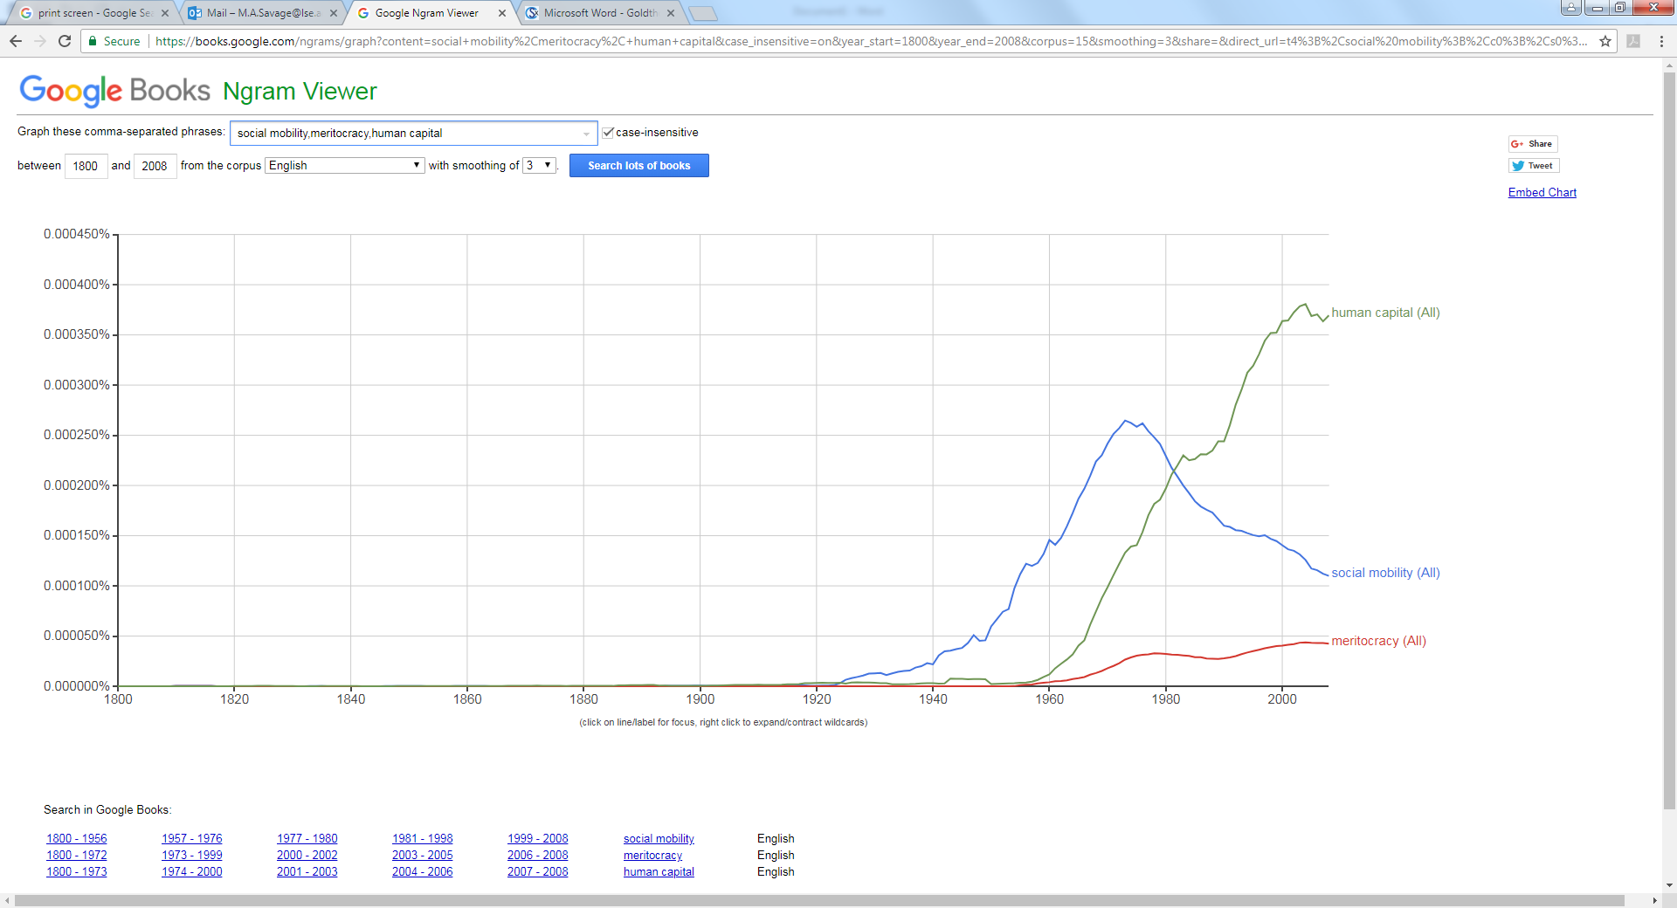
Figure 1: google ngram showing trends in the use of terms ‘human capital’, ‘social mobility’ and ‘meritocracy’

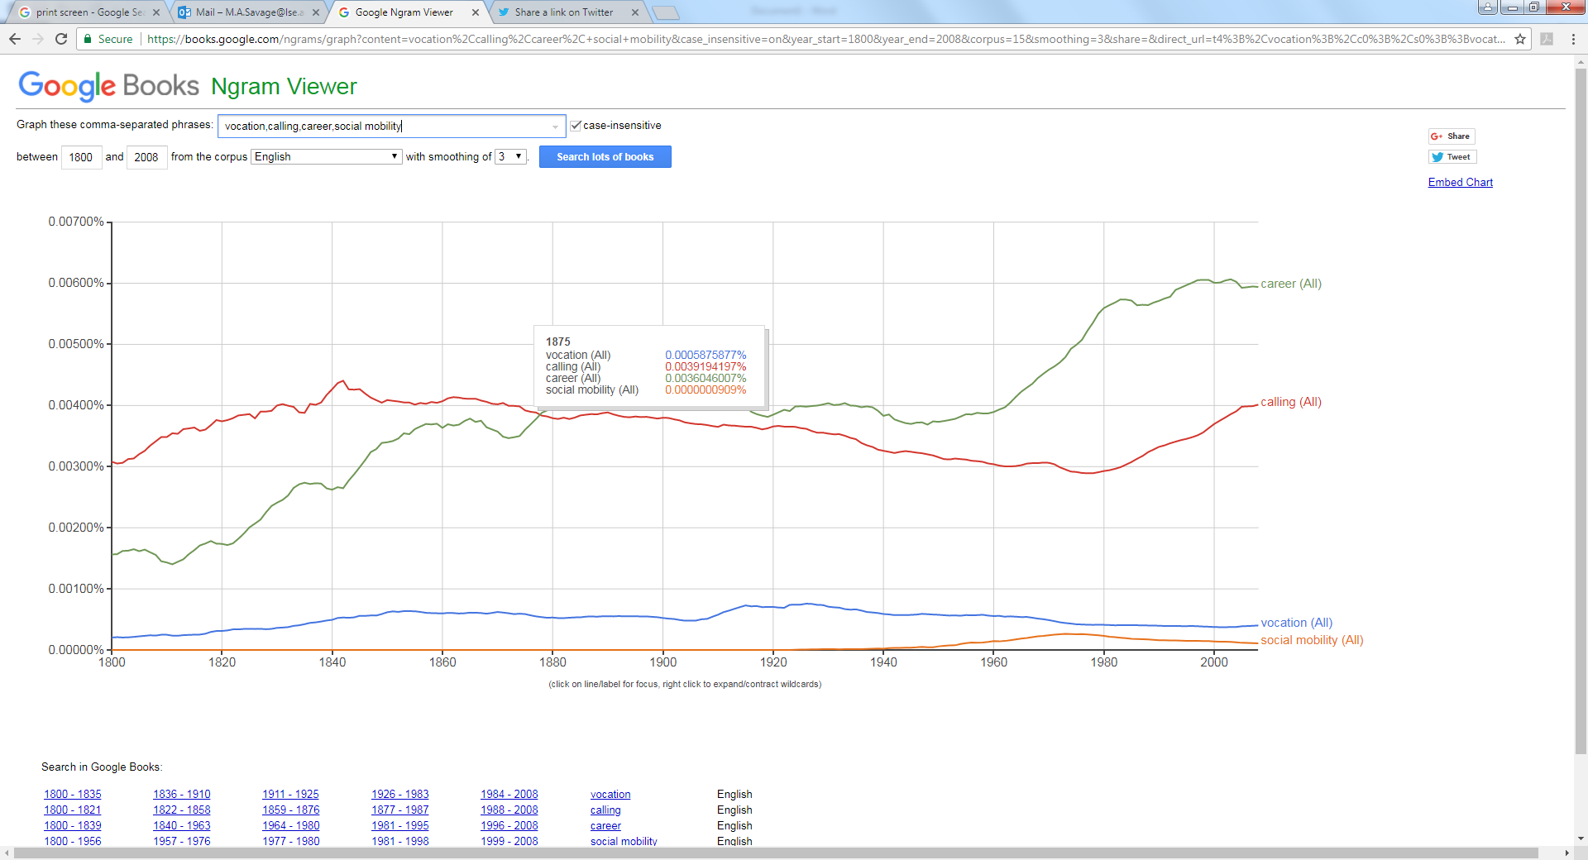
Figure 2: google ngram showing trends in relative English language use of terms ‘calling’, ‘career’, ‘vocation’ and ‘social mobility’ 1800—2008.
32.9%
0.5%
26.8%
1.8%
0.9%
4.2%
26.4%
4.2%%
1.4%

Figure 3: visualisations of life trajectory from qualitative interviewees of 1958 birth cohort.

Table 1: Life trajectories by outlier cluster
 | 3 - staircase | 7 – jags | Other number | Drew own diagram (numbered according to which of the visuals it most approximates to)
Economic elite | 2 cases | - | 1 case | 1,3,3,
Cultural elite | 2 | 3 | 1 (2), | 3,3,2,3,3-7
Disenfranchised | 5 | 2 | 1, 4, 5, 8 | 1,1

