Transition dynamics in European labour markets during crisis and recovery

Vassilis Monastiriotis, Corrado Macchiarelli, and Nikolitsa Lampropoulou
Paper accepted for publication at Comparative Economic Studies
DOI : 10.1057/s41294-019-00084-1

Abstract
The crisis has resulted in a substantial rise in unemployment in Europe and a notable divergence in unemployment rates and labour market outcomes post-crisis. In this paper we offer a detailed examination of the transitional dynamics underpinning changes in employment, unemployment and inactivity across the EU member states during the long period from before the crisis until the recent recovery (2004-2016). We document substantial differences in transitional dynamics across countries and disparate shifts in these over time. We also find systematic cross-country differences in the medium- and long-run trajectories of employment and unemployment generated by these dynamics, which can broadly be associated to differences in labour market institutions and models of labour market regulation and industrial relations (varieties of capitalism or production regimes). Applying a counterfactual analysis, we further document how altering the dynamics of labour market transitions may contribute to reducing significantly the levels of unemployment, and cross-country disparities in these, across the EU.

Keywords: Labour market transitions; unemployment; crisis; EU; counterfactual analysis
JEL codes: O52, J62, J88, P51, G01

- Introduction
The period since the eruption of the global financial crisis has been a period of immense turbulence in the European economy. The transmission of the crisis in Europe through the ‘toxic assets’ and financial uncertainty that ensued, took various forms – from a housing bust in countries such as Spain and Hungary, to a banking crisis in countries such as Ireland and Cyprus, and to a solvency crisis in countries such as Greece and Portugal. With these, the Euro-area became engulfed into a political and institutional crisis, related to the governance of EMU and of the bailout agreements and national adjustment programmes that followed.
These developments had an immense impact on the labour markets across Europe. Following a period of subsiding unemployment since 2004, unemployment rose sharply after 2008, rising from just below 7% in 2008 to 9.7% in 2010 and to near 11% in 2013; while in some countries unemployment reached historically unprecedented levels – e.g., above 25% in Spain and Greece. And while at the EU level unemployment today seems to have returned close to its pre-crisis trough (7.3% in 2017), unemployment levels remain exceptionally high in large pool of countries.
A diverse literature emerged, following these developments, that sought to examine the dynamics governing unemployment change in Europe during this turbulent period. This included macroeconomic studies examining shifts in the Phillips Curve (Bulligan and Viviano, 2017) and in the responsiveness of unemployment to changes in output (Cazes et al., 2013), studies examining the individual drivers of unemployment and of youth unemployment in particular (Carcillo et al., 2013; Eichhorst and Neder, 2014; Mauro and Mitra, 2015; Dolado et al., 2013; Kelly and McGuinness, 2015), as well as a limited number of studies examining labour market transitions, and the inflows and outflows from unemployment in particular (Ward-Warmedinger and Macchiarelli, 2014; Daouli et al., 2015; Macchiarelli et al., 2018). Despite this, a detailed and comparative investigation of the dynamics characterising labour market transitions across Europe during this period is still missing from the literature. In this paper we focus exactly on this issue and examine the transition dynamics exhibited in European labour markets during the episodes of crisis and recovery.
Specifically, using data from the Eurostat Labour Force Survey (EU-LFS) covering the national economies of the European Union for the period 2004-2016, we examine the shifts in transition probabilities between key labour market statuses (employment, unemployment and inactivity) at key points in time relating to the crisis. Further, we investigate how transition dynamics shifted the equilibrium levels of employment and unemployment over time and across space, by deriving the ergodic distributions related to the observed labour market transitions in each country over the period. Drawing on this, last, we implement a counter-factual analysis which allows us to unveil the degree to which the country-specific transition dynamics explain country differences in observed and equilibrium unemployment across the EU space.
Our evidence is informative of the differences in employment and unemployment dynamics across the EU space and of the different degrees of fluidity (or flexibility) of the different national labour markets in the EU during and after the crisis. Consistent with wider evidence elsewhere in the literature, it documents that transitional dynamics are much more favourable in the Nordic group of EU countries, which is mostly associated with the model of ‘flexicurity’ and perhaps least favourable in the Southern countries. At the same time it also unveiled a trend of worsening transitional dynamics in the former group post-crisis and persistent disequilibria in the Southern group despite the sizeably declining unemployment there in the “recovery” period; while the Central Eastern group of countries, comprising the former New Member states of the EU, shows improvements post-crisis both with regard to the equilibrium distribution of labour market outcomes and with regard to the transitional dynamics of their labour markets (e.g., flows into and out of unemployment).
The structure of the paper is as follows. In the next section we present the considerations for our analysis, examining in some more detail the evolution of unemployment across the EU during the period 2004-2016, reviewing relevant contributions from the recent literature on the topic, and presenting our data and approach. Section 3 presents our descriptive analysis of labour market transitions across the EU, identifying common trends and key differences across countries and across groups of countries belonging to different ‘production regimes’ (Esping-Andersen, 1990; Hall and Soskice, 2001). In section 4 we proceed instead to examine how these transitional dynamics influence the distribution of labour market outcomes across the EU in the medium- and long-run. Specifically, we first derive the equilibrium (steady-state) unemployment deriving from the imputed transitional dynamics and examine how this compares with the actual country-specific unemployment evolutions as observed in the data; and, subsequently, we implement a counter-factual analysis, which seeks to understand how different country transitional dynamics influence labour market outcomes (employment, unemployment) across the EU space. The last section concludes with some observations about the workings of national labour markets in the EU and some implications for policy.

- Considerations for the analysis
2.1. Stylised facts and literature
As noted already, European unemployment has shifted sizeably with the crisis. As depicted in Figure 1, unemployment in Europe rose sharply in the early phase of the crisis (2008-2010), reaching levels that had in the past been associated with the thesis of ‘Euroscelrosis’ (Bentolila and Bertola, 1990). What is more, the evolution of unemployment in the EU exhibits a clear double-peak pattern, with unemployment subsiding somewhat in 2011 but rising again soon after, reaching its peak in 2013 – a development clearly associated with the political and policy turbulence seen in the EU at the time (bailout agreements, transmission of the Greek crisis, concerns about the viability of the Euro-zone).

[FIGURE 1 AROUND HERE]

Despite the fact that the crisis has on the whole been felt across Europe, national developments with regard to unemployment have not been uniform. As is depicted in the maps of Figure 2, in the early part of the crisis unemployment rose sharply in a small number of countries, mainly those exposed to mortgage lending (Hungary, Spain, Portugal, Ireland and the UK), while at the same period unemployment continued its declining trend in other countries such as Germany, Poland, Bulgaria and even Greece. Instead, the depth of the crisis (from 2009 to 2012) saw unemployment rising fast in a broader range of countries, including this time also Greece, the Baltics, Italy, Slovenia, Slovakia, Denmark and the Netherlands. What is more notable perhaps is the divergence in unemployment paths in the subsequent period. The period since 2012/13 has been a period of unemployment adjustment in a large part of Europe (including the Baltics, the UK, Ireland, Germany and most New Member States); but has continued to rise in the south (Greece, Spain, Portugal Italy) as well as in parts of the EU ‘core’ (France, Austria, Belgium, the Netherlands and Finland).

[FIGURE 2 AROUND HERE]

These country specific evolutions are suggestive of the heterogeneous labour market transitions and dynamics characterising the EU space and motivate our further analysis of this. This heterogeneity in unemployment paths and dynamics has already been identified in the literature. For example, Boeri and Jimeno (2016) have documented that the Eurozone crisis marked a significant divergence in unemployment trajectories across (groups of) countries, leading on the whole to widening unemployment differentials across the EU. Cazes et al (2011 and 2013) and Zwick et al (2016) have also documented significant variations in unemployment adjustment across countries, which they attribute in part to country differences in national labour market institutions such as Employment Protection Legislation (EPL) and working-time regulations.
At the same time, the literature provides evidence of significant shifts in labour market fluidity. For example, work conducted by the Task Force of the Monetary Policy Committee of the European System of Central Banks (ECB, 2012) has shown that the crisis coincided with an outward shift of the Beveridge Curve, implying deteriorating matching and a shift towards higher long-term unemployment. A similar result has been obtained by Guichard and Rusticelli (2010) for the OECD.
Concerning in particular, however, the issue of labour market mobility (transitions), the literature is somewhat more mute. Prior to the crisis, a body of literature had documented an increase in labour market mobility across employment, unemployment and inactivity during the last two decades before the crisis – with differences in the extent of mobility across countries being attributed to institutional factors such as labour and product market regulation, active labour market policies, and union density. For example, Petrongolo and Pissarides (2008) attribute to such labour market institutions the differences they observe, across countries, with regard to the relative importance of the inflow and outflow rates of unemployment for the overall level of unemployment in each country. Elsby et al. (2009) found instead a relatively equal contribution of inflows and outflows to the unemployment stock in Europe; while similarly Kilponen and Vanhala (2009) argued that European countries have generally low rates of both unemployment inflows and unemployment outflows – concluding that this results in a relatively high degree of unemployment persistence overall. Finally, focusing more specifically on the issue of labour market transitions at the individual level, Ward-Warmedinger and Macchiarelli (2014) have shown that in the pre-crisis period (1998-2008) transition dynamics have been rather heterogeneous across the EU, with the probability of exiting unemployment (into employment) being as much as twice as high in some countries (e.g., Denmark, Sweden) compared to the worst performers.
Drawing on these observations, our analysis in this paper seeks to shed light on the dynamics of labour market transitions across the EU space and over the period from before the crisis until recently. Specifically, we examine how transitions across labour market states (employed, unemployed and inactive) changed in the course of the crisis (and the subsequent recovery) leading to different types of labour market adjustment across (groups of) countries; how, in result, the equilibrium distribution of labour market outcomes (and deviations from equilibrium) shifted in each country over the period; and the extent to which national transition dynamics have contributed to achieving less or more advantageous labour market outcomes in each of the countries in our data.
A note should be made about the notion of equilibrium used here. Under the assumptions of the Markov Chain analysis (as explained in the next section), statically observed transition dynamics can be used to derive the steady-state (and thus equilibrium) distribution of labour market outcomes (i.e., employment, unemployment and inactivity). This notion of equilibrium is different from that often found in the macroeconomics and labour economics literatures, which focus on the concept of the “non-accelerating-inflation rate of unemployment” (NAIRU). The latter is an equilibrium level of unemployment (and unemployment only) in the sense that it is the level of unemployment that accommodates a constant rate of inflation and thus maintains unemployment constant (in the absence of external shocks) without requiring some corrective policy intervention. The former (ergodic distribution) is instead the steady-state position not only of the unemployment rate but also of the rates of employment and inactivity; and represents the position that the economy would find in the long-run if its observed transition dynamics were preserved indefinitely and if no external shocks occurred to the system. In short, the NAIRU definition is about the level of unemployment that does not put pressures on the price level in the economy; whereas the Markov Chain definition is about the level of unemployment that will prevail in the long run ceteris paribus.

2.2. Data and methodological approach
To examine the aforementioned issues, our analysis uses individual-level micro-data from the Eurostat Labour Force Survey (EU-LFS), covering all EU countries available. The EU-LFS data contain detailed information on employment, unemployment, inactivity and on various individual characteristics such as gender, age, marital status, level of education, region of residence, and others. Although the EU-LFS has a small longitudinal component (respondents appear in the sample for 5 consecutive quarters), our analysis relies on repeated cross-sections, i.e., without following the same individuals over time (pseudo-panel). Instead, we rely on recall questions about past employment status (employment, unemployment or inactivity) to identify changes in labour market status over time (on a year-to-year basis, based on the annual EU-LFS files). Our sample consists of working age individuals aged between 15 and 64.
In parts of our analysis we group countries together according to the different social systems / production regimes to which they belong, following theoretical classifications from the comparative political economy literature (Esping-Andersen, 1990; Hall and Soskice, 2001). Beyond the presentational convenience, this also in order to facilitate some comparisons, and discussion, of transition dynamics across different institutional settings. Our underlying assumption is that different regulatory and institutional systems produce different transitional dynamics in the labour market – even for a given distribution of initial labour market statuses and external factors influencing labour market outcomes (e.g., domestic demand, international prices, exchange rate fluctuations, etc). This is consistent not only with available empirical evidence, as reviewed in section 2.1 (e.g., Petrongolo and Pissarides, 2008; Cazes et al, 2013), but also with economic models of the labour market (see, inter alia, Boeri and van Ours, 2013).
Adoption of such classifications reflects the view that it is not specific labour market institutions that can singularly account for differences in the extent of labour market flexibility (on the wider point about this, see Monastiriotis, 2007) but that it is rather the combination of institutions, as embodied into national ‘varieties’ of employment relations that allows more, or less, ‘fluid’ transitions across labour market statuses. We can demonstrate this with two examples. Stringent regulations for temporary employment contracts (e.g., as measured by the OECD EPL-temp index) are known to reduce both the inflows into employment and the outflows from unemployment and thus the overall fluidity of labour market transitions (Sala et al, 2012). On the other hand, stricter regulations for permanent contracts have been shown instead to raise the incidence of temporary jobs and thus to contribute to larger flows between employment and unemployment (Hijzen et al, 2017). Instead, the generosity of unemployment benefits, especially with regard to their eligibility duration, is known to contribute to lower exits from unemployment, but to more successful ones, with the implication that it also contributes to lower exits into inactivity (Marinescu, 2017). Our data and focus do not allow us to examine in any appropriate depth the specific link between observed labour market transitions and the specific regulations and institutions governing each labour market in the EU. Instead, our focus is with broad categories of institutional models, as identified in the literature. From these, we can draw some prior expectations, for example that labour market transitions will be higher in systems with relatively low levels of protection for temporary contracts but generous unemployment insurance (closer to the Nordic or flexicurity model) and lower in systems characterised by rigid regulations (high EPL-temp) and poor unemployment insurance (such as those observed in the Mediterranean). We examine these expectations in the analysis that follows in sections 3 and 4.

Our analysis covers the period from 2004, well before the eruption of the global financial crisis, to 2016 (the latest year available in our data), when the European economy had broadly speaking recovered fully from the crisis. To look closer at the different episodes of the crisis, in parts of the analysis we pool the annual information into three sub-periods representing pre-crisis (2004-2008), crisis (2009-2013) and recovery (2014-2016). These sub-periods are consistent with the peak-trough dates of European unemployment as depicted earlier in Figure 1.
To examine labour market transitions, we focus on three key labour market ‘states’, namely employment, unemployment and inactivity. We define a labour market transition as a move, for any individual, from any one of these states to another over a period of two subsequent years. Based on these transitions, we can calculate the transition probability (P_{t}^{AB}) between any two states (A and B) as the number of individuals transitioning from state A to state B between years t-1 and t (AB_{t-1,t}) divided by the stock of individuals originally in state A (at time t-1).
$P_{t}^{AB}=Pr⁡\{\left\{S_{t}=B | S_{t-1}=A\right\}=\frac{{AB}_{t-1,t}}{A_{t-1}}$ (1)
This results into a 3x3 transition matrix, P, embedding the raw probabilities of transitions across all states – with the right-hand off-diagonal elements showing the probabilities of increasing labour market detachment (e.g., from employment to unemployment or inactivity and from unemployment to inactivity) and the left-hand off-diagonal elements showing the probabilities of successful labour market transitions (e.g., from inactivity to unemployment or employment and from unemployment to employment); and the diagonal elements showing the stability, or persistence, of each labour market status across periods, i.e., the probabilities for remaining in a particular status in t+1 given membership into that status in t.
We can describe various aspects of this matrix with the use of a number of summary indexes. The first concerns the overall degree of stability in the labour market (Monfort, 2008) and can be calculated as
$S=\frac{Tr(P)}{n}$ (2)
where S is a general stability index; Tr(P), the trace of the transition probability matrix, is the summation of the elements of the main diagonal of this matrix; and n is the number of labour market statuses considered in the analysis. This index is essentially a measure of persistence of labour market statuses, i.e., it gives us the aggregate probability that an individual who finds herself in a particular position (labour market status) in time t will remain in the same position one year later. High values of this indicate limited ‘fluidity’ in the labour market, implying that – for any given level of unemployment and inactivity – individuals who find themselves in an adverse labour market status have fewer opportunities to escape this status.
A second index concerns successful labour market entries (Marston et al., 1976; Theeuwes et al., 1990), or successful exits from inactivity, and can be calculated as
$SL(I)=\frac{P_{IE}}{P_{IE}+P_{IU}}$ (3)
where the subscripts IE and IU show moves from inactivity to employment and to unemployment, respectively. This index is important in capturing the ability of the labour market to attract individuals who are currently detached from the labour market directly into jobs. High values of this index suggests that barriers to entry in the labour market (psychological, economic, skills-related, etc) are relatively small.
Inversely, a third index concerns unsuccessful exits from unemployment (Ward-Warmedinger and Macchiarelli, 2014), calculated as
$FL(U)=\frac{P_{UI}}{P_{UI}+P_{UE}}$ (4)
This index captures what in the literature is referred to as the “discouraged worker” effect, namely probability of individuals to detach themselves completely from the labour market after a spell of unemployment.
These indexes offer a snapshot of the short-run labour market dynamics of each country at each point in time. More importantly, the transition matrix P can also be utilized to analyse the implied long-run (steady-state) values of each labour market status in a dynamic sense. Specifically, by applying the observed transitions onto the initial labour market status in the sample (i.e., the shares of employment, unemployment and inactivity at the start of the period) iteratively over a sufficiently long horizon, we can arrive at the equilibrium values of employment, unemployment and inactivity, respectively, implied by the observed transition dynamics. As it is standard in the literature, this is referred to as an ergodic distribution. The number of iterations required for the ergodic distribution to be reached is a measure of the speed of convergence towards the steady-state. As is common in the literature, this is measured via the following statistic
$t^{o}=\frac{-ln⁡(2)}{ln⁡(λ_{2})}$ (5)
showing the half-life of convergence (tº), where λ₂ is the second eigenvalue of the transition probability matrix P. The statistic measures the number of periods (years) it takes for the distribution to move half of the distance between its initial position and the position found in the steady-state.
Calculating the ergodic (steady-state) distribution for each transition event (i.e., between any two periods) and every country allows us to examine how the long-run dynamics implied by the observed transition probabilities vary over time and across countries (or country-groups). In addition, if further allows us to implement a counterfactual analysis in order to examine how the transition dynamics of each country affect their long-run equilibrium. Specifically, using the transition dynamics observed in a selected ’benchmark’ case, one can calculate a counterfactual equilibrium for any one country, which would have occurred if the transition dynamics of the ‘benchmark’ case were applied on the actual (observed) initial labour market state of that country. The difference between ‘actual’ and ‘counterfactual’ equilibrium provides us then with an assessment of the difference in equilibrium employment, unemployment and inactivity in each country that is uniquely attributable to the distance between the transition dynamics of this country and the transition dynamics observed in the reference country. We implement this analysis using some characteristic ‘benchmarks’ (Greece, Sweden and the group of Nordic countries). Our choice of benchmarks is informed of course by wider discussions in the literature and in policy (EC, 2007), both about the effectiveness of particular ‘models’ (such as the Nordic or flexicurity model) for delivering good labour market outcomes (low unemployment) without compromising on the fluidity of the labour market, and about the range of national performances with regard to this (see, inter alia, Grönlund et al, 2017, and Christopoulou and Monastiriotis, 2018). But the choice also serves a presentational purpose, as it allows us to make a strong contrast between the derived results across cases. We select Sweden and Greece as the two country benchmarks as these exhibit transition dynamics which produce the best and poorest simulated results overall (lowest and highest counterfactual equilibrium unemployment, respectively); and the Nordic group as the one being most closely linked to the policy model favoured by the EU (EC, 2007).

- Distributional dynamics: labour market transitions and stability
Our analysis of labour market transitions covers a large number of countries (25) over a long time-period (12 years), thus producing overall 300 3x3 transition matrices (a total of 2,700 transition probabilities). It is of course impossible to present, or comment upon, all these year-to-year country-specific transitions. We thus present our results in aggregate form, highlighting selectively the patterns that are of interest. Specifically, the transition dynamics across the three states are presented here for the four country groups (without country-specific detail) for the three key sub-periods in our analysis (pre-crisis: 2004-2008; crisis: 2009-2013; and post-crisis: 2014-2016); while the summary indexes of mobility, successful labour market entries (SL) and unsuccessful unemployment exits (FL) are presented for each of the countries covered by our analysis albeit still aggregated at the sub-period level.

[TABLE 1 AROUND HERE]

Starting with the transition dynamics across the three states (Table 1), we observe that in all country groups and for all periods – as should be expected – stability is greatest in the cases of employment and inactivity and lowest for the case of unemployment. In all groups, entries from employment into unemployment increased with the crisis (e.g., from 2.8% to 3.7% in the Central Eastern group), while unemployment exits (into employment) declined (e.g., from 28.2% to 25.2% in the same group), with the exception of the Nordic group where successful exits from unemployment seem to have increased sizeably during the crisis. Trends in the recovery period are however more diverse. In the Central Eastern and Mediterranean groups employment-to-unemployment transitions declined post-crisis (by about 1 percentage point); but in the Nordic and (less so) Continental groups such transitions intensified further. Similarly, unemployment persistence (the middle cell in each sub-matrix) increased during the crisis and declined only marginally post-crisis in the Central Eastern group; increased sizeably with the crisis and continued to increase post-crisis in the Nordic and Mediterranean groups; and rose noticeably only in the recovery period for countries in the Continental group. While to some extent this reflects country differences in the timing of the crisis and in the unemployment trajectories followed subsequently (Monastiriotis, 2018), it also reflects differences in the fluidity of the different labour markets and in their extent of unemployment adjustment – with such adjustments appearing most favourable in the Central Eastern group.
Figure 3 presents the country detail in the overall stability of labour market states (stability index) across the three periods. As can be seen, in the Mediterranean countries (Cyprus, Spain, Greece, Italy and Portugal) stability increases over time, being highest in the recovery period and lowest pre-crisis; while in the Central Eastern group most countries follow a hump-shaped pattern, with stability increasing during the crisis but declining, often significantly thereafter. Exceptions to these are Malta in the Mediterranean group, where the stability index changes little; Bulgaria and Romania, where stability increases across all periods; and Latvia, where stability declines across periods. In the Nordic and Continental groups there is more heterogeneity, with Denmark and the Netherlands (Nordics) as well as Austria (Continental) following the trend found in the Mediterranean; Belgium and Luxemburg (Continental) showing a decrease in the stability index over time; Finland (Nordic) and France (Continental) exhibiting decline with the crisis and increase during the recovery period; and finally Sweden (Nordic) exhibiting the reverse pattern. On the whole, stability appears highest in southern, eastern and southeastern countries (Greece, Italy, Bulgaria, Romania, Croatia, Slovenia, Slovakia and Poland); and lowest in the countries of the Nordic group (Sweden, Denmark and the Netherlands) and in Luxemburg. Tentatively, this seems to be related to the labour market models of these countries: lower stability in countries that are closer to the ‘flexicurity’ model and higher stability with countries with more rigid regulations and less coordinated industrial relations systems.

[FIGURE 3 AROUND HERE]

The extent of successful labour market entries and unsuccessful unemployment exits, and its variation over time and across countries, is presented in Figures 4 and 5. As can be seen, successful labour market entries had been higher in the pre-crisis period (averaging 70% across countries and ranging between 45% in Croatia and 95% in the Netherlands), but their decline during the crisis period was been rather modest in most countries (average of 62.7% across countries, with a range between 35% and 88%) while the ranking of countries on this measure changed very little (Spearman rank correlation coefficient of 0.867). The situation changed little also in the recovery period (cross-country average of 64%, rank correlation coefficient of 0.835).

[FIGURE 4 AROUND HERE]

[FIGURE 5 AROUND HERE]

Cross-country variation in unsuccessful unemployment exits is much greater. For example, in the ‘recovery’ period this varied from around 5% in the Czech Republic and little over 10% in Hungary, Slovenia, Slovakia, Romania and Croatia (all countries belonging to the Central Eastern group), to over 40% in Finland, Luxemburg, and the Netherlands, followed closely by Sweden (analytically more closely to the Nordic group). As with the successful labour market entries, the picture seen in the recovery period is very similar to that observed in the ‘crisis’ period; but this time the picture is drastically different in the pre-crisis period, where some Central Eastern countries exhibited much higher rates of unsuccessful unemployment exits (e.g., Romania at near 40%) whereas other Nordic and Continental countries had much lower rates, often below 20%.
All in all, the transition probabilities summarised here present quite a diverse picture of labour market adjustments both across space and over time. Underneath this diversity, however, some patterns can be identified. In countries not greatly affected by the crisis (Nordics, Continental), the rate of transitions from employment to unemployment increased only modestly with the crisis but continued to increase well into 2016. Instead, in countries more directly exposed (Central Eastern and especially Mediterranean), the recovery period shows clearly a reduction of such ‘unsuccessful’ labour market transitions. In the Mediterranean group this translated into an overall trend of increasing stability in labour market states (including higher unemployment persistence), whereas in the Central Eastern group stability declined post-crisis and, with it, unemployment persistence also went down. Although a systematic exploration of the drivers of these patterns is well outside the scope of this paper, we note that these patterns do not seem to be particularly at odds with common intuition concerning the dynamics of the crisis in the different parts of the EU (see Monastiriotis, 2018, for a fuller discussion of this).

- Steady-state equilibrium and counterfactual analysis
4.1. Steady-state unemployment
The transitions and flows presented so far give a static picture of the short-run (year-on-year) dynamics of the EU labour markets. In this section we turn our attention to how these short run dynamics influence the long-run (steady-state) equilibrium of the different labour market states (employment, unemployment and inactivity). As was noted in section 2.2, long-run dynamics are derived by calculating the ergodic distribution implied by the transition probabilities observed for each country at each point in time. By deriving these equilibrium values for each year in the data (i.e., based on the transition matrix observed in each year), we are able to observe how the equilibrium changes year-on-year on the basis of changes in the transition dynamics in each country under study.
Figure 6 presents the derived equilibrium values for the case of unemployment, plotted against the actual unemployment rates observed in the data. As can be seen, there are important country variations in all three aspects: the level of equilibrium (and actual) unemployment; the temporal evolution of equilibrium and actual unemployment; and the distance between equilibrium and actual unemployment. For countries such as Austria, Belgium, Cyprus (until 2013), Greece (until 2012), Croatia, Hungary, Italy and perhaps Portugal (until 2009), equilibrium unemployment follows quite closely actual unemployment – suggesting that the actual level of unemployment in these countries is not due to (transitory) deviations for equilibrium but rather possibly due to structural factors. In contrast, for countries such as Bulgaria, the Czech Republic, Denmark, Estonia, Spain, Finland, France, Luxemburg, Malta and the Netherlands (as well as for a subset of other countries post-crisis), actual unemployment is above the equilibrium – sometimes, importantly so.
For these countries, the evidence suggests that adjustment dynamics inside the labour market (mobility across states) play, at least in part, some role in accounting for the observed level of unemployment. It is worth noting also the case of Slovenia (and Italy), where actual unemployment appears to have been for a prolonged period below its equilibrium level – indicating cyclical conditions in the labour market which contributed to dampening unemployment. It is also interesting to note that deviations from equilibrium (of the adverse form) are not systematically higher in countries known for their relatively poor labour market performance (e.g., such as Greece or Spain): in fact, pre-crisis, countries such as Luxemburg, the Netherlands and Sweden had larger deviations than those observed in any of the Mediterranean countries (Portugal, Italy, Greece and Spain, in particular).

[FIGURE 6 AROUND HERE]

Sizeable country differences also exist with regard to the speed by which transitions lead to a steady-state of labour market outcomes (as measured by the half-life of convergence measure), suggesting important differences in the fluidity of labour markets across the EU (full results not shown, but available upon request). Pre-crisis, this varied between 2.7 years (in Denmark) and 10.9 years (in Italy). The crisis period saw an increase in the time to convergence, with the minimum rising only marginally (2.8 years, again in Denmark) and the maximum rising somewhat more markedly (11.4 years, in Bulgaria). Post-crisis we observe instead more differentiation, with the minimum falling to 2.6 years (Sweden) and the maximum rising further to 14.1 years (Bulgaria).

4.2. Counterfactual analysis
To examine further how transition dynamics contribute to the obtained equilibrium values for unemployment (as well as of the other labour market states), we proceed here to implement a counterfactual exercise, as discussed in section 2.2. The exercise relies on constructing a hypothetical unemployment distribution towards the steady-state path for each country (or country group), on the basis of the transition dynamics observed in a selected reference country, and then calculating the distance between the actual and hypothetical distributions. Specifically, as a first step, we apply iteratively over five years the transition dynamics of the reference country to the actual distribution of labour market statuses of each of our countries, so as to derive the counterfactual distribution of labour market states in t+5. Then, we calculate the same distribution (in t+5) using the same initial distribution but applying this time the country specific (actual) transition dynamic. Our last step is to calculate the difference between the two distributions: this gives us the amounts of employment, unemployment and inactivity (in percentage points) that would have shifted in a 5-year period if each country had the transition dynamics of the reference country.
Figure 7 reports the result from two such exercises, one using the transition dynamics of Sweden as the reference point (left panel) and one using the transition dynamics of Greece (right panel), focusing exclusively on the post-crisis period. In turn, in Figure 8 we use the transition dynamics of the Nordic group and apply them to the actual distributions of the other country groups, this time for both the crisis and post-crisis periods. As can be seen in Figure 7, transition dynamics play a very important role in equilibrium unemployment. With the exception of Hungary and Lithuania, if the EU countries had the transition dynamics exhibited by Sweden in the post-crisis period, they would have a much better employment performance (in equilibrium terms); while a large majority of countries would also have lower equilibrium unemployment (exceptions include the Czech Republic, Malta, Estonia and Luxemburg). At the extreme, in countries such as Greece, Croatia, Portugal and Slovenia, equilibrium employment could be higher by over 20 percentage points. As is evident from the graph, the main factor driving these results is the far superior performance of Sweden with regard to labour force participation (lower inactivity), implying much lower counterfactual inactivity rates in practically all countries (with Hungary and Latvia constituting marginal exceptions). In turn, when using Greece as the counterfactual the picture reverses almost fully. This time, with few exceptions, the transition dynamics of Greece produce more unemployment and inactivity and less employment.

[FIGURE 7 AROUND HERE]

Similarly, in Figure 8 we see that the transition dynamics observed for the Nordic countries also have the tendency to produce superior labour market outcomes in the rest of the EU, especially in the post-crisis period. For the crisis period, the counterfactual produces less unemployment in all three country groups but it produces more employment only in the Mediterranean and Central Eastern groups; for the Continental group, the difference shows instead as increased inactivity. For the post-crisis period, instead, counterfactual employment outcomes are better everywhere, ranging between 3% in the Central Eastern group and 8% in the Mediterranean group, while inactivity appears universally lower by around 2.5-3.0 percentage points.

[FIGURE 8 AROUND HERE]

Evidently, the results from these counterfactual analyses show that transition dynamics play a very important role for the determination of labour market outcomes across the EU. This suggests that, despite the observed structural differences across countries and their marked differences with regard to actual and equilibrium unemployment rates (e.g., as shown in Figure 6), policies aiming at altering the transition dynamics governing the EU’s national labour markets – presumably by increasing mobility and the fluidity of transitions across states (see vis. Figures 3-5) – can have a dramatic effect in reducing unemployment differentials and raising overall employment levels across the European space. We discuss the implications of this observation in the concluding section.

- Conclusions
The last decade since 2008 has been a particularly turbulent period for the European economy and for many of the national economies within the EU. What started as a ‘toxic assets’ crisis in the USA, was transmitted via a number of channels to the European continent with devastating consequences not only on the financial and fiscal sectors but also in the labour market – with unemployment at the EU level rising to double-digit figures and hitting in some countries historically unprecedented levels. While a number of studies have examined how labour markets in the EU have adjusted to this shock, evidence concerning labour market transitions, and their short- and long-run dynamics, remains limited. In this paper we have attempted to fill this gap, by providing an extensive analysis of labour market transitions across the national economies of the EU, examining not only how year-on-year transitions evolved during the course of the crisis but also how this affected the equilibrium (steady-state) distribution of labour market outcomes (employment, unemployment and inactivity) across the EU. With the latter, we were also able to trace how the transition dynamics found in different parts of the EU may have influenced actual medium-term labour market outcomes.
Our results sketch a mixed picture of some general EU-wide trends but also some notable heterogeneity across countries (as well as country groups). The crisis saw a substantial increase in unemployment persistence in all but the Nordic countries and particularly so in the Mediterranean countries, which were of course worst hit by the crisis. Employment persistence (or, stability) went down for all groups; but within groups there was some significant variation in overall stability of labour market states as well as in the intensity of labour market re-attachment (successful entries into employment from inactivity) and de-attachment (unsuccessful exits from unemployment into inactivity). Post-crisis, unemployment persistence declined in the group of Central Eastern countries, but it continued increasing for countries in the Mediterranean and Continental groups while it rose quite dramatically – while staying however at significantly lower levels than in the rest of Europe – in the case of the Nordic group. In the same period, flows from unemployment into employment remained highest for the Nordic group of countries, but followed a downward trend everywhere except for the group of Central Eastern countries. In some cases (Central Eastern and Mediterranean countries), exits from employment into unemployment contributed proportionately more to declining unemployment, as they fell quite substantially (by over 1 percentage point or some 20-30%). In this sense, economic recovery in the post-2013 period was quite varied across the EU space, leading to greater heterogeneity in national unemployment rates post-crisis compared to the pre-crisis period – as has also been documented elsewhere in the literature (Boeri and Jimeno, 2016). Particularly for the Mediterranean group, the 2014-16 period can hardly be dubbed as “recovery”, as successful and unsuccessful labour market transitions remained in this period well away from the levels observed before the crisis for this country group.
Our analysis of long-run dynamics revealed that this heterogeneity concerns also the implied equilibrium distributions of labour market outcomes and in particular equilibrium (steady-state) unemployment. By 2016, observed (actual) unemployment rates have been above, or well-above, equilibrium in the vast majority of EU member states – and especially so in countries such as Greece, Spain, Malta, Luxemburg and Sweden. On the other hand, a number of countries (Slovenia, Italy, Hungary, France, Austria) are exiting the crisis with unemployment rates close to the long-run equilibrium implied by their transition dynamics; while in no country is current unemployment below the imputed equilibrium. A large literature exists which seeks to explain the observed heterogeneity in unemployment rates across the EU, identifying a host of factors relating not only to labour market institutions but also to a host of other structural and policy-related factors (such as export orientation, industrial composition, proximity to markets; or wage/incomes policies, price stability, industrial policy interventions, etc). Our analysis contributes to this debate, by revealing further a significant role played also by distributional dynamics relating to the fluidity of transitions observed in different EU member states. Drawing on a counterfactual analysis, which applied the distributional dynamics observed in some exemplary cases to predict the resulting medium-term distribution of labour market outcomes in the full population of EU member states, we were able to show that favourable distributional dynamics (as those found in Sweden) could produce within a five-year period sizeably less unemployment and more employment in the vast number of cases (with counterfactual employment probabilities being higher in countries such as Greece, Portugal and Slovenia by more than 20 percentage points); while the opposite was true for more adverse distributional dynamics (like those found in Greece). At the country-group level, the distributional dynamics found in the Nordic countries could have produce unemployment rates that would be lower by as much as 8 percentage points if applied to the distribution of labour market outcomes seen in the Southern group.
There is an important policy message emanating from these results. Despite the recent “recovery” seen across the labour markets of the EU, significant differences remain not only in labour market outcomes per se but also – and, we would argue, more importantly – in the dynamics underpinning labour market transitions across the national labour markets of the EU. Indeed, cross-country variability in transition dynamics seems to account to a large extent for the observed country differences in employment, unemployment and inactivity rates. To us, this seems as a clear case suggesting that much more policy attention should be placed on understanding the factors driving each country’s transition dynamics and on devising policies aiming at making these dynamics more favourable (in the sense of leading to higher employment and lower unemployment rates in the medium- and long-run). To some extent, of course, it should be expected that the intensity and directionality of transition dynamics could be related to the quality of labour market institutions and the extent of regulatory and other rigidities found in each country. Indeed, it is worth noting that in our analysis the most adverse labour market dynamics were observed in those cases (the Mediterranean group and Greece in particular) where labour and product market rigidities are known to be particularly pervasive. However, evidence of weak transition dynamics and disequilibrium was also unveiled for other countries, some of which have lower unemployment rates overall and are generally thought to have less restrictive labour market institutions (such as the Czech Republic or Estonia); while the most favourable transition dynamics – albeit at a declining rate – are found for the Nordic group countries, which is generally associated with the model of ‘flexicurity’. This emphasises the need for policy efforts aiming at addressing the labour market problems of Europe to move beyond the simple distinction between ‘rigidity’ and ‘flexibility’ and focus instead on the most appropriate forms of labour market ‘recalibration’ (Picot and Tassinari, 2014) suitable in each national context. Although such an analysis of the links between different forms of institutional calibration and the prevailing transition dynamics in the labour market has been outside the scope of this paper, we hope that our analysis has contributed in directing policy and future academic research in this direction.

References

Bentolila, S., & Bertola, G. (1990). Firing costs and labour demand: how bad is eurosclerosis?. The Review of Economic Studies, 57(3), 381-402.
Boeri, T. (2002). Who's Afraid of the Big Enlargement?: Economic and Social Implications of the European Union's Prospective Eastern Expansion (No. 7). Centre for Economic Policy Research.
Boeri, T., & Jimeno, J. F. (2016). Learning from the Great Divergence in unemployment in Europe during the crisis. Labour Economics, 41, 32-46.
Boeri, T., & Van Ours, J. (2013). The economics of imperfect labor markets. Princeton University Press.
Bulligan, G., & Viviano, E. (2017). Has the wage Phillips curve changed in the euro area?. IZA Journal of Labor Policy, 6(1), 9.
Carcillo, S., Fernández, R., Königs, S., Minea, A., (2013). “NEET Youth in the Aftermath of the Crisis: Challenges and Policies”, OECD Social, Employment and Migration Working Papers, No. 164, OECD Publishing.
Cazes, S., Verick, S., & Al Hussami, F. (2011). Diverging trends in unemployment in the United States and Europe: evidence from Okun's law and the global financial crisis (No. 994676293402676). International Labour Organization.
Cazes, S., Verick, S., & Al Hussami, F. (2013). Why did unemployment respond so differently to the global financial crisis across countries? Insights from Okun’s Law. IZA Journal of Labor Policy, 2(1), 10.
Christopoulou R. and Monastiriotis V. (2018). Did the crisis make the Greek economy less inefficient? Evidence from the structure and dynamics of sectoral premia. GreeSE Paper No125, Hellenic Observatory, LSE.
Daouli, J., Demoussis, M., Giannakopoulos, N., & Lampropoulou, N. (2015). The ins and outs of unemployment in the current Greek economic crisis. South-Eastern Europe Journal of Economics, 13(2).
Dolado, J. J., Jansen, M., Felgueroso, F., Fuentes, A., and Wölfl, A. (2013). “Youth Labour Market Performance in Spain and its Determinants: A Micro-Level Perspective”, OECD Economics Department Working Papers, No. 1039, OECD Publishing.
EC (2007). Towards Common Principles of Flexicurity: More and better jobs through flexibility and security. Communication from the Commission to the European Parliament, the Council, the European Economic and Social Committee and the Committee of the Regions, Brussels.
ECB (2012), Euro Area Labour Makrets and the Crisis, ECB Occasional Paper No138, Task Force for the Monetary policy Committee of the European System of Central Banks, ECB.
Eichhorst, W. and Neder, F. (2014). “Youth Unemployment in Mediterranean Countries”, IZA Policy Paper, No. 80.
Elsby, M. W., Michaels, R., & Solon, G. (2009). The ins and outs of cyclical unemployment. American Economic Journal: Macroeconomics, 1(1), 84-110.
Esping-Andersen, G. O. (1990). The three worlds of welfare capitalism. Blackwell Publishing Ltd, Cambridge.
Grönlund, A., Halldén, K., & Magnusson, C. (2017). A Scandinavian success story? Women’s labour market outcomes in Denmark, Finland, Norway and Sweden. Acta Sociologica, 60(2), 97-119.
Guichard, S., & Rusticelli, E. (2010). Assessing the impact of the financial crisis on structural unemployment in OECD countries.
Hall, P. A. (2001). Varieties of capitalism: The institutional foundations of comparative advantage. D. W. Soskice (Ed.). Oxford: Oxford University Press.
Hijzen A., Monduato L. & Scarpetta S. (2017). The impact of employment protection on temporary employment: Evidence from a regression discontinuity design. Labour Economics, 46, 64-76.
Kelly, E. and McGuinness, S. (2015). "Impact of the Great Recession on unemployed and NEET individuals’ labour market transitions in Ireland", Economic Systems, 39(1), 59–71.
Kilponen J. and Vanhala J. (2009), Productivity and Job Flows: heterogeneity of new hires and continuing jobs in the business cycle, ECB Working Paper No1080, ECB.
Macchiarelli C., V. Monastiriotis and N. Lampropoulou (2018), “Transitions in the EU labour market: Structure, crisis and recovery”, Report to the DG-EMPL, European Commission.
Marinescu I. (2017). The general equilibrium impacts of unemployment insurance: Evidence from a large online job board. Journal of Public Economics, 150, 14-29.
Marston, S. T., Feldstein, M., & Hymans, S. H. (1976). Employment instability and high unemployment rates. Brookings Papers on Economic Activity, 1976(1), 169-210.
Mauro, J. and Mitra, S. (2015). “Understanding Out-of-Work and Out-of-School Youth in Europe and Central Asia“, World Bank Other Operational Studies 22806, The World Bank.
Monastiriotis, V. (2007). Labour Market Flexibility in UK Regions, 1979-1998. Area, 39(3), 310-322.
Monastiriotis, V. (2018). Labour market adjustments during the crisis and the role of flexibility. Social Situation Monitor Research Note (May 2018), Directorate-General for Employment, Social Affairs and Inclusion, Brussels.
Monfort, P. (2008). Convergence of EU regions: Measures and evolution. Brussels: European Commission, Regional Policy.
Petrongolo, B., & Pissarides, C. A. (2008). The ins and outs of European unemployment. American economic review, 98(2), 256-62.
Picot, G., & Tassinari, A. (2014). Liberalization, dualization, or recalibration? Labor market reforms under austerity, Italy and Spain 2010–2012. Nuffiled College Working Paper Series in Politics No1741, Oxford University.
Sala H., Silva J. & Toledo M. (2012). Flexibility at the margin and labor market volatility in OECD countries. Scandinavian Journal of Economics, 114(3), 991-1017.
Sapir, A. (2006). Globalization and the reform of European social models. JCMS: Journal of Common Market Studies, 44(2), 369-390.
Shorrocks, A. F., & Foster, J. E. (1987). Transfer sensitive inequality measures. The Review of Economic Studies, 54(3), 485-497.
Theeuwes, J., Kerkhofs, M., & Lindeboom, M. (1990). Transition intensities in the Dutch labour market 1980–85. Applied Economics, 22(8), 1043-1061.
Ward-Warmedinger, M., & Macchiarelli, C. (2014). Transitions in labour market status in EU labour markets. IZA Journal of European Labor Studies, 3(1), 17.
Zwick, H. S., Syed, S., & Shah, A. (2016). Augmented okun's law within the emu: working-time or employment adjustment? a structural equation model. Economics Bulletin, 36(1), 440-448.

FIGURES AND TABLES

Figure 1 – Unemployment rate in the EU
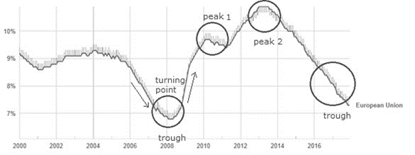
Source: Eurostat data

Figure 2 – Changes in unemployment across the EU
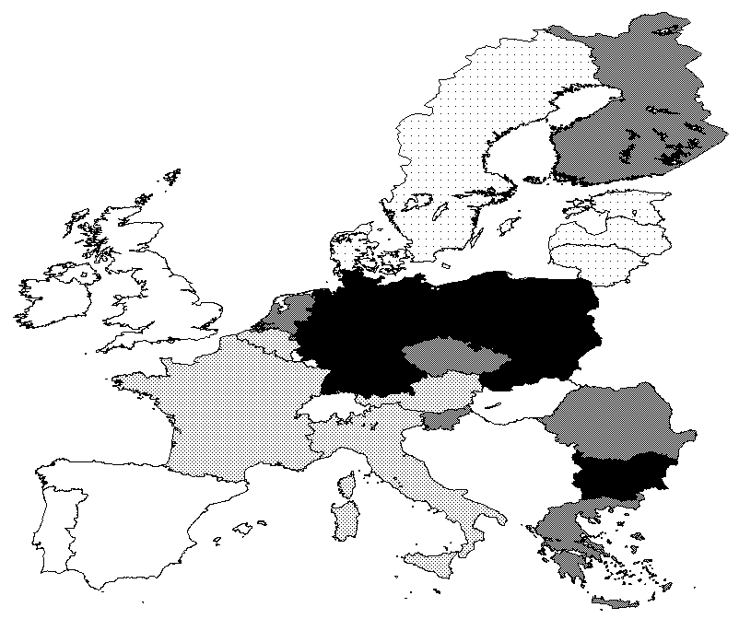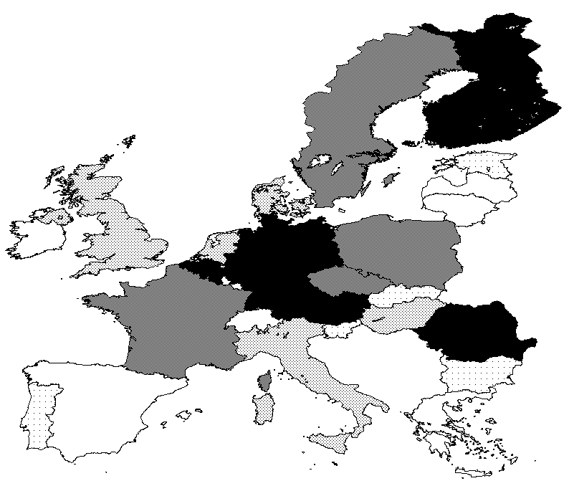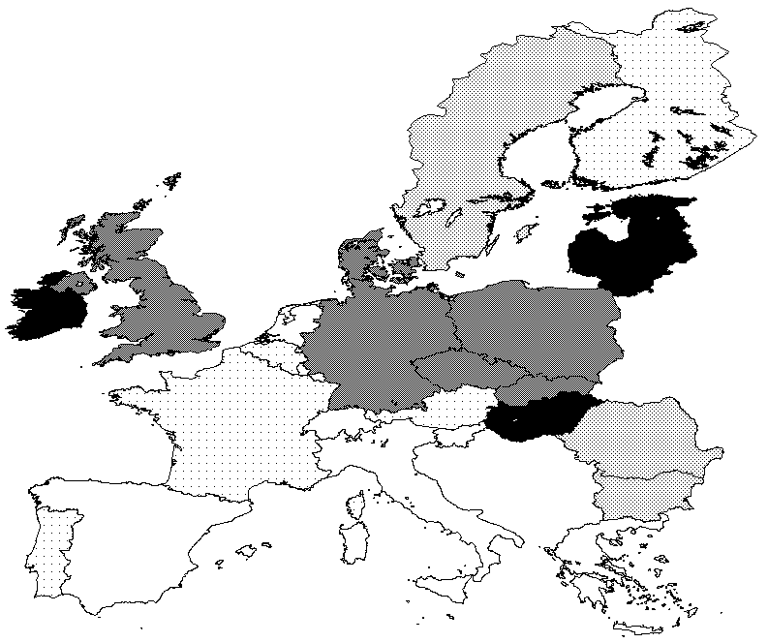
2004/06-2007/09 2007/09-2010/12 2010/12-2013/15
Legend: Top quantile; 2nd quantile; 3rd quantile; 4th quantile; Bottom quantile
Source: Authors’ elaboration of Eurostat data

Figure 3. Stability of transitions by country and period

Notes: Stability index as explained in the text.

Figure 4. Successful labour market entries

Notes: SL index as explained in the text.

Figure 5. Unsuccessful unemployment exits

Notes: FL index as explained in the text.

Figure 6. Actual and steady-state unemployment rates
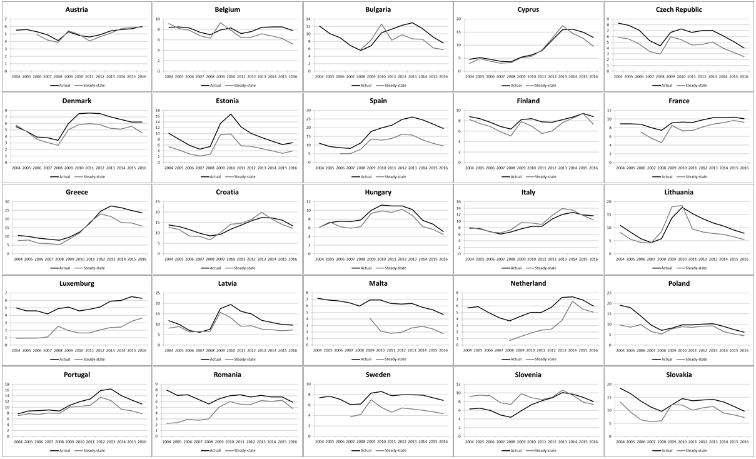
Sources: LFS microdata and Eurostat aggregate unemployment data. Authors’ computations.

Figure 7. Counterfactual steady-state distributions

Sweden Greece
Sources: LFS microdata, authors’ computations.

Figure 8. Counterfactual steady-state distribution by country group (benchmark: Nordics)

Crisis Post-crisis
Sources: LFS microdata, authors’ computations.

Table 1. Transition probabilities by period and country groups
 |  | 2004-2008 |  |  | 2009-2013 |  |  | 2014-2016
 |  | E | U | I | E | U | I | E | U | I
Central Eastern | E | 0.936 | 0.028 | 0.036 | 0.927 | 0.037 | 0.036 | 0.945 | 0.024 | 0.031
 | U | 0.282 | 0.624 | 0.094 | 0.252 | 0.697 | 0.051 | 0.280 | 0.666 | 0.054
 | I | 0.045 | 0.021 | 0.934 | 0.032 | 0.017 | 0.952 | 0.031 | 0.014 | 0.954
Nordics | E | 0.898 | 0.016 | 0.086 | 0.893 | 0.027 | 0.081 | 0.888 | 0.032 | 0.079
 | U | 0.211 | 0.318 | 0.471 | 0.375 | 0.356 | 0.269 | 0.345 | 0.430 | 0.226
 | I | 0.102 | 0.02 | 0.878 | 0.094 | 0.028 | 0.878 | 0.109 | 0.037 | 0.855
Continental | E | 0.933 | 0.033 | 0.034 | 0.923 | 0.041 | 0.035 | 0.920 | 0.043 | 0.037
 | U | 0.321 | 0.597 | 0.083 | 0.308 | 0.594 | 0.097 | 0.280 | 0.639 | 0.080
 | I | 0.038 | 0.013 | 0.949 | 0.044 | 0.021 | 0.936 | 0.040 | 0.02 | 0.940
Mediterranean | E | 0.936 | 0.032 | 0.032 | 0.914 | 0.054 | 0.031 | 0.930 | 0.044 | 0.026
 | U | 0.314 | 0.588 | 0.098 | 0.214 | 0.704 | 0.082 | 0.208 | 0.712 | 0.080
 | I | 0.035 | 0.025 | 0.940 | 0.024 | 0.031 | 0.945 | 0.021 | 0.031 | 0.948
Note: E=employed; U=unemployed; I=inactive. Observations are weighted according to the labour force share (15-64) in each country over the aggregate. Elements showing a probability of remaining in the same labour market state (employment, unemployment and inactivity) are in bold.
Sources: EU-LFS microdata, authors’ computations.

Due to missing data on recall questions (past employment status), Germany, the UK and Ireland are excluded from the analysis. Data availability is also limited for some years for some other countries – namely for France, Austria and Spain in 2004-2005; for Sweden in 2004-2006; for Bulgaria and the Netherlands in 2004-2007; and for Malta in 2004-2008.
We identify four such groups: Central Eastern (Bulgaria, Czech Republic, Estonia, Croatia, Latvia, Lithuania, Hungary, Poland, Romania, Slovakia and Slovenia); Nordics (Netherlands, Finland, Denmark and Sweden); Continental (Belgium, France, Luxemburg and Austria); and Mediterranean (Greece, Spain, Italy, Cyprus, Portugal and Malta). To produce the groups we weight each country on the basis of their GDP. Similar groupings have been used elsewhere in the literature of European labour market dynamics (see, for example, Boeri, 2002; Sapir, 2006; and Ward-Warmedinger and Macchiarelli, 2014).
For a recent analysis of transition probabilities using more granular labour market states see Macchiarelli et al (2018).
This is essentially a transformation matrix, transforming the past distribution of employment outcomes (‘states’) into the current one – or, in matrix notation, F_{t} = P*F_{t-1}.
This index is bounded between [0, 1] and can thus be interpreted as a percentage. The inverse of this measure is the well-known Shorrocks’ (1987) mobility index, which shows in turn the aggregate probability of individuals changing their labour market status between t and t+1, on the basis of matrix P.
In Markov Chain analysis an ergodic distribution is the distribution deriving from multiplying an initial distribution (here, of employment states) F_{t} by a power n of the transition matrix P such that, for any k>0, F_{t+s} = P^{n}F_{t} = P^{n+k}F_{t} = F_{t+s+k}. It is thus equivalent to the notion of steady-state. Such a distribution exists if and only if the transition matrix is positive-recurrent, meaning that each and every state can re-occur with a positive probability (i.e., for any state in period t the transition dynamics guarantee that a return to that state will occur in the future, no matter how distant). The ergodic distribution can be calculated by using the left eigenvector that corresponds to the unit (isolated) eigenvalue.
Full results are available from the authors upon request.
Our measure of employment includes successful job-to-job transitions (‘labour market churn’). From results not shown (but available upon request), it appears that the percentage of labour market churn is rather constant both across countries and over time (at around 10%), with few exceptions (e.g., falling in Spain from 15% pre-crisis to 8% post-crisis).
This was accompanied by a substantial decline of transitions from unemployment to inactivity, suggesting perhaps a stronger ‘added worker’ effect in this group.

